THE HASHEMITE KINGDOM OF JORDAN-MINISTRY OF EDUCATION
GENERAL SECONDARY CERTIFICATE EXAMINATION-2011
GENERAL ENGLISH
المستوى الثالث - الدورة الشتوية – الكتاب الجديد
DATE: 29/2/2018 TIME: ONE HOUR AND A HALF
ملحوظات: (1) أجب عن جميع أسئلة هذه الورقة
(2) للمتقدمين لجميع الفروع الأكاديمية
-------------------------------------------------------------------------------------------------------------
Read the following article carefully, and then in your ANSWER BOOKLET answer all the questions that follow. Your answers should be based on the article.
In England, almost 50% of school leavers go on to higher education. The figure has not always been as high as this. Twenty years ago, it was closer to 30%, and thirty years before that, it was only about 5%. Another huge change has been financial. Before 1998 CE, higher education in the UK was completely free for UK citizens. Since then, tuition fees have been introduced. Most students borrow this money from the government. They don't have to repay it immediately. Instead, they pay it back slowly out of future earnings. Despite the high cost, most students choose to study away from home. A recent survey of 17,000 students revealed that only 7% wanted to stay at home while they studied for their degree. Of course for most young people, living away from home means borrowing even more money from the government. So why don’t students choose to avoid debt by staying at home, where they don't have to pay rent? Most of them say that they want to move to the university of their choice, rather than the nearest one. Another strong motive is the desire to live in a new culture. Where do these students live? Many have rooms in halls of residence, especially in their first year; others rent flats or houses. A lucky minority live in property that their parents have bought for them. Most of them need to learn to cook, do their own washing and manage their time and money.
Question number one: ( 22 points )
1. There were two huge changes, which occurred in higher education in England.
(2 points)
………………………………………………………………………………….
2. There are two reasons for students who want to study abroad. Mention them.
(2 points)
…………………………………………………………………………………..
3. Where do students who study abroad live?
(4 points)
…………………………………………………………………………………..
4. Write down the sentence, which indicates that students don't have to pay off the government at home.
(3 points)
……………………………………………………………………………….

PAGE TWO
5. How can British government help its citizens to complete their studying?
(3 points)
……………………………………………………………………………………
6. What does the underlined word it refer to? (2 points)
…………………………………………………………………………………………
7. Find the word from the text which means Accommodation provided by a university or college. (2 points)
................................................................................................................................
8. When was higher education in the UK free for citizens? (2 points)
…………………………………………………………………………………..
Critical Thinking
studying abroad has many advantages and disadvantages. Think of this statement and, in two sentences write your point of view. (2 points)
……………………………………………………………………………………………………………………………………………………………………………………………..

Question number two: Choose the suitable item from those given to complete each of the following sentences and write it down in your ANSWER BOOKLET. (8 points)
tuition | Developed nation | play it by ear | debt | linguistics

1. ……………………. is a country that’s economically and socially advanced.

2. Studying ………………………. lets me focus on my love of language in an analytical way

3. I’m not sure if it’ll be warm enough to have a barbecue. We’ll have to……………...
4. Do you have maths ……………….. at the weekend?

5. You can borrow money from the bank and pay your …………………

B : Study the following dictionary entry and answer the question that follows. Write the answer in your ANSWER BOOKLET. (3 points)
keep your chin up! I’m sure everything will be fine in the end.

There is a missing word in the above body idiom, rewrite the sentence including the missing word?

C: Study the following sentences and answer the question that follows
Write the answer down in your ANSWER BOOKLET (6 points )
- Kareem is a …………………………….. journalist, he has worked previously . ( qualification / qualified / qualify )
- Is one side of the brain more…………………..………….. than the other? ( dominate / dominance / Dominant )

PAGE THREE

Question number three : Correct the verb between brackets, then write your answers down in your ANSWER BOOKLET. (18 points) 1. Amer drinks more than his brother.
Amer‘s brother ……………………………………………………………..

2. Losing weight is not as easy as putting on weight.
Losing weight is ……………………………………………………………..

3. football match there are more scores than in a basketball match.
basketball match there aren‘t……………………………………………..

4. Ala'a doesn’t have as many stamps as Ghada. Ghada ………………………………………………………….……………
5. Neither games nor internet are as good as books. books ……………………………………………………………..……………
6. The warmer country in the region is Saudi . ( cold) The least .............................................................................................................

B: Study the following sentence, and answer the question that follows. Write the answer in Your ANSWER BOOKLET.( 3 points )

Why don’t you go the space school next year …?
What is the function in the above sentences?

* Editing
Find four mistakes (one grammar , one punctuation, and two spelling mistakes) (4 points )
The contradectory views of the study suggest that the number and length of school days are not the only factor in determining whether students will sucseed at school or not?

…………………………………………………………………………………………………………………………………………………………………………………………………………………………………………………………………………………………………..

PAGE FiVE
B. GUIDED WRITING (4 points)
Read the information below, and in your ANSWER BOOKLET, write four sentences using the given notes below Use the appropriate linking words.
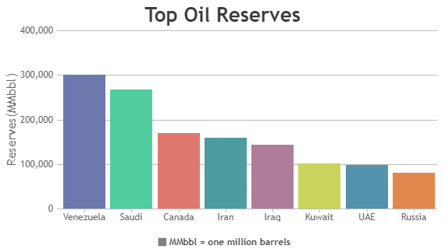

……………………………………………………………………………………………………………………………………………………………………………………………………………………………………………………………………………………………….

FREE WRITING

Think of three ways in which people will be living in the future. Write about 80 words (7 points)
…………………………………………………………………………………………………………………………………………………………………………………………………………………………………………………………………………………………………………………………………………………………………………………………………………………………………………………………………………………………………………………………………………………………………………………………………………………………………………………………………………………………………………………………………………………………………………………………………………………………………………………………………………………………………………………………………………………………………………………………………….………………………………………………………………………………..……………………………………………………………………………………………………………………………………………………………………………………

ABEER ATHERH

