
اسم الطالب : …..................................…
الصف الرابع
الفصل الاول
اعداد : أم قصي ابو عاذره
0782986841

Unit 1
Arabic meaning :-
Lab……………….Library ……………..park ………………hall ………………..read a book ……….
Have science …………P.E …………… ride a bike …………………pray…….….mosque ……
**********************************************************************************************************************
Lab | Park | library | hall

-We always have science in the …………………..1
2- We always read books in the ………………………
3- We do P.E in the ………………………..
4- We ride our bikes in the …………………
always / never
- I ……………..….brush my teeth .1
- I ……………..….talk in the library .2
- I ……………..… do my homework .3
- I ……………….. get up late .4
- I ……………….. forget my schoolbooks.5
- I …………….…. Listen to my teacher.6
- I ……………..… talk in the library .7
8- I ……………..… run in class .
Order :-
- favourite / day / My / Friday / is 1
……………………………………………………………………………
- Is / subject / Arabic / favourite / My 2
…………………………………………………………………………….
We live in Amman , It's a big city . Our house is near the mosque . We go to the mosque to pray . We always visit the Roman Theatre with our parents at the weekend . We go shopping at the market . We visit the museum . we never touch anything in the museum . We like our city .
1- Amman is small city . ( )
2-Kareem and Samira don’t live near the mosque . ( )
3-They go to the mosque to pray .( )
4-They never go to the museum .( )
5-They like Amman .( )
ch / sh
)……..ildren 1
2) go …..opping
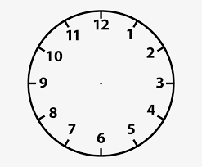
quarter to three quarter past nine half past four eleven o'clock
Arabic meaning :-
Islamic Education …………………… 2)- Maths………………………………….. - 1)
3)- Science……………………………….. 4)- Social Studies …………………
ea / ar
ne…..r a p..…k m…...ket ak…...ee
A: What's your favourit subject ?
B : …………………………………………………………………….
A: What's your favourit day ?
B : ………………………………………………………………………
We live in Amman , It's a big city . Our house is near the mosque .
We go to the mosque to pray . We always visit the Roman Theatre with our parents at the weekend . We go shopping at the market . We visit the museum . we never touch anything in the museum . We like our city .
Kareem and Samira
1: Amman is asmall city .( )
2: They touch every thing in the museum .( )
3: Their hous is near the mosque .( )
4: They like their city . ( )
Complete ( never /always )
I ……………………..get up late.
I …………………….. talk in the library .
I …………………… listen to my teacher .
Order and write :
Favourite / day / my / Friday / is

Usually | Always | Never

1- Huda ……………………..plays football. ( √√ )
2-Anas ……………………..does his homework every day. (√ )
3-Sami…………………..writes stories daily. (x)

Unit 2
This is King Abdullah Stadium in Amman .Many people come here to watch football matches . My dad sometimes takes me to the stadium . I like watching football matches . Twenty-two people play football in a match . I like playing football . I always play football on Saturday . our football team sometimes wins . samira can't play football . she sometimes plays table tennis Kareem
1-What sport do people play at king Abdullah Stadium ? ……………..………………
-Who does Kareem go to the stadium with ? ..............................2
3-Does Kareem like watching football match ? ................................
4-How many people play in a football match ? ............................
5-When does Kareem play football ? ....................................
6-Can Samira play football ? ........................................
Write the number :-
Twenty –two ….. twenty – eight ……. Twenty three …… twenty – nine ……
*************************************************************************************************************************
- I like …………….………( play / playing / played )1
- I'm good at …………….( run / running / running )2
3-She sometimes …………….( play / plays / played )
4-We sometimes ……………..( play / played / playing )
*************************************************************************************************************************
- 1-What's your name ? …………………………………………. .
- 2-What's your favourite subject ? ……………………………………………….
- 3-What are you good at ? …………………………………………………………..
- 4-What’s your favourite sport? ……………………………………………………
5-Do you like playing handball ? …………………………………………………….

This is King Abdullah Stadium in Amman . Many people come here to watch football matches . my dad sometimes takes me to the stadium . I like watching football matches . twenty two people play football in a match .I like playing football. I always play football on Saturday . Our football team sometimes wins . Samira can’t play football . She sometimes play table tennis .

( 1 ) Kareem plays football on Friday . Right Wrong
( 2) Samira sometimes plays table tennis . Right Wrong
( 3 ) What sport do people play at King Abdullah Stadium ?.............
( 5 ) How many people play in a football match ? ……………………………
( 6 ) Can Samira play football ? …………………………………………..
Listen and draw the time ( 4 marks )
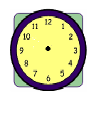

- ***********************************************************************************************************************
( th ) ( ch ) ( sh )
---ildren go---opping ----ursday fa----er fi----
Football | Basketball | Cycling | Running

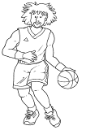 | 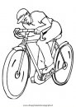 | 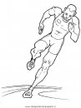 | 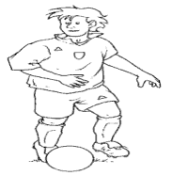

Q3: Change numbers into words and words into numbers. (4 m)
1) 20 …………….………………
2) 22 ……………..……..
3) twenty seven …………………………
4) twenty nine ………………………
It's quarter to seven | It's half past ten
Q4: Put the correct time under each picture using words from the box.
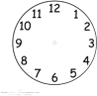 ……………………………………… ………………………………………….
Q5: Complete the following using words from the box: (5 m)
is | who | are | what | I
1)…………………………………._ is this? This is my friend Ibrahim.
2) ………………………are you doing Ghalib? I'm studying.
3) Luay and Yassin …………………..good students.
4) ………………… like to watch T.V.
5) My name ……………………….. Muhammad.
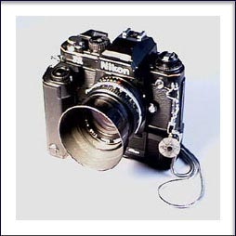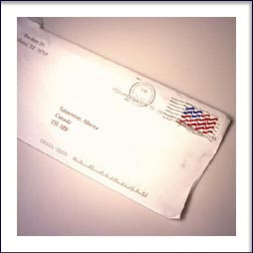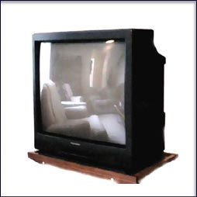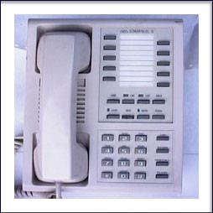
T.V Computer Phone Letter Camera : Com
Unit three
Arabic meaning :-
1- reading
2-setting
-using ………………3
-sending …………………..4
5-writnig ……………
- ***********************************************************************************************************************
writing | sending | Learning | using | reading | setting
- I'm ……………………a book .1
2- I'm ……………………. a letter .
- I'm …………………….the table .3
- I'm ……………………..the computer .4
-I'm ……………………an email .5
6- I'm ………………….. about Jordan .
Write with capital letters :-
1- mum is cooking
………………………………………….……..
2- dad is reading about jordan
…………………………………………………..
3- issa is hellping mum
……………………………………………………
4- alia is writing
……………………………..…………………….
- she write about amman and aqaba5
Dear Laila and Ali ,
We're going to Aqaba ,Dad is driving . We aredriving through the mountains . We are visiting Hammamat Ma'in . There is avery big waterfull .The water is very warm . The sky is blue ,We are swimming and playing in the water in Hammamat Ma'in . Here is a pgoto .
Samira and Kareem
1) The family is travelling to Aqaba by car/ plane.
2) There is / isn’t a waterfall at Hammamat Ma’in.
3) The water is warm / cold.
4 )Kareem and Samira are swimming in the water/reading about the waterfall .
5) Kareem and Samira are looking at / sending a photo
Arabic meaning :-
1- visiting the waterfull …………………….
2- driving through the mountain ………………………
3- going to Aqaba ……………………………
4- swimming in water warm ………………………………
Match :-
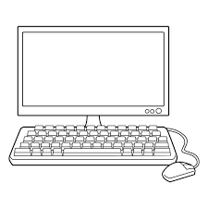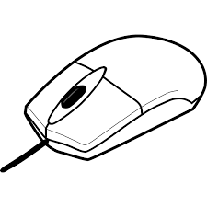
Mouse Computer Monitor Printer keyboard
. / ?
1-This is our diary
-Do you write a diary 2
-We are learning 3
Q3)- Write and use capitals? (6 points)
1-issa is helping mum
2- dad is reading about Jordan
3-alia and muna
bl / fl / cl
……ying 2… imb 3 ….. ue
always | use | swimming | warm

1.)The water is …………………… in Hammamat Ma’in.
2.) Kareem is good at …………………………… .
3.)I ……………………. do my homework after school.
? / .
1) This is our diary
2) Do you write a diary
3) We are learning about Aqaba
4) Our school project is about Jordan
5) Do you like sailing
Copy and complete with the punctuation: (capitals, .or ?) (4 points):
1. i always do my homework

Unit five
Dear Grandma and Grandpa ,
We're in aqaba ! We 're staying in a hotel by the sea . We'r at theMarine Park on the beach . We aren't swimming . We're looking at fish and a turtule . The turtle isn't swimming . It's sleeping ! Mum is buying somebook.
Samira and Kareem
1) Where are Samira and Kareem? ………………………………………………….
2) Where are they stay ?............................
3) Are they swimming now ? …………………………………………………………….
4) What are Samira and Kareem looking at ? …………………………………………….
5) Is the turtle swimming ? ………………………………………………………………..
6) Is Mum looking at the fish ? …………………………………………………………….
Order and write :-
1-are / a/ boat / waiting / We / for
…………………………………………………………………..
2-fast / boat / The / sailing / isn't.
……………………………………………………………………
3-is/the/dolphins / making / a / video / Kareem / of
……………………………………………………………………………………
1) Are they waiting for bus? (a) No, she isnt.
2) Is he taking some photos? (b) No, it isn't .
3) Is the shark playing with the fish ? (c) No, they arn't .
4) Is she phoning her mother ? (d) No,he isn't
5) Are you healthy ? (e) Yes, I'm
- 1) Is Samira's mother visiting the museum?
No , …………………………………….
2) Is Kareem's father playing tennis ?
No, ………………………………………
3) Is Kareem swimming ?
Yes , ………………………………….
4) Is Samira writing postcards ?
No , ………………………………….
5) Is Grandma reading a postcard ?
Yes , …………………………………
Arabic meaning :-
1) Marine park……………
2) waiting…………………….
3) a boat………………………
4) bottom……………………..
5) glass…………………………
6) shark………………………..
7) dolphin……………………
Opened | listened | watched | played
- 1) Khalid ----------------the door yesterday.
2 2) Faris ---------------TV last night.
3- 3) Mansour--------------tennis.
4- 4) Khaldoun ------------------to music.

Q3- Punctuate the following sentences.
ali likes going to amman (………………………………………………..) 1)
2) what are you doing (………………………………………………………………)
Q4: Match the following questions with answers.
1-What is your name? a- I am 10 years old
2-How old are you? B-I am fine thank you
3-What are you good at? C- My name is Hamad
4- How are you? D- I am good at English.
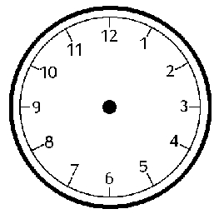
It's ten o'clock It's quarter to eight It's half past three It's quarter past one
Q4)- Circle the right answer : ( 5 points)
1)-A tree is ……… a flower.
a-taller than b- short c-tall
2)- A wolf is………….a dog.
a-playing b- more dangerous c-dangerous
3)- We ………………. Do our homework.
a-swim b-always c-never
4)-The dolphins are …………………
a-jumping b-jump c-playing
5)- Dad …………. Travelling by car. a-is b-are c-am
B)-Read and write . (3points)
a.) What is your favorite sport ?
…………………………………………………………………..
b. )What are you going to do at the weekend?
……………………………………………………………………
Q5) – Order and write sentences. (6 points)
1-) favourite / day / My / Friday / is
. ……………………………………………………………………….
2-) fast / boat / The / sailing / isn't.
…………………………………………………………………………..
3-)drink / I / always / milk.
…………………………………………………..……………………..
Q6)- Read and Write : (4 points)
is are am
1-I --------- making a video .
2-They --------- playing football.
3-She -------- writing an email.
4 –Ibrahim ----------- watching television.
Unit 6
To: Ali and Laila
We're going to go to Deir Alla ! Deir Alla is west of Amman .At my uncle's farm, we're going to see the animals! Then, we're going to have a picnic at the Yarmouk River. After this, we're going to visit the old Roman Theatre at Umm Qais . Kareem and Samira
- Who wrote this letter?......................
- To whom?.................
- Where is Deir Alla ? : It’s (north / west) of Amman.
- They going to visit the old Roman Theatre. ( right / wrong)
5)The underlined word- picnic - means……………………
East | West | South | North

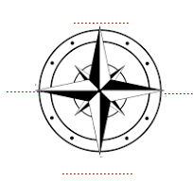
draw | farm | Plant | Pick | Sun hat

1) We'r going to visit ……………..in Deir Alla .
2)We'r going to ……….aubergines .
3) We'r going to ……………… fruit,
4) I'm going to ……………………pictures.
5)I'm going to take my …………………………
br cr dr
……ayon …..aw ….. ush
Arabic meaning :_
1) farm………………………
2) plant aubergines……………….
3) chicken………………………
4 ) tomatoes…………………….
5) pick fruit……………………
6)sun hat ……………………….

chickens | sun hat | farm | tomatoes

1)We're going to visit a ……………………
2)We're going to see the …………………
3)I'm going to plant …………………..
4I'm going to take my ……………………..
Arabic meaning :-
1) go to the sport center ……………….
2 )go to the library……………………….
3)pray at themosque…………………..
4)use the computer …………………..
Write and use capital :-
1) dear ali and laila
……………………………………………………………
2)dier alla is westamman
…………………………………………………………….
3) we'r going to roman theatre at um qais
…………………………………………………………….
4)kareem and samira
……………………………………………………………
*********************************************************************
A: What are you going to do on Saturday ?
B : ………………………………………………………………….
We're going to go to Deir Alla ! Deir Alla is west of Amman .At my uncle's farm, we're going to see the animals! Then, we're going to have a picnic at the Yarmouk River. After this, we're going to visit the old Roman Theatre at Umm Qais .
Kareem and Samira
1)Who wrote this letter?................
2)To whom?...................
3)Where is Deir Alla ? : It’s (north / west) of Amman.
4)They going to visit the old Roman Theatre. ( right / wrong)
5)The underlined word- picnic - means……………………

Q2)- Fill in the blanks with the correct word : (5 points)
Islamic Education - driving- football - vegetables - email

1-I am going to play ………………..…..
2-Fatima is writing an …………………….
3-We are ……………………. through mountains.
4-My favorite subject is …………………….. .
5-They are going to plant………………………

Unit 7
Arabic meaning :-
travelling ………………..walking up……………………step…………………………….
top…………………………Castle ……………………………..
**************************************************************************************************************************
1) We usually go to the market a)a photo of us!
2) Uncle Hassan is taking b) to Ajloun .
3 ) He is standing c) the steps .
4 ) Today we're travilling d) at the top of the castle
5) Uncle Hassan is walking up e) to the library
6) We usually go f) on Saturday .
**********************************************************************************************************************
1) I usually ………………. Lots of photo .( take / taking )
Now + ing
2) I'm …………………….. aphoto now
Usually +
فعل مجرد
3) I'm ………………………..up the steps now!
4) We usually ………………….to school .
**********************************************************************************************************************
century | bridge | steps | room | gate
1) The castle fromm the twelfth …………………….
2) I'm walking across the ………………………
3) Now I'm going through the ……………………
4) This is my favourit ……………….. in the castle .
5) I'm walking up all the …………………..
6) Now I'm looking down from the …………………………….
1)I usually ……………..( deink / drinking ),
Today + ing
2) Today I'm …………………….( cook / cooking)
3 ) Now I'm ……………………( play / playing ).
*************************************************************************************************************************
1) What do you usually do? ( ) I'm cooking.
2)What are you doing now? ( ) I usually play.
3)What are you going to do ? ( ) I'm going to play sport
4 )Are you playing football ? ( ) Yes I'm .
tr / tw
…..ee / elfth
Unit 8
Arabicc meaning :-
squirrels……………… deer………………… forest………………green………………… trees………… prety prettier autumn…………… wolves……………fox…………….jackal…………………… frightened……………………… dangerous……………………

bigger | dangerous | trees | forest | prettier

1) Squirrels live in ………………………
2) The flowers are ………………………….in spring .
3) The deer isn't ………………… animal .
4) The animals live in the ………………………
5) An elephant is …………………….than a cat .

squirrels | people | flowers | animals | deer

1)Jackals and other big …………………….live in Ajloun forest .
2) A wolf is more dangerous than a …………………
3) small animal called …………………..live in forest .
4) There are more …………………….in the forest in the spring .
5) ………………come to the forest to walk .
***********************************************************************************************************************
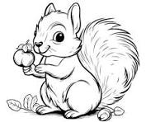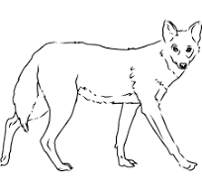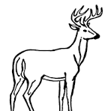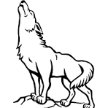
deer wolf squirrel jackal
***********************************************************************************************************************
1) Adeer is …………than a squirrel . ( small )
2) A wolf is ……………………….than a squirrel . ( dangerous )
3)Adeer is ………………….. than z jackal . ( big )
4) Adeer is ………………….than a squirrel . ( fast )
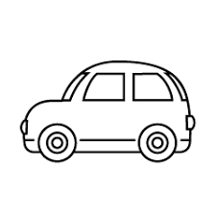 ( big ) 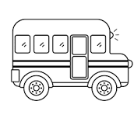
The bus is ……………………………………… the car .

at the top | across | walking up | Picking | planting | looking down | making
1) We'r …………………… fruit.
2) The apples are …………………….. of the tree .
3) I'm …………………………. The ladder.
4) Hassan is walking ……………………….the garden .
5) He's …………………………flowers .
- 6) Muna is …………………avideo .
- 7) I'm …………………………the ladder .
- *********************************************************************************************************************
doctor | pilot | teacher | chef

1)…………………..work in airport to fly plane.
2 ) ………………..work in a hospital to help a child with stomachache .
3) …………………. Work I a restaurant to cook delicious lunch .
4) …………………. Work in a school to teach in class .

