The Ministry of Education
First Exam
Name: ............................................................................................................................. Class: 1 Th Grade
★ Match the word with picture :-

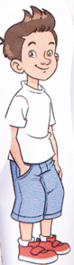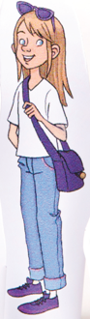

Hala Malek Ann Bill Meg Tom Lama
★ Writ the missing letters :-


…ill …alek ….ala …nn ….om …ama …..eg
★ Match the word with picture :-

Mum dad sister brother

