Q1: Function to find & display sum of rows & sum of cols. of a 2 dim. array A

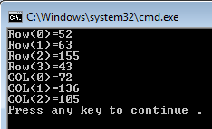

#include <iostream>
using namespace std;

void SumRowCol(int A[][3], int , int );

int main()
{
int A[4][3] ={{12, 29, 11},
{25, 25, 13},
{24, 64, 67},
{11, 18, 14}};
SumRowCol(A,4,3);

return 0;
}

void SumRowCol(int A[][3], int N, int M)
{
for(int R=0;R<N;R++)
{
int SumR=0;
for(int C=0;C<M;C++)
SumR+=A[R][C];
cout<<"Row("<<R<<")="<<SumR<<endl;
}

for(int C=0;C<M;C++)
{
int SumC=0;
for(int R=0;R<N;R++)
SumC+=A[R][C];
cout<<"COL("<<C<<")="<<SumC<<endl;
}

}

Q2) // Selection sort with pass-by-reference. This program puts values into an
// array, sorts them into ascending order and prints the resulting array.

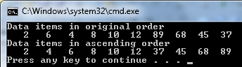

#include <iostream>
using namespace std;

#include <iomanip>
using std::setw;

void selectionSort( int * const, const int ); // prototype
void swap( int * const, int * const ); // prototype

int main()
{
const int arraySize = 10;
int a[ arraySize ] = { 2, 6, 4, 8, 10, 12, 89, 68, 45, 37 };

cout << "Data items in original order\n";

for ( int i = 0; i < arraySize; i++ )
cout << setw( 4 ) << a[ i ];

selectionSort( a, arraySize ); // sort the array

cout << "\nData items in ascending order\n";

for ( int j = 0; j < arraySize; j++ )
cout << setw( 4 ) << a[ j ];

cout << endl;
return 0;
}

// function to sort an array
void selectionSort( int * const array, const int size )
{
int smallest; // index of smallest element

// loop over size - 1 elements
for ( int i = 0; i < size - 1; i++ )
{
smallest = i; // first index of remaining array

// loop to find index of smallest element
for ( int index = i + 1; index < size; index++ )

if ( array[ index ] < array[ smallest ] )
smallest = index;
swap( &array[ i ], &array[ smallest ] );
} // end if
} // end function selectionSort

// swap values at memory locations to which
// element1Ptr and element2Ptr point
void swap( int * const element1Ptr, int * const element2Ptr )
{
int hold = *element1Ptr;
*element1Ptr = *element2Ptr;
*element2Ptr = hold;
}

Q3) Data Members, set Functions and get Functions
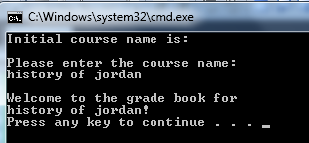
// Define class GradeBook that contains a courseName data member
// and member functions to set and get its value;
// Create and manipulate a GradeBook object.
#include <iostream>
using std::cout;
using std::cin;
using std::endl;

#include <string> // program uses C++ standard string class
using std::string;
using std::getline;

// GradeBook class definition
class GradeBook
{
public:
// function that sets the course name
void setCourseName( string name )
{
courseName = name; // store the course name in the object
} // end function setCourseName

// function that gets the course name
string getCourseName()
{
return courseName; // return the object's courseName
} // end function getCourseName

// function that displays a welcome message
void displayMessage()
{
// this statement calls getCourseName to get the
// name of the course this GradeBook represents
cout << "Welcome to the grade book for\n" << getCourseName() << "!"
<< endl;
} // end function displayMessage
private:
string courseName; // course name for this GradeBook
}; // end class GradeBook

// function main begins program execution
int main()
{
string nameOfCourse; // string of characters to store the course name
GradeBook myGradeBook; // create a GradeBook object named myGradeBook

// display initial value of courseName
cout << "Initial course name is: " << myGradeBook.getCourseName()
<< endl;

// prompt for, input and set course name
cout << "\nPlease enter the course name:" << endl;
getline( cin, nameOfCourse ); // read a course name with blanks
myGradeBook.setCourseName( nameOfCourse ); // set the course name

cout << endl; // outputs a blank line
myGradeBook.displayMessage(); // display message with new course name
return 0; // indicate successful termination
} // end main

