25
Class: 1st Grade Date:
Name:………………………… Time:

Q1: Read and Match( 2 points )
- What’s your name? A. It’s a clock.

- What’s this? B. I’m Samira.

- How are you? C. It’s white.

- What colour is it? D. I’m very well thank you.

Q2: Match objects with their names.( 6 points )

1.door 2. Window 3. Chair 4. Pencil 5. Robot 6. Bag

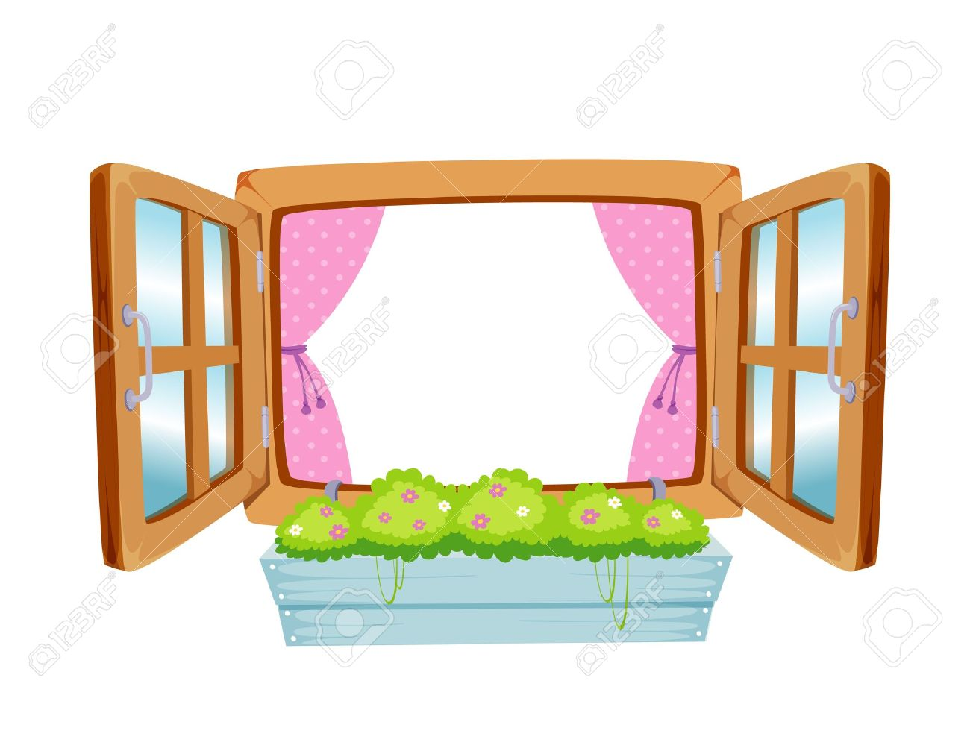
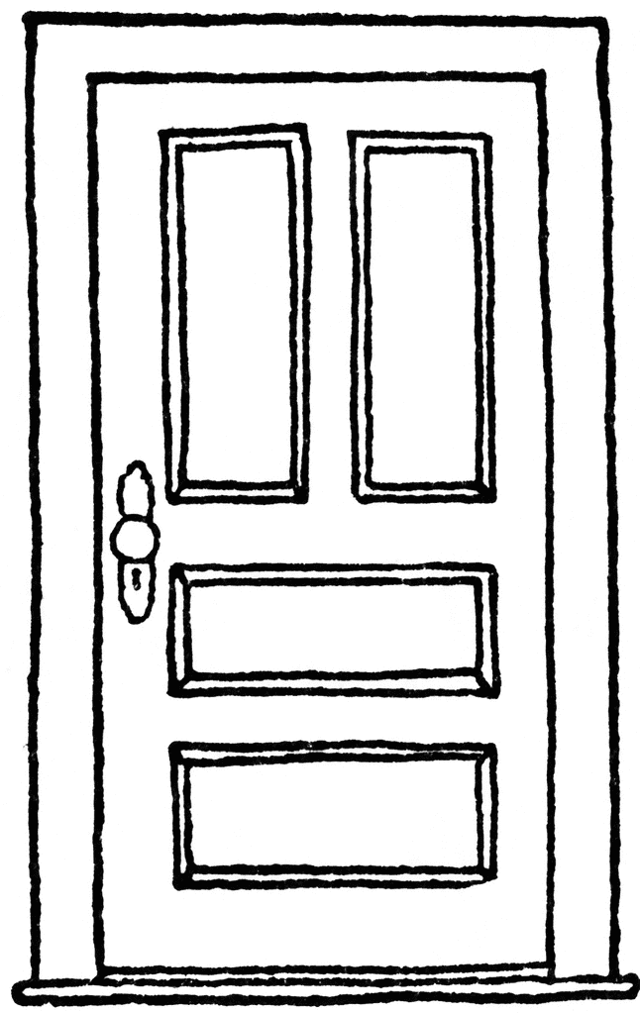


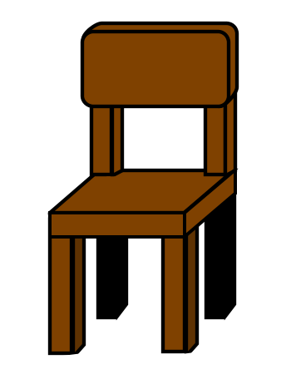


Q3: Look and circle( 3 points )

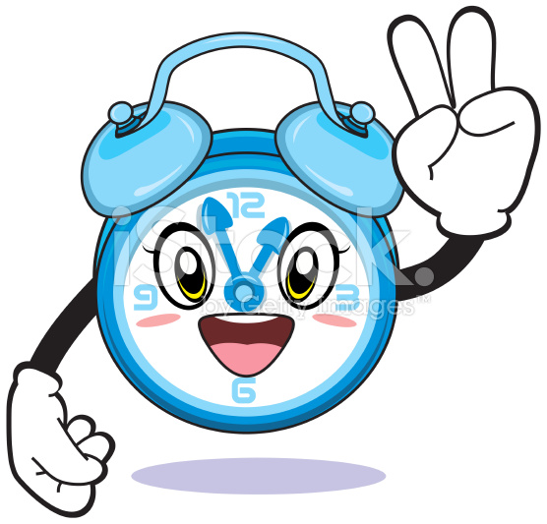

- This is a book a.b.



- Three birds a. b.

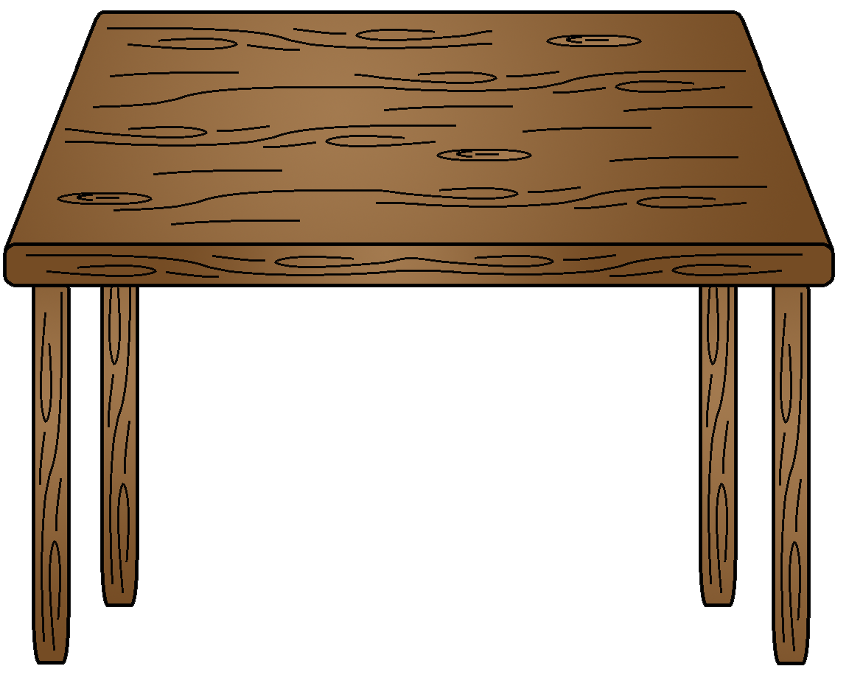
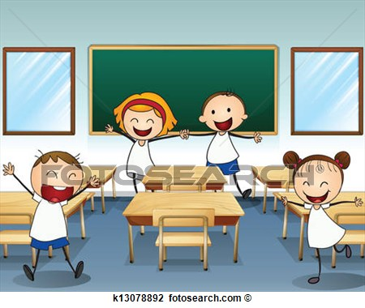
- This is a table a. b.

Q4: Count ( 5 points )
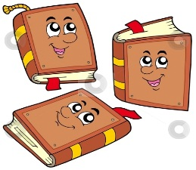
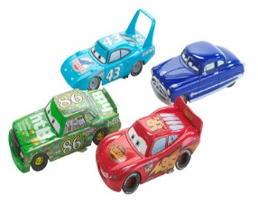
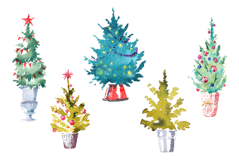

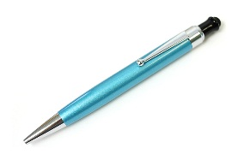

Q5: Listen and color ( 3 points )



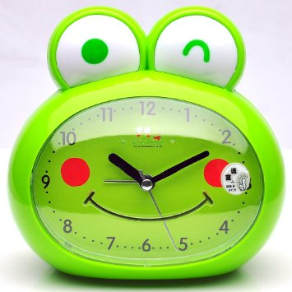

Q6: Write the letters ( 6 points )

A |  | C | D |  |  | G | H |  |  | K
 | b |  |  | e | f |  |  | i | j

Best Wishes
☺T.

