Match
-----------------------------------------------

How many sweets are there? There are eighteen

Can I have nine figs, please There are eleven one sweets

How many children on the bus? Sure, you can
-------------------------------------------------------------------------
Fill in with got to bed go to school get up have breakfast have lunch brush teeth

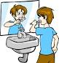

----------------------------------- -----------------------------------

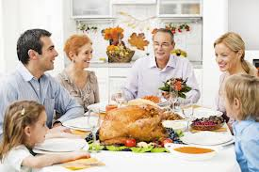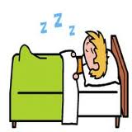

------------------------------------- ---------------------------------
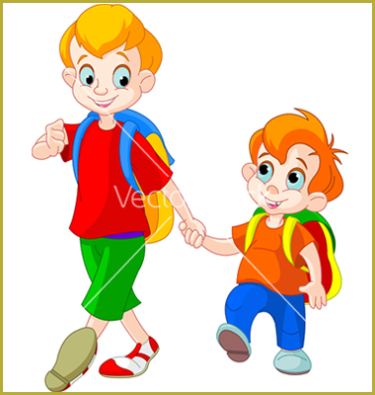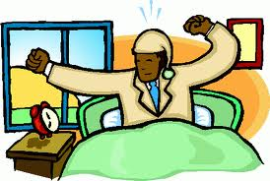

----------------------------------- -----------------------------------
Match

Fig I get up at six o'clock

Sweets It's eleven o'clock

Cake I'm fine thank you

Olive At half past tow

Twenty 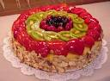

Fourteen 20

How are you Amjad? 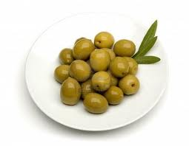

What time is it, please 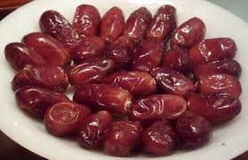

What time is lunch? 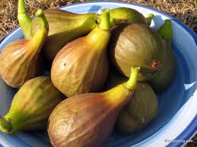

14

What time do you get up? 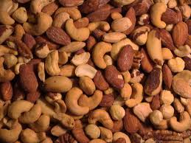

Dates

Nuts 