English language Exam
Second Semester
Second Exam
Name: Date: Class:- 4TH grade

1-Read the following text carefully ,and answer the questions :-(6 points)
My grandparents lived in a desert, they didn’t live in houses they lived in tents. Their goats and camels lived in the desert, they travelled from place to place.
In the past people didn’t have mobile phones or computers. They didn’t go to museums, and they didn’t watch television or listen to the radio .children didn’t have bicycles and lots of toys . They watched the stars and they talked.
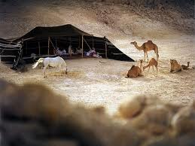 Ali
- Where did Ali’s grandparents live?
-------------------------------------------------------------------------------------------------------------
- What did people do in the past?
-------------------------------------------------------------------------------------------------------------
- Ali’s grand parents have camels. T - F
- Ali’s grand parents have mobile phones. T-F
- The underline pronoun refer to--------.
- Do you prefer living in a city or in a desert
--------------------------------------------------------------------------------------------------.

2-Read and complete:-

Used - visited – learned – lived - sewed
- We visited --------------a zoo.
- We -----------about how people------------in the past.
- The women----------clothes.
- They ------goat’s hair for the tents. (4points)

3-Look and say:-
1-Yesterday ,Mum------------------  her bedroom.
2-Yesterday the boy-- ----------- --- 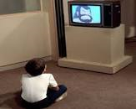 TV.
3-Yesterday the man----------------- 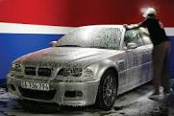 his car.
4- Yesterday the boy -------------------  his teeth.
5- Last week the boy---------------- . (5 points)
THE END
WITH MY BEST WISHES

4-Write a bout you:-
I was ill yesterday. I didn’t enjoy my day in bed !

1-Ididn,t------------------------------------------  .
2-I----------------------------- -------------------------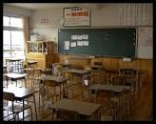
3-I----------------------------------------------------- 
4-I------------------------------------------------------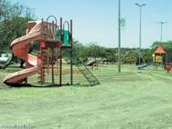
5-I------------------------------------------------------ (5 points)

