Teachers' Manual
Table of Contents
The English Division
Chapter | Title | Page
- | Introduction | 1
1 | Goals and Principles of Education | 2
2 | Directives to Teachers of English. | 5
3 | General Principles for English Teachers. | 15
4 | Reading Comprehension | 24
5 | Useful Ways for Testing | 31
6 | Test Writing | 39
7 | Educational Aids | 46
8 | Vocabulary & Pronunciation | 51

Introduction
A word from the English division. | In the beginning of a new scholastic year and a teaching career, we welcome new and veteran teachers alike to the honorable task of teaching the new generation. Your mission is never impossible. Yet, it is a difficult one. Therefore, we intend to help you start well in to this new line of work. The aim of this kit is to provide the new teachers with handy tips on how to have a good start based on knowledge provided by experienced supervisors who have the chance to visit teachers in their schools and observe how teachers deal with different situations in real life situations.  The manual includes chapters on: -  Goals and principles of education, classroom management, Skills such as listening, speaking, reading and writing, using audio-visual aids. There is also a chapter on testing: oral and written. Lesson planning has a chapter of its own due to its importance. We do not claim that we have included every new piece of information there is in the field of education. The kit works best as a quick reference to all teachers. We wish you all the best.  AbdulRahman H. AlTammami  The English Division.  Riyadh Educational Zone. .  Goals and Principles of Education  Introduction:  It is the purpose of this chapteris to highlight some goals and principles of education with special reference to the educational system in the Kingdom of Saudi Arabia. To begin with, specific definitions must be given for each of the following:  i) Education  Education is generally defined as "the process through which a person is trained for the society in which he lives". In other words" education denotes the formation of the young, both through the introduction of values and the passing on of accumulated knowledge". Also, education is a process of socialization that enables the young to achieve adult standards of technical performance and the capacity to take part in the social life of the family, the group, the community and the country to which they belong". (Caxton Ency. V.7 P. 15 I- 1 52" - London-1983).  Accordingly, this process must necessarily have a clear set of goals to achieve or realize. It must also be based on fundamental principles.  ii) Principles:  "A principle is the idiomatic statement that rules the whole process of education and is normally regarded as the framework of the educational input" (Dr. A.A. Malik - K.S.U.- 2000). However, the main principle of education is that it is a process of helping students to achieve the self-understanding and self-direction necessary to make informed choices and move towards personal and general goals. As a guiding doctrine, a principle usually "focuses on the complete development of individual students through a series of services designed to maximize school learning, stimulate career development and respond to personal and social concerns related to the individuals growth". (Malik -2000)  Principles of education include all the following:  ▪ Assessing learners' needs and learning outcome.  ▪ Planning and preparing for effective learning.  ▪ Interpreting learning unit specifications and requirements.  ▪ Creating, facilitating and maintaining a climate conducive to effective learning.  ▪ Assessing of learning and evaluating learning sessions.  ▪ Evaluating the use, quality and effectiveness of the teaching methods used.  ▪ Identifying and addressing problems confronting the society and problems related to professional practice.  So, principles are required by educationists to develop specific programs with measurable goals and systematic evaluation procedures to demonstrate their effectiveness.  iii) Goals:  "Goals are the expected outcome of the educational process". A goal is an overall target, while an objective is a short-term end. Long term objectives or goals are the economic, social or behavioral targets, which are derived from the educational strategies or policy of a given country. These goals differ universally in many aspects and they are naturally affected by several factors. So, "the goals of education are the result of philosophical reflections on man, on human existence, on culture, beliefs on values, on national and individual economic and social needs, and on the system of relationships connecting man to nature, environment and to the society in which he lives". (Education Today -UNESCO- 1977).  So, sources of educational philosophy in the kingdom emanate from the following:  a) Islamic ideology of education, which is based on Quran and Sunnah.  b) Social tradition and way of life.  c) Comprehensive understanding of life and modern means and attitudes related to the promotion of literacy and providing basic skills to the individual.  However, the concept of educational goals implies, that man is being launched towards a future, which he hopes will be a better one. On the other hand, there are some educational objectives, which fall within the domain of educational policy and are aimed at concrete solutions to the problems confronting societies. Goals usually indicate the fundamental and cultural orientations of a certain country or community. "Goals and objectives of education are emanations of value systems and norms which are also explicit in other cultural contexts such as religion, belief, customs, ideologies and literary works. They correspond to the aspirations, structures and other determining forces of the societies, which have secreted them. Three general indicators characterize them. The nature of the man, the nature of the society and the nature of the knowledge". (Education Today - UNESCO- 1977). However, an analysis of educational systems reveals that they are based not only on explicit goals and objectives but also on implicit principles and orientations. These are often expressed in official texts and are ruled by some political, professional and moral regulations. Practically, it is now a universal trend to make education available and accessible for every member of the society young or old, man or woman, normal or handicapped, with emphasis on passing on the beliefs, aspiration and values relating to the society in questions.  Educational objectives can be categorized into many levels: they include the following:  ▪ Long-term objectives (economic / social goals) or targets. These are derived from the educational policy.  ▪ Intermediate objectives, (learning objectives) - derived from the goals above -include goals for each schools level i.e.:  a) Elementary school objectives.  b) Intermediate school objectives.  c) Secondary school objectives.  ▪ Curriculum objectives for each level based on the learning objectives for that level.  ▪ Objectives for each school subject.  ▪ Teaching or behavioral objectives that are to be realized by the teacher during each 45- minute period.  "These behavioral objectives are to be realized inside the classroom within a limited and specific time frame. The total sum of all periods realizes the educational objectives of the subject matter. Consequently, realization of the objectives of all the school subjects collectively will conduce to the realization of the objectives of the school level concerned and so the process goes on". So, in each lesson plan, the teacher has to state out clearly  * General aims.  * Specific aims.  * Behavioral aims.  On this respect, "the teacher's job is no longer limited to providing the student with information, however, it is extended to the development of personality, inclinations and capabilities to nurture a qualified citizen who is capable to contribute effectively to life in his society, to its prosperity and progress". (Development of Education - in K.S.A. , Min. of Education. 1996 P. 20-2 1).  Principles of Education in Saudi Arabia  Selected from (Development of Education in K.S.A.) Ministry of Education - 1999).  * The purpose of education in Islam is to have students believe in Allah as the Lord, creator and sustainer of the universe, and to help them understand Islam in a correct and comprehensive manner as it was revealed to prophet Mohammed( p.b.u.h.).  * Providing the student with necessary information and various skills which enable him to be an active and productive member in his society.  * Respecting the dignity of the individual and offering him equal opportunities to develop his skills so that he can contribute to the development of his nation economically, socially and culturally.  * Demonstrating complete harmony between religion and science and encouraging the spirit of scientific thinking through observation, research and training.  * Teaching social studies in a way conducive to the understanding of history, Islamic civilization and the environment.  * Arabic language is the lingua Franca in the Kingdom but students have to be furnished with at least one of the living languages of the world.  * Helping the individual to grow physically, emotionally, spiritually and socially in a proper way.  * Giving special education and care to the handicapped.  * Mutual consultation between the ruler and his subjects in a way conducive to the building up and reinforcement of commitment, loyalty and respect.  Some Goals and Objectives of Education in K.S.A.  Selected from (Development of Education in the Kingdom. 1999)  * Implanting Islamic creed and teachings of Islam in the child's mind on the basis of belief in the unity of God and the Prophet hood of Mohammed (pbuh).  * Teaching children principles of good conduct and acceptable way of behaviour. Acquainting students with various basic skills, especially language, counting and other related information.  * Nurturing students along Islamic social life that is marked by fraternity, cooperation, sense of duty, love of work and knowledge and shouldering of responsibility.  * Providing students with sound basic concepts and Islamic education to enable them to preach and spread Islam.  * Preparing all students to work in various walks of life confidently and respectfully.  * Helping gifted and competent students to continue their studies in all fields and academic specializations.  * Increasing the students' awareness of the cultural, economic and social problems of their society and preparing them to participate in solving these problems.  Conclusion:  The ultimate goal of the educational system and policy is "the change in the students' behaviour from the entrance behaviour at the beginning of the schooling programme to the expected output behaviour as the result of studying a specified curriculum with certain objectives which have been deliberately chosen and stated".  Bearing in mind that the Kingdom of Saudi Arabia has its distinct entity as the cradle of Islam and as a prosperous and flourishing country with various economic and natural resources, its educational policy aims at achieving the following goals ultimately:  * Providing citizens with the skills required to serve, manage and develop their own country.  Replacing foreign labour at tall levels by qualified Saudi nationals.  * Creating a class of educated cadres and leaders to fill vacancies left by departing expatriates.  * Creating a more productive labour force and endowing it with increased knowledge and skills.  * Providing the kind of training and education that would promote literacy while encouraging modern attitudes on the part of divers segments of population.  * Providing widespread employment and income earning opportunities. (Education and Development - Joseph Kizerbo- UNICEF - 199 1).  Clearly, in a rapidly developing and ambitious country like Saudi Arabia, education is expected to play a vital and constructive role in the realization of cultural, social and economic growth of the nation in the light of a proper understanding of Islam and the potentials of the Muslims nation in general.  Finally, "It has to be noted that the goals and principles of education in the Kingdom of Saudi Arabia have been workable within the worldwide educational projects and strategies, specially the increased efforts to regulate guidance for the educationists greater demands for professional accountability. "A.A. Malik - Ph.D. Riyadh-2000).  However, this has been a humble attempt to deal with the objectives and goals of education, hopeful that this issue would be given due care nationwide.  By: MosaedAI-Mojahid Supervisor, English Language, Riyadh Educational Directorate, South Supervision Centre, Riyadh, 1421-2001.  References:  Policy of Education in the kingdom of Saudi Arabia - Ministry of Education. Development of Education in the Kingdom of Saudi Arabia. - Ministry of Education, National report Riyadh 1996.  The handbook of the Kingdom of Saudi Arabia - Ministry of Information Riyadh 1997.  Caxton Encyclopedia - volume 7- London 1983.  Education and Development - Joseph Kizerbo - UNICEF 199 1.  Education Today for the World of Tomorrow. By Charles Humel UNESCO. 1977.  Goals and Principles of Education - A paper by Dr. A.A. Malik. K.S.U. Riyadh - 2000- Ph.D.  Directives to Teachers of English in  the Intermediate and Secondary  Schools.  Dear Teachers of English,  It is an ample opportunity to congratulate you on the occasion of the new school year, and thank those prominent, hardworking and distinguished teachers who were very cooperative from all aspects. We, on the other hand, are very much pleased to have new teammates. We greet them and wish them success and best of luck.  The educational supervisors, as usual, visit schools for the sole purpose of developing school staffs as opposed to merely inspecting the teachers' performance. During some of their previous visits, they observed some shortcomings in some teachers' performance as well as competence. We strongly believe that we should never be ashamed of stating the clear deficiencies that we often see and observe during some teachers' presentation. Stating these deficiencies helps teachers to avoid making them repeatedly. So, there come the weak spots in which we, teachers of English, should keep away from: -  *Rushing a lesson in order to finish all that is in the teacher's book.  *Making no notes of some lessons you, the teacher, has not finished.  *Neglecting vocabulary, particularly in the intermediate stage. Teachers should give regular oral and written vocabulary quizzes.  *Not encouraging pupils to learn some new words every day, or stressing the fact that they should spend some time in the library, pursuing short stories, news magazines...etc.  *Not bringing the students into a full awareness about the prospects of their future, and that is why they do not appreciate the time they spend at school, and do not know why they are studying English.  *Giving pupils fewer assignments than expected.  *Not telling the students to assign a separate book for homework and another for class-work.  *Missing one goal that is essential for all pupils. That is to learn to communicate, because language is communication.  *Marking home assignment and workbooks haphazardly.  *Ignoring YM important instructions in the teacher's books  *Keeping the teaching aids, including cassettes, perhaps hidden somewhere in the school and not using them properly.  *No quick revision if there are some spare minutes at the end of a lesson.  *No specific aim of the lesson; whatever comes to mind is said.  *Discouraging pupils speaking up in class by correcting thorn too much, not making notes of their mistakes but interrupting them.  *Not using chorus work to practice rhythm, sometime asking pupils to repeat in chorus a sentence that they do not understand.  *Going round the class asking each pupil in turn, not pointing suddenly and unexpectedly, or calling a pupil's name or asking a volunteer to answer a question.  * Helping gifted pupils only, not the slow ones.  *Not returning to those who had given Incorrect answers and asking them to give the right ones after correction had been made.  *Asking all the questions themselves.  *Talking too much,' not reducing the amount of talking by using mime, drawing on the board or making pair and group work.  *Trying to read the notes in his preparation while teaching, not studying the notes for each lesson in advances.  *Translating each item Into Arabic; very little English is used then.  Having poor command of the target language. Rarely listens to the English Broadcasting Corporation, seldom reads English texts or attends meetings where English is the means of communications  *The class-climate is boring. The teacher never smiles, praises, or jokes.  *The teacher often criticizes pupils' behaviors. Pupils, therefore, show no signs of enthusiasm to participate.  *No warm-up questions when the class formally starts.  *No classroom controls It Is because the teacher anticipates having difficulties with pupils.  *Asking his pupils, " Do you understand? "The teacher should never ask such a question because pupils are too shy to show their ignorance and they remain quiet.  *Ignoring the importance of testing. Testing actually enables teachers to measure their own success and failure in the classroom helping them to know when lesson plans must be modified to meet the pupils' unforeseen problems and urgent needs.  Now, having stated most of what had been reported to our office regarding some imperfections of some teachers' performance and competence; we should look for the most appropriate strategy to overcome such shortcomings and hence improve the teachers' performance.  To put it briefly, read those written weak spots repeatedly till you become quite sure of determining areas of strength and weakness, then, refer to the teacher's book, where you would find a solution for almost every difficulty. The teacher's book, in fact, is the key to the course (ESA). It includes detailed coverage of everything teachers need to attain solid Improvement in their teaching process, subsequently, avoiding the faults mentioned earlier.  Clear sense of directions: -  Aims, preparations, format, content, and making of an oral examination can be seen and read clearly In the fast few pages of the teacher's book (Appendix A - C). It is worth mentioning here too that the Teacher's Book does not state regulations of an oral test. With this regard, we would like you to remember that a pupil, who fails in the first session and enrolls in the second, should have oral and written rests. That is to say. [Examination rules applicable to the second term are to be followed in the second session]. The distribution of marks given to you will clear up the matter.  The ultimate Aim of Our Education:-  Education, as you know, charters and implements the desires of a nation by bringing up its younger generations according to its wanted principles and values. The Educational policy of the Kingdom has a provision that ought to be followed in all stages of Education. It is based on Islam, which the nation embraces as a creed, a system of observances, a code of ethics, legislation, a law and a complete way of life. The teacher's goal as an active member of this nation, therefore, is to bring up a faithful citizen capable of building up his nation and also to develop a feeling of responsibility among students towards their faith. This is the real leading and positive role of you- the teacher. We believe that you are not only capable of perceiving the clear and ultimate aim of our educational message, but also willing to put this great responsibility into practice. In you, our trustworthy teachers, we have confidence.  Riyadh Directorate of Education,  Goals and Principles of Education  Introduction:  It is the purpose of this chapteris to highlight some goals and principles of education with special reference to the educational system in the Kingdom of Saudi Arabia. To begin with, specific definitions must be given for each of the following:  i) Education  Education is generally defined as "the process through which a person is trained for the society in which he lives". In other words" education denotes the formation of the young, both through the introduction of values and the passing on of accumulated knowledge". Also, education is a process of socialization that enables the young to achieve adult standards of technical performance and the capacity to take part in the social life of the family, the group, the community and the country to which they belong". (Caxton Ency. V.7 P. 15 I- 1 52" - London-1983).  Accordingly, this process must necessarily have a clear set of goals to achieve or realize. It must also be based on fundamental principles.  ii) Principles:  "A principle is the idiomatic statement that rules the whole process of education and is normally regarded as the framework of the educational input" (Dr. A.A. Malik - K.S.U.- 2000). However, the main principle of education is that it is a process of helping students to achieve the self-understanding and self-direction necessary to make informed choices and move towards personal and general goals. As a guiding doctrine, a principle usually "focuses on the complete development of individual students through a series of services designed to maximize school learning, stimulate career development and respond to personal and social concerns related to the individuals growth". (Malik -2000)  Principles of education include all the following:  ▪ Assessing learners' needs and learning outcome.  ▪ Planning and preparing for effective learning.  ▪ Interpreting learning unit specifications and requirements.  ▪ Creating, facilitating and maintaining a climate conducive to effective learning.  ▪ Assessing of learning and evaluating learning sessions.  ▪ Evaluating the use, quality and effectiveness of the teaching methods used.  ▪ Identifying and addressing problems confronting the society and problems related to professional practice.  So, principles are required by educationists to develop specific programs with measurable goals and systematic evaluation procedures to demonstrate their effectiveness.  iii) Goals:  "Goals are the expected outcome of the educational process". A goal is an overall target, while an objective is a short-term end. Long term objectives or goals are the economic, social or behavioral targets, which are derived from the educational strategies or policy of a given country. These goals differ universally in many aspects and they are naturally affected by several factors. So, "the goals of education are the result of philosophical reflections on man, on human existence, on culture, beliefs on values, on national and individual economic and social needs, and on the system of relationships connecting man to nature, environment and to the society in which he lives". (Education Today -UNESCO- 1977).  So, sources of educational philosophy in the kingdom emanate from the following:  a) Islamic ideology of education, which is based on Quran and Sunnah.  b) Social tradition and way of life.  c) Comprehensive understanding of life and modern means and attitudes related to the promotion of literacy and providing basic skills to the individual.  However, the concept of educational goals implies, that man is being launched towards a future, which he hopes will be a better one. On the other hand, there are some educational objectives, which fall within the domain of educational policy and are aimed at concrete solutions to the problems confronting societies. Goals usually indicate the fundamental and cultural orientations of a certain country or community. "Goals and objectives of education are emanations of value systems and norms which are also explicit in other cultural contexts such as religion, belief, customs, ideologies and literary works. They correspond to the aspirations, structures and other determining forces of the societies, which have secreted them. Three general indicators characterize them. The nature of the man, the nature of the society and the nature of the knowledge". (Education Today - UNESCO- 1977). However, an analysis of educational systems reveals that they are based not only on explicit goals and objectives but also on implicit principles and orientations. These are often expressed in official texts and are ruled by some political, professional and moral regulations. Practically, it is now a universal trend to make education available and accessible for every member of the society young or old, man or woman, normal or handicapped, with emphasis on passing on the beliefs, aspiration and values relating to the society in questions.  Educational objectives can be categorized into many levels: they include the following:  ▪ Long-term objectives (economic / social goals) or targets. These are derived from the educational policy.  ▪ Intermediate objectives, (learning objectives) - derived from the goals above -include goals for each schools level i.e.:  a) Elementary school objectives.  b) Intermediate school objectives.  c) Secondary school objectives.  ▪ Curriculum objectives for each level based on the learning objectives for that level.  ▪ Objectives for each school subject.  ▪ Teaching or behavioral objectives that are to be realized by the teacher during each 45- minute period.  "These behavioral objectives are to be realized inside the classroom within a limited and specific time frame. The total sum of all periods realizes the educational objectives of the subject matter. Consequently, realization of the objectives of all the school subjects collectively will conduce to the realization of the objectives of the school level concerned and so the process goes on". So, in each lesson plan, the teacher has to state out clearly  * General aims.  * Specific aims.  * Behavioral aims.  On this respect, "the teacher's job is no longer limited to providing the student with information, however, it is extended to the development of personality, inclinations and capabilities to nurture a qualified citizen who is capable to contribute effectively to life in his society, to its prosperity and progress". (Development of Education - in K.S.A. , Min. of Education. 1996 P. 20-2 1).  Principles of Education in Saudi Arabia  Selected from (Development of Education in K.S.A.) Ministry of Education - 1999).  * The purpose of education in Islam is to have students believe in Allah as the Lord, creator and sustainer of the universe, and to help them understand Islam in a correct and comprehensive manner as it was revealed to prophet Mohammed( p.b.u.h.).  * Providing the student with necessary information and various skills which enable him to be an active and productive member in his society.  * Respecting the dignity of the individual and offering him equal opportunities to develop his skills so that he can contribute to the development of his nation economically, socially and culturally.  * Demonstrating complete harmony between religion and science and encouraging the spirit of scientific thinking through observation, research and training.  * Teaching social studies in a way conducive to the understanding of history, Islamic civilization and the environment.  * Arabic language is the lingua Franca in the Kingdom but students have to be furnished with at least one of the living languages of the world.  * Helping the individual to grow physically, emotionally, spiritually and socially in a proper way.  * Giving special education and care to the handicapped.  * Mutual consultation between the ruler and his subjects in a way conducive to the building up and reinforcement of commitment, loyalty and respect.  Some Goals and Objectives of Education in K.S.A.  Selected from (Development of Education in the Kingdom. 1999)  * Implanting Islamic creed and teachings of Islam in the child's mind on the basis of belief in the unity of God and the Prophet hood of Mohammed (pbuh).  * Teaching children principles of good conduct and acceptable way of behaviour. Acquainting students with various basic skills, especially language, counting and other related information.  * Nurturing students along Islamic social life that is marked by fraternity, cooperation, sense of duty, love of work and knowledge and shouldering of responsibility.  * Providing students with sound basic concepts and Islamic education to enable them to preach and spread Islam.  * Preparing all students to work in various walks of life confidently and respectfully.  * Helping gifted and competent students to continue their studies in all fields and academic specializations.  * Increasing the students' awareness of the cultural, economic and social problems of their society and preparing them to participate in solving these problems.  Conclusion:  The ultimate goal of the educational system and policy is "the change in the students' behaviour from the entrance behaviour at the beginning of the schooling programme to the expected output behaviour as the result of studying a specified curriculum with certain objectives which have been deliberately chosen and stated".  Bearing in mind that the Kingdom of Saudi Arabia has its distinct entity as the cradle of Islam and as a prosperous and flourishing country with various economic and natural resources, its educational policy aims at achieving the following goals ultimately:  * Providing citizens with the skills required to serve, manage and develop their own country.  Replacing foreign labour at tall levels by qualified Saudi nationals.  * Creating a class of educated cadres and leaders to fill vacancies left by departing expatriates.  * Creating a more productive labour force and endowing it with increased knowledge and skills.  * Providing the kind of training and education that would promote literacy while encouraging modern attitudes on the part of divers segments of population.  * Providing widespread employment and income earning opportunities. (Education and Development - Joseph Kizerbo- UNICEF - 199 1).  Clearly, in a rapidly developing and ambitious country like Saudi Arabia, education is expected to play a vital and constructive role in the realization of cultural, social and economic growth of the nation in the light of a proper understanding of Islam and the potentials of the Muslims nation in general.  Finally, "It has to be noted that the goals and principles of education in the Kingdom of Saudi Arabia have been workable within the worldwide educational projects and strategies, specially the increased efforts to regulate guidance for the educationists greater demands for professional accountability. "A.A. Malik - Ph.D. Riyadh-2000).  However, this has been a humble attempt to deal with the objectives and goals of education, hopeful that this issue would be given due care nationwide.  By: MosaedAI-Mojahid Supervisor, English Language, Riyadh Educational Directorate, South Supervision Centre, Riyadh, 1421-2001.  References:  Policy of Education in the kingdom of Saudi Arabia - Ministry of Education. Development of Education in the Kingdom of Saudi Arabia. - Ministry of Education, National report Riyadh 1996.  The handbook of the Kingdom of Saudi Arabia - Ministry of Information Riyadh 1997.  Caxton Encyclopedia - volume 7- London 1983.  Education and Development - Joseph Kizerbo - UNICEF 199 1.  Education Today for the World of Tomorrow. By Charles Humel UNESCO. 1977.  Goals and Principles of Education - A paper by Dr. A.A. Malik. K.S.U. Riyadh - 2000- Ph.D.  Reading Comprehension  Suggestions and Activities:-  The following article deals with Points we invite teachers to consider prior to attempting the reading skill.  Before staring your lesson, think about these questions:  1- What is the purpose of the reading passage? Is it to improve your students' reading skill or to reinforce structure?  2- On average, how many new words are included in the passage and  how do you deal with them?  3- When introducing the text, who reads?  a) You. b) The student aloud c) The student silently  4- In the textbooks which you use, do these questions cheek your students'  comprehension of the text?  5- Are the questions in any sort of order? E.g. From easy to difficult to answer.  Do the parts of text, which provide the answer to the questions, follow the same order as the questions themselves?  6- Are the questions you use, GLOBAL OR SEPECIFIC?  Global questions check whether your students have understood the idea which is central to the whole text. Usually students have to read most of a text to be able to answer a global question.  Specific questions, however, focus on some points of detail. Students can answer these questions by reading one sentence, for example.  Now read this, Please!  Questions that follow the reading of a passage are usually intended to check whether the class as a whole has understood the passage or not. In practice, what invariably happens is that the same brighter students answer all the time, while the others stay quite in many cases, it is impossible for the teacher to tell if these others have really understood nothing or they are just too lazy to put up their hands.  Types of comprehension Questions  ▪ Multiple-choice questions.  ▪ True / false statements.  ▪ Open ended questionings.  ▪ Open ended statements.  ▪ Polar questions. (Students answer only with yes or no)  There are many ways of answering that all the class does participate.  Try just one of these activities:-  Activity one:  Make the students answer the questions. Write some questions.  The questions should be carefully graded, going from very easy to more and more difficult to answer. This activity will finish when the first student has answered all the questions.  Notice:  In this way, each student can work at his own speed and within his own limitations.  Observation:  The weaker student will have answered only the earlier, easier questions while  the brighter students may have answered them all.  Activity two: (A game)  Write each question on a piece of card and distribute these cards amongst the students. When a student finishes writing the answers on his piece of card, he then asks the teacher for a different question or to exchange his card with another student. The first student to have answered all the questions is the winner.  Activity three  Use TRUE/FALSE statements. Give the class a statement and have students decide weather it is true or false.  Notice:  By applying this activity, it is easy to involve the entire class by asking them to put up their right hand for true and their left for false. You are able to cheek comprehension at a glance.  Activity four. (A game)  The class is divided into two teams and each team chooses a representative. At the front of the class are two chairs; a true chair and a false chair. The two students stand midway between the two chairs. The teacher or one of the other students from the class makes a true / false statement and the students at the front have to got to the appropriate chair and sit on it. The first student to sit on the appropriate chair wins a point for his team.  Planning a lesson involving a text.  If your lesson involves a text, how will you handle it?  Naturally, when you are handling a long text, the first thing that comes to your mind is to split it up into short, more manageable parts.  Who reads?  1. Students read aloud after you.  2. The students read aloud.  3. The students read silently.  Then you can adapt one of these methods.  1- The text or part of the text is written on the board. In this way the students see a different script and their attention is focused on the teacher and on their books.  2- The text is built up orally with the help of some pictures and word cues.  3- Questions and answers.  4- Jumbled sentences on card, stuck on the board.  5- Students read and put the sentences in the right order.  6- Students read the text in their books, and then put the sentences in the right order.  7- The text can be represented as a gap-filling exercise (just remove every seventh word or so.) The students can either read the text or fill in the missing words, or they can read and fill in the missing words without having previously seen the completed text.  8- Paired text completion:  Students A and B are given copies of the text where different information has been left out. The two copies so prepared that students A and B can fill in their spaces and thus complete their texts by asking their parents questions.  Now look at the following practice activities which can be done on a text and decide what skills they are practicing.  Find and point to a word beginning with ‘a’ and ending with ‘e’ in the first paragraph.  One student makes g the question from word prompts. Another student answers the question. E.g. (What / friends / wearing?)  (Student 1: What were the friends wearing?)  (Student 2: They were wearing…)  3. Jumbled letters:  What is the word 'fneid’?  4. Finish this sentence  You: They had been.  Student: They had been climbing for an hour.  5.Find this word (any word) in the text and write it on the board  6. Jumbled words:  (Yesterday suggested boss to his job he changed his) students arrange the words in the right order without having the text in front of them or depending on the ability to see it before the class does. They can read the text and put the words in the right order.  7. Find all the four letter words in the paragraph….  8. Students retell the text orally using picture or word prompts.  9. Students write a dialogue base do n the text.  10. Structure practice based on the text, e.g. should +have + pp.  You: They didn’t take any water.  Student: They should have taken some water.  11. Revelations:  You have a word written on a piece of card and reveal the word to the students letter by letter. At each stage the students try to guess what the word is. Once the word has been guessed, students tell you what the next letter is going to be.  12. Parallel text:  Students use the original text as a base and substitute various pints of information to produce a different text.  Conclusion  With very little effort on the part of the teacher, checking comprehension of a reading text needs be neither boring nor limited to only a few students, but it can be an interesting activity which all the class can take part in.  Useful Ways of Testing  One of the most important qualities of a good English language exam is variation in the way of testing. Here are some different ways for examining grammar, vocabulary, comprehension and composition. So, not on any account should a teacher stick to just one or two ways of testing. The following is just exemplary of how things are expected to go on, but of course your exam must not go outside the framework of the structures and vocabulary that have been taught to your students.  A-Grammar:  1 - They (is, are, am, be) from Saudi Arabia. Choose (or Underline)  2- Ali (wrok) in an office Correct  3- a/is doctor? he Rearrange to make a question.  4- He wrote a book about Ask using "What"  5- He is play .... football now. Complete  6- They make cars in Japan. Change into passive, etc.  7- Ali likes apples. Change into negative, etc.  8- Fuad reads magazines. Start with the underlined word. Report  9- The teacher: Do you like English? Report  10- If I were a bird, I …. Complete  11-…doing/has/He/ been/for/this/ a year Put in order  12- You didn't go there, …? Add tag question.  B-Vocabulary:  1 -Match A with B:  _____A________________________________B_____________  a- Demand I- can be used  b- un-usable 2- need  3- cannot be used  2-Write the correct words: - [exits, melts, sun]  a-If you heat ice, it...  b-The............. rises in the east.  3-Use one of these words in a sentence of your own [visible, visit]  4- Complete:  a- The opposite of advantage is …  b- Conser ... means protecting the environment.  5 -Odd word out [or underline the odd word] book/ pen/ banana.  6- Re-write the sentence using ‘equal’. Sami and Ali are of the same height.  7- Correct the mistake: Saturday is the second day of the week.  C- DICTATION:-  1- Write the missing letters …  2- Complete: 1 one 2 …  3. Circle the correct spelling. Aple/ apple/ able/ apble.  4. Re-arrange: heavy/ big. Add ‘s’ fly/ wife. Ad ‘ing’ to ‘ride’ / ‘cut’  D- Comprehension  - Some Yes/No & Eh-questions ((direct questions)).  - Find in the passage a word which means (e.g. many).  - Find in the passage the opposite of (e.g. expensive)  - Correct the sentence (or Put T or F) M-r. AI-All is a mechanic.  - The word (e.g. him) in line 5 refers to …  - Choose: AI-Ali goes to work ... a-by car b-on foot c- by boat  E- Composition  - Using guide words (or a table).  - Using pictures.  - Using questions whose answers are to be elaborated.  - Summary in the students' own words.  2-POINTS OF DISCUSSION  Language and self-development.  It is noticed that after only a few years from graduation, a teacher's command of English tends to become weaker and weaker.  What is the reason?  Well, that happens because English for most teachers is dealt within the confines of schoolbooks. So the best way for teachers to improve their English or at least keep up to a satisfactory level is to follow these suggestions.  a- Set aside a few hours weekly for English.  b- Study closely and thoroughly at least one grammar book a year.  c- Read one English magazine and some English newspapers a month.  d- Get yourself involved in a casual or planned discussion in English with your colleagues or supervisor to improve your spoken English and acquire a certain amount of fluency.  e- Do some translation form Arabic into English to activate your passive English words and to acquire some more that you do not know.  f- Write an essay every month and get it checked by some of your colleagues whom you think are good for this.  Teaching Aids [benefits, types, and requirements]  a- Their benefits:  1 - They attract students' attention and stimulate them.  2- They simplify the lesson.  3- They make the lesson vivid and lively.  4- They provide realistic situations.  5- They help students speak providing prompts, cues, etc.  6- They save time.  7- Things learned from them are not easily forgotten.  b- Their types:  They can be either ready-made or self-made (teacher-produced). They comprise posters, flash cards, recordings, slides, transparencies (for the overhead projector) real objects (like an apple, a pen, a model, etc) and TV & video.  c- Their requirements:  1-They should be large enough to be seen by all students.  2- They should be clear enough to be legible (read easily)  3- They should be neat enough to be attractive and stimulating.  4- They should be easy to hang and use.  WEAK STUDENTS  To help weak students improve their performance and overcome certain problems, a teacher has to study their points of weakness and try to solve them through what is called "remedial exercises" inside and outside the class. These exercises should go on and on until you achieve the desired result.  1 -Common points of weakness should be dealt with collectively inside the class.  2-Students who are weak in reading should be given short sentences, then a short paragraph, and then a longer one to be read with the teacher's help inside the school and to be practised at home several times. Later on they will be examined and encouraged by getting higher marks.  3-Students who are weak in vocabulary can be assigned from 10 to 20 words to learn by heart at home and be examined at school by the teacher. Getting higher marks should encourage them.  4-Students who are weak in handwriting can be given a certain paragraph to copy at horne and are advised to take special care of the correct position; shape of each letter and spacing.  Test Writing  Prior to the actual writing of a test, we invite teachers to look at the distribution of marks.  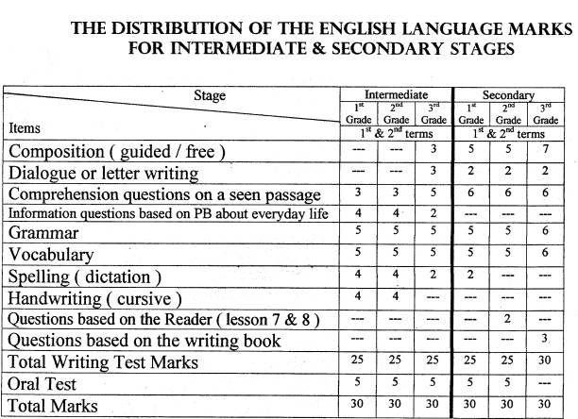  Now that we have agreed upon the types of questions and marks allotted to each question, we can ask questions related to the actual writing of tests. Some of these questions include: -  1- How do I write a composition question?  COMPOSITION :- There are many ways of writing questions in English that can be considered composition questions and here are some:  1) Write a paragraph about " Trains as a means of transportation". It is preferable to limit the choices to only one subject. This topic is an example of the many topics you can give and it could be guided or free. e.g. you may use the following words or ideas then you state a number of words or ideas, which can help the pupils, come up with a decent piece of writing. It is also important to decide how much the students should write by limiting the composition to a number of lines, sentences or paragraphs but it is better to be to the number of words.  2) Write a paragraph about water answering the following questions:  A: Where do we find water?  B What is the importance of water?  C: What do we use water for? etc... . .  The answer to these questions is put together into a paragraph with appropriate transitional expressions and connectors.  3) You can give a paragraph where the sentences are not in the correct order, and then the students should rewrite them in the correct order.  2- What about dialogues?  When attempting to write dialogue questions, follow these steps:-  1) You can start a dialogue then ask the students to complete it.  2) You can give a dialogue with missing parts and you ask the students to complete it.  3) You can give a dialogue with missing parts and you give them choices to choose from and put them in the correct places.  4) You can give a dialogue with miss placed parts and you ask them to rearrange them correctly.  1- Letter writing is important, so how do I test this skill?  We suggest that you try the following: -  1) You can start a letter and ask the students to finish it.  2) You can give them a letter without the essential information like the  date, address etc ... and ask them to write the missing information.  3) You can also write a question saying "Write a letter to your friend Umar. Tell him that you are going to be abroad for three weeks and you cannot keep in touch with him. Your name is Nabeel and your address  is 3986 king Street, Riyadh K.S.A. Then they should organize and write the letter in the best possible way.  4- How do I form ‘INFORMATION QUESTIONS’?  1) You can use direct questions like: Why do people collect stamps? etc... 2) You can use matching to match questions with some answers.  3) Try your questions to test the students' ability to express their skill in understanding certain questions and coming up with suitable answers i.e. not to memorize a number of answers to certain questions.  4) You can also use write capital letters of the following small letters? etc ... this is for first intermediate.  5) Complete a, e......1.......1....... ? etc. .....  5- How can I write good OMPREHENSION questions?  You give the students a passage then you ask them some questions about the passage or paragraph. The passage could be from inside the text or similar to what the students have already taken. Please bear in mind the following notes:  1) Your questions should test the students' ability to extract information from the reading.  2) You should not limit the questions to only one style but variety is required.  3) You can use true or false questions.  4) You can use choose the correct answer.  5) You can use find from the paragraph a word opposite to ........... or meaning the same as etc...  6) You can use reference questions e.g. what does the underlined pronoun refers to?  7) All the answers should be inside the paragraph so no outside information is needed.  8) Short answers should be given a full mark because what is intended here is comprehension not grammar.  6- How do I write good grammar questions?  Here are some suggestions:-  1) Do as shown between brackets.  2) Circle the correct answer Khaled is (tall, taller, the tallest). 3) Write (a/an).  4) Write the past from the following verbs (eat, drink, clean).  5) Correct the verb in brackets. Ali is (read) a book.  6) Underline the verbs, adjectives and adverbs in the following paragraph. And you can put a table  7) Rearrange the following words to make a meaningful sentence.  8) Put (X) to show the time line  9) You can give them an answer and you ask them to give you the question.  10) Do not give many questions to a certain grammatical point. For example you ask them to report and you give them four sentences.  11) Always, when you give multiple choices, give choices no fewer than three, to make the students’ chance of guessing the answer much less.  7- It is important that I test VOCABULARY. Do you have any suggestions?  When testing vocabulary, you need to be aware of the following wording of your questions:-  1) Write the correct word under the picture.  2) Fill in the gaps with suitable words. It is preferable to give choices and they are to be more than the number of the sentences. So if you have five sentences give seven alternatives.  3) Matching.  4) Giving multiple choices.  5) Asking the students to give you the antonyms or synonyms to some words.  6) Put these words in meaningful sentences of your own.  7) Explain these words. The correct answer could be putting them into sentences or giving the antonyms or synonyms.  8) Substitute a word from the sentence with a word that means the same as “…….”  8- Spelling is different from vocabulary, how can my questions show the difference clearly?  You need to be extra careful when setting you questions that test your students’ spelling ability. Therefore, we suggest the following: -  1) You can give a word with a missing letter or letters, and the students come up with the letters. It is better for it t be in a sentence.  2) Choose the correct answer. Equi-ment (d, r, p, s, g)  3) The (damand, demand, dimand, dumand) for cold drinks increases in hot weather.  4) Rearrange the following letters to make a meaningful word. (mceo).  5) 1 had an ace ..... yesterday when 1 was driving my car. (Complete the spelling)  9- As for handwriting, which is very important at the intermediate level, how can I set questions for this skill?  Handwriting is important at all levels of learning English. Pupils, however, sit for a handwriting test at the intermediate level. Therefore, your test should clarify the purpose o the test. We suggest these steps: -  1) Copying a sentence, sentences or a small paragraph.  2) To be more precise, it is advisable to draw the four lines on the exam sheet so that the students could write neatly.  3) Your marks should be given to clarity and readability.  Finally, what have been stated here are just examples or suggestions but that does not mean that teachers could not have samples of questions that have not been mentioned, so always try to be creative when you start preparing for the exam.  Written by: Abdulrahrnan bin Saleb AL-Furaih
  The answer
  The answer.
  The answer
  The answer
  The answer
  The answer
  Verb | Adjective | Adverb | Noun
  The answer
  The answer

Educational Aids
Educational aids can be defined as pictures, objects and other things an instructor uses for the benefit of his students by looking at or listening to.
My aim, in this short paper, is to verify three issues that concern visual aids. Why we should use audio-visual aids is the first question. The second question is how to use them effectively. The final question deals with what materials we can use as educational aids.
Teachers in general need to -use educational aids, as defined above, in order to guarantee the following advantages: -
a. Focus on a number of human senses
b. Help simplify explain difficult concepts.
c. Leave longer lasting impressions.
d. Give realistic impacts.
e. Enhance level of teaching.
f. Break monotony.
g. Help inform students of their levels, skills and knowledge.

These advantages, however, never suggest that teachers use excessively. Teachers will discover that there are the aids they intend to use in their classrooms.
Some of the things that teachers, planning to use instructional aids, find disadvantageous include:-
a) Audible materials Visual aids are not audible.
b) Visual aids are not really visible enough.
c) The use of educational aids hinders the traditional lecturing.
d) Aids are sometimes complex and difficult to operate hence to use in a classroom.
e) Aids are often costly.
Therefore, it is very wise to consider the above disadvantages prior to using any one individual educational aid. Teachers must take all necessary precautions that the educational aids they intend to use give learners the opportunity to feel and examine them aids at a closer range. Teachers, therefore, should make sure that these aids benefit all learners concerning the time allotted to each student in the classroom.
What educational aids can we use in the classrooms?
Some common examples of educational aids include: -
1. Overhead projects
2. Slide projectors.
3. Opaque projectors.
4. Audio video tape recorders.
5. Film projector.
6. Flip charts.
7. Chalk/white board
8. Magnetic boards.
9. Posters.
10. Charts and cards.
11. Reallia.
1 – Overhead Projector:-
Avoid leaving the light on when you have no transparency on the stage.
Remember not to allow head or shoulder to get in the way of projector.
Do not move the projector while it is ‘on’.
2 - Slide projector
Projector must be pre-focused and tested, and lenses must be cleaned before class period.
Projector must be firmly and securely in position, with electric cords protected.
The projected image should fill the screen.
Darken the room when necessary.
3- Opaque projector: -
If material is colour, complete darkness is necessary.
Do not project for lengthy periods due to heat and heat damage.
Do not use flammable objects.
4- Audio video tape recorder: -
It is an effective aid for self-development, demonstrations, case study, and role-playing. Before starting to record the presentation, get to know the recorder. Run tests before your recording and playing back to determine proper settings of controls for volume and tone.
5 - Film projector: -
Pre-focusing and adjusting of equipment is a must.
Be sure projector is firmly positioned and electric wires are protected.
Thread the film prior to lesson.
Make proper introduction before you start.
Choose the theme of your film carefully.
Have a spare bulb ready.
6-Flip chart: -
Turn the pages carefully.
Be sure colour and size of writing or class can see printing.
Stand to the side.
Do not lean against the stand.
You should know the contents of your flip chart presentation so you know what comes next.
Do not leave chart on display after it has been used.
7- Chalkboard / Whiteboard.. –
Plan the material, considering:
The surface size of the board.
The distance between the board and the last row.
Do your chalkboard presentation on a piece of paper prior to class. Print legibly, neatly, and large enough.
Use the eraser not your fingers when correcting your writing.
Clean the whole board.
Do not talk when writing.
8-Magnetic board: -
Be sure objects are not too heavy for magnet.
Plan your presentation, piece by piece.
Have the board tilted at a slight angle.
Do not talk to the board.
9-Posters:-

10- Charts and cards:-

11- Realeia: -
Teachers can also bring real objects to class such as real food items.
12-The human factor: -
Teachers are invited to use gestures, facial expressions and miming to ensure that the meaning of a certain concept is well illustrated and understood by the students. Instructors in this sense must keep up with the new materials and uses for them. They should read excessively about these materials in professional journals. On top of this, they should develop a sense of learning outcome. An active imagination will reveal unlimited relative ideas. There is always a better way to achieve what one aspires to.

Vocabulary
Dear teachers,
Here are some words that the supervisors see difficult to pronounce. The list will help you anticipate the difficulty for a better lesson planning and performance in the classroom.
This list comes from “The first year intermediate”.
No. Page Word Transcription
1 morning
2 afternoon
3 3 tum
4 exercise
5 5 4 eraser
6 6 4 gate
7 7 5 quarter

To view the lists, click on each thumpnail. It will become large enough for viewing.

Group1
Vocabulary

Dear teacher,
Here are some words that teachers in various schools have found important to teach in different levels. They will help you anticipate the words that your students may find difficult to understand or pronounce.

The first list of words comes from the first year intermediate-

Group 2
Word | Unit | Lesson | Page | Note
favorite | 1 | 3 | 2
age | 1 | 3 | 2
twelfth | 2 | 1 | 2
religion | 2 | 2 | 4
February | 2 | 2 | 5
expensive | 3 | 4 | 7
probably | 3 | 3 | 10
juice | 4 | 2 | 13
fever | 4 | 3 | 14
tower | 5 | 1 | 17
heavier | 5 | 1 | 17
weigh | 5 | 2 | 18
shopping | 6 | 3 | 19
abroad | 6 | 1 | 22
sight-seeing | 6 | 1 | 22
apartment | 6 | 1 | 22
dentist | 6 | 2 | 23
touring | 6 | 3 | 24
geography | 6 | revision | 24
showed | 6 | 2 | 30
orbited | 7 | 2 | 30
borrowed | 7 | 4 | 31
measured | 8 | 2 | 30
bought | 9 | 2 | 30
brought | 7 | 4 | 30
nurse | 10 | 1 | 45
difference | 10 | 4 | 47
headmaster | 11 | 1 | 49
headache | 11 | 1 | 49
temperature | 11 | 2 | 49
continuous | 11 | 2 | 50
thumb | 11 | 4 | 52
together | 12 | 3 | 56
repaired | 13 | 4 | 63
modern | 14 | 1 | 64
noisier | 14 | 2 | 65
quieter | 14 | 2 | 65
comfortable | 14 | 3 | 66
powerful | 16 | 1 | 73
engine | 16 | 1 | 73
countries | 16 | 4 | 76
cyclist | 17 | 1 | 78
blow | 17 | 2 | 79
ambulance | 18 | 1 | 84
laughing | 18 | 3 | 86
sight | 19 | 3 | 86
businessman | 20 | 1 | 97
scientist | 20 | 1 | 97
mechanic | 20 | 2 | 98
sandwiches | 21 | 1 | 101
journey | 21 | 3 | 103
regularly | 22 | 1 | 106
shouted | 22 | 3 | 107
wolf | 22 | 3 | 107
attacking | 22 | 3 | 108
believe | 22 | 3 | 108
immediately | 22 | 4 | 108
enough | 23 | 1 | 111
windy | 23 | 1 | 111
stomach-ache | 23 | 3 | 112
crash | 23 | 2 | 112
solution | 23 | 3 | 114
thirsty | 23 | 4 | 115
falcon | 23 | 4 | 115
leave | 24 | 1 | 117
could | 24 | 1 | 117
because | 24 | 2 | 118
invited | 24 | 4 | 121

A list of words for the second year secondary

Unit one
Word | Lesson | Page | Pronunciation (transcription)
accident | 1 | 1
dangerous | 2 | 2
accidentally | 2 | 2
experiment | 3 | 5
operator | 3 | 5
interesting | 5 | 9
detector | 7&8 | 13
approximately | 7&8 | 17
Unit two
electrocution | 1 | 18
precaution | 3 | 20
prevent | 5 | 24
Unit three
spread | 2 | 36
permanently | 3 | 37
Peninsula | 7&8 | 45
Unit four
balanced | 1 | 54
carbohydrate | 1 | 55
tomato | 2 | 56
convenient | 3 | 58
deficiency | 7&8 | 65
nutritional | 7&8 | 69
Unit five
facilities | 1 | 71
circular | 3 | 75
recently | 3 | 75
statistics | 7&8 | 81
autumn | 7&8 | 85
Unit six
pollution | 1 | 89
ozone | 2 | 91
stratosphere | 2 | 91
occur | 3 | 93

A list of words for the second year secondary (Term 2)
Unit one
word | Lesson | Page | Pronunciation (Transcription)
extract | 1 | 1
vibrations | 2 | 3
clothes | 2 | 3
symbol | 2 | 3
exhibit | 7&8 | 11
tradition | 7&8 | 15
Unit two
express | 3 | 25
via | 3 | 25
stable | 7&8 | 33
pigeon | 7&8 | 35
stopped | 7&8 | 37
Unit three
athletes | 2 | 43
responsible | 3 | 44
Unit Four
Xian | 1 | 61
prostrate | 2 | 62
supposed | 3 | 65
ambassador | 7&8 | 73
Unit Five
interview | 1 | 77
entrance | 2 | 78
specialized | 2 | 78
lamb | 3 | 80
fascinating | 7&8 | 89
engraver | 7&8 | 89
bazaars | 7&8 | 91
Unit six
scarce | 2 | 95
civilization | 2 | 95
generally | 3 | 99
habits | 7&8 | 107
See transcription
Group 3
A list of words for the third year secondary

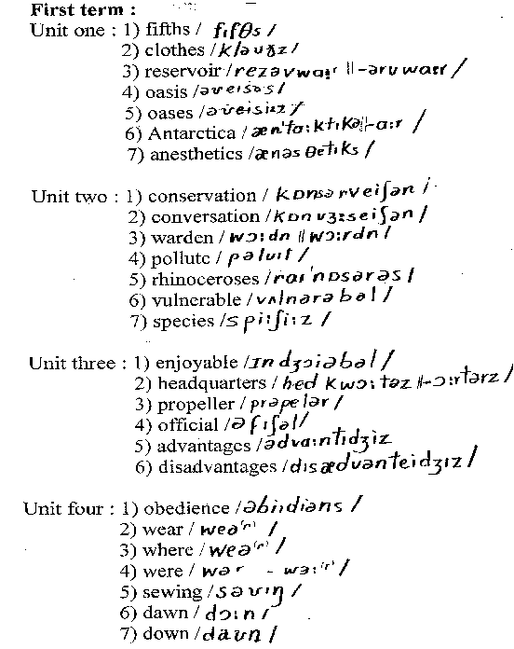

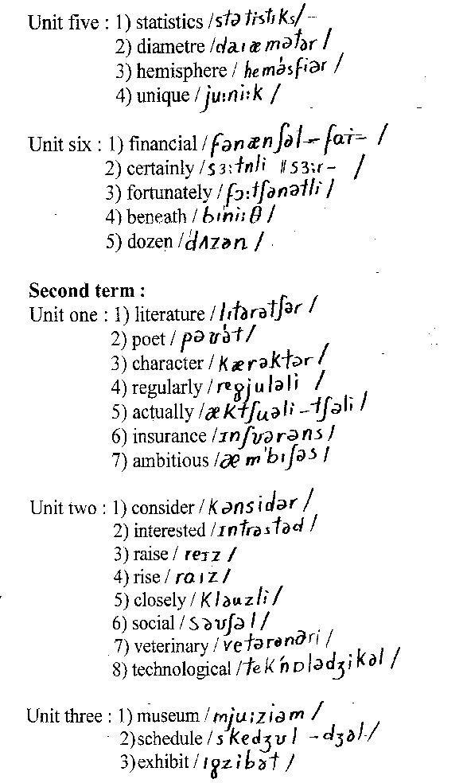

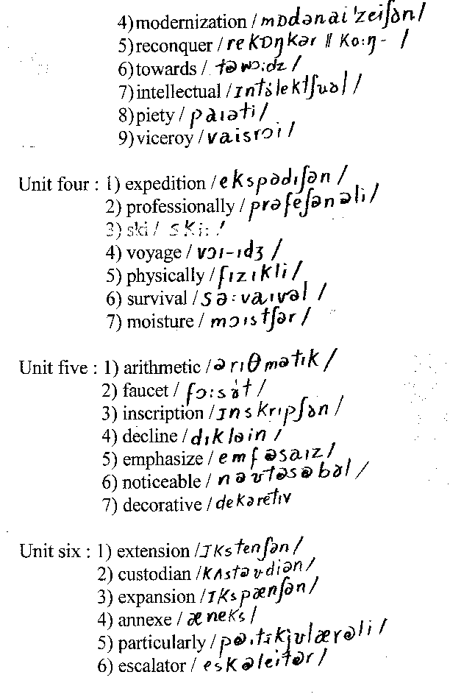

Group 4

