Baqa’a Prep.G/s3
Name:……………………………….. English Exam Grade 4th ( )

Q.1/ Read the text, then answer the questions below:-
Dear Ali
My favourite museum is the children’s museum. It is in Al-Hussein National Park in Amman. It is the brightest museum. My favourite room is the planetarium. It is great place to learn about the life on Earth.
Kareem
- The email is from…………………. To ……………………..
- What’s kareem’s favourite room?----------------------------------------
- The children’s museum is in --------------------------------------------
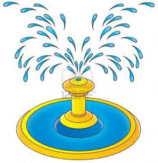
- The underlined pronoun refers to -------------------------------------
5- The planetarium means --------------------------------

Q.2/ Complete the following sentences ( planetarium , fountain , stage )
1- The water in the -------------------------- is great.
2- We can see the stars and planets in the ----------------------------------------

Q.3/ Choose the correct answer:
1- venus is the ( hottest , coldest )planet.
2- Jupitar is the ( coldest , biggest ) planet.
3- The sun is a ( planet , star )
4- The earth takes a ( month , year ) to move around the sun.

Q.4 /Answer the following questions:
- What is your favourite museum?
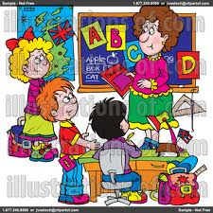
----------------------------------------------------------------------------------
- Where was your sister yesterday?
--------------------------------------------------------------------------------------

Q.5/ Punctuate the following sentences:
1- In the past the shops were here.
---------------------------------------------------------------------------------------------
2- amman is the capital of Jordan
-------------------------------------------------------------------------------------------------------

Q.6Write the places:
( baker pharmacy hospital )
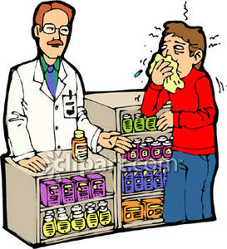

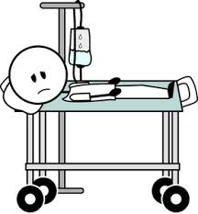

Q.7 Complete the table :
big | biggest
dry

