My name is: ……………………………

1.Colour:- (6 marks)
green

blue
yellow
red
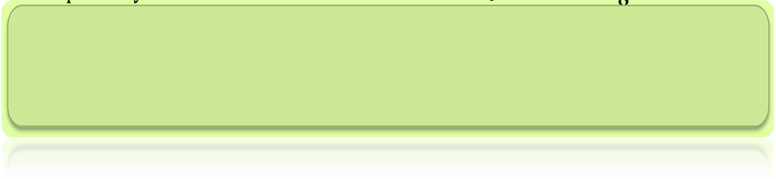
First Exam Class: First Grade
First semester

Match letters(3marks)

A
b

B
c

C
a

10 marks) )match:- look and
ز
a chair
 a window a window

Book a
a girl
a Pencil 
Write:-(6marks)
…………………………………………………………………………………………………………………………………………………………………………………………………………………………………………………………………………………………………………………….................................
……………………………………………………………………………………………………………………………………………………………………………………………………………………………………………………………………………………………………………………………………………………
........................................................................................................................................................................................................................................................................................................................................................

THE END WITH MY BEST WISHES

