12 Rules for Good Cursive Handwriting

1. Good writing is based on a
pattern of ovals and parallel lines. 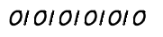
2. All small letters start at the top. 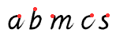
3. All the down strokes are parallel. 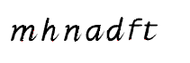
4. All similar letters are the same height. 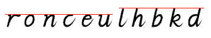
5. All down strokes are equidistant. 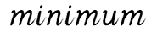
6. The space between words
is the width of the small letter o. 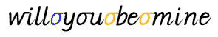
7. Ascenders and Descenders are no more
than twice the height of small letters, preferably less. 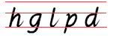
8. Capital letters are no higher
than the ascenders, preferably less. 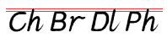
9. Lines of writing are far enough apart
for ascenders and Descenders not to touch. 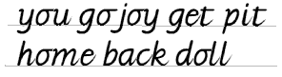

10. Letters which finish at the top join horizontally. 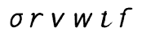
11. Letters which finish at the bottom join diagonally. 
12. Letters which finish on
a stroke moving left, are best left un- joined. 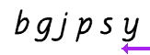

Dr_subahi@yahoo.com

