School: Al-Nuzha Prep. B/S (No.1(:(

1st English Exam / Second Semester
(2013 –2014)

Grade 8

Name :………………………………………………………………………… A B C D E

Department of Education

Area: North Amman
Exam’s Time:
40 minutes

A
Reading/Speaking /
Writing

40

I. Reading Comprehension
ِ A) Read the following passage, then answer the questions below:
There are tens of millions of pieces of rubbish. Scientists call this orbital debris.
You will find the most unusual things floating around the Earth. Well, it’s also a problem in the sky. On a clear night, look up in the sky. What will you see? You will see the moon, the stars and the satellites. Although you won’t see, you will also be looking at the largest scrap yard in the solar system. Most of this rubbish comes from satellites and rockets that stopped working and fell apart.
So let’s start thinking of ways to tidy space up!

1) Are the following sentences True (T) or False (F)? (2 points)

( ) Orbital debris caused by the pieces of rubbish in the solar system.
( ) Most of this rubbish comes by nature.

2) What’s the meaning of “to tidy up”? (1 point)

a) to clean up b) to end up c) to play

3) where does the rubbish that floats in space come from ? ( 2 points )

……………………………………………………………………………………………………………

4) Find a word in the text that means: (1 point)

broke off: …………………………..
__________________________________________________________________________

B- Venus is the second planet from the Sun. it revolves backwards. A day on Venus lasts 243 Earth days. Venus is the hottest planet in the Solar System (around 470 C.) Its atmosphere consists of carbon dioxide. Venus has no moons, but it has mountains and volcanoes.

C- True ( T ) or False ( F ) . ( 3 points )
1- Venus is a planet in the Solar System. ( )
2- A day on Earth lasts 243 Venus days. ( )
3- Venus revolves backwards. ( )

D- Complete the following sentences using the words from the list given
(5 points)
{ compass, astronomer, zero gravity, to float, scrap}

1. My car is like ………………….. it’s old and useless.
2. He used a ……………….. to know which way north was.
3. The ………………….. spent hours studying the stars at night.
4. It’s easy to ……………….. on the Dead sea.
5. You can float in the space because of …………………..
___________________________________________________________________________

II. Speaking:

A) Complete the following dialogue. Use these words. (5 points)
will \ travel \ be \ beautiful \ system

Sami: What …………. life ……... in the future?
Ali: Oh, I think we will ………..…. to our solar system.
Sami: What will solar ………… be?
Ali: It will be very ……………….
___________________________________________________________________________

III. Writing

A. Change the following sentences into negative and into interrogative: (4 points)

1. Living in Mars will be easy.

X……………………………………….……..…….. ……………………………………………..?

2. Our math exam will be a piece of cake.

X………………………………………………….. …………………………………………….?

B. Choose the correct answer: (3 points )
1- Schools …………… different in 2100. ( are, will , will be )
2- Mary won’t……….. Medicine in the future. ( studied, study, will study )
3- In 2050, People will ………….. to space easily. ( traveling, traveled, travel )

C- Re-write these sentences using first, then and finally. Use the future simple. (6 points)

What will the stages for traveling to Jupiter be? …………………………………. (we/send) a robot to explore the landing site. …………………………………..….. (it/return) to Earth with a sample of Martian rock and soil scientists will study this carefully. …………………………………….. (people/ travel ) to Jupiter, but not earlier than 2035.

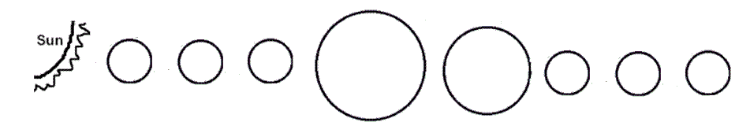
D- Identify the names of planets sequentially: (8 points)

M V E M J S U N

