Unrwa/ Department of Education
Name: ……………………………….. English Exam Fourth grade ( A / B )
Date: …………………………………. Nazzal. Prep. G/SCH2
(4 pts.) Q1. Read carefully, and then answer:
Quraysh Street in Amman wasn't a street in the past. It was a river. You can see a stone fountain in the street. The fountain is old. In the past, the fountain was bigger. There were mosaics and a pool. The pool wasn't for swimming. The water in the pool was from the river. The houses weren't here in the past. Now you can see the fountain between the houses.
1. Where is Quraysh Street? …………………………………………………………………………………………………………………………..
2. What Was Quraysh Street in the past? ………………………………………………………………………………………………
3. Was the pool for swimming? ………………………………………………………………………………………………………………
4. The underlined pronoun It refers to: …………………………………………….
Q2. Complete the sentences by reordering the letters: (2 pts.)
1. We can learn about the stars and the planets in the …………………….………………………..(ptlenaiuram)
2. …………….……………..…….. is the biggest planet. (Jepiutr)
3. I can swim in the swimming ………………………………………(olpo)
4. We live on the planet …………….…………………………. (aEtrh)
5. The sun is a ………………………………… (tars)
Q3. Copy and complete the punctuation: ( . , capitalization): (2 pts.)
in the past the restaurant wasn't here it was a school.
……………………………………………………………………………………………………………………………………………………………………………...

Q4. Re-order these broken sentences: (2 pts.)
1. the biggest / The Earth / isn't / planet
…………………………………………………………………………………………………………................................. ……
2. called / Our city / Amman / wasn't
……………………………………………………………………………………………………………………………………….

Q5. Complete with ( was /were ): (2 pts.)
1. On Monday, I …………………….…………..at the market.
2. In the past, the houses …………………….………smaller.
3. The castle ……………….………………..bigger.
4. There ……………..…………….animals.
Q6. Match the opposites: (2pts.)
1. The darkest ( ) a) The driest
2. The biggest ( ) b) The fastest
3. The wettest ( ) c) The smallest
4. The slowest ( ) d) The brightest
Q7. Choose the correct answer: (6pts.)
1. Venus is …………………………………..planet.
a) the hotest b) the hottest
2. January is …………………………………………….August.
a) colder than b) the coldest
3. …………………………………is the slowest animal? The turtle.
a) Who b) Which
4. Wadi Rum is …………………………………….city in Jordan.
a) the driest b) drier
5. …………………………………is the tallest person in your family? My father.
a) Who b) Which
6. Jerash is ……………………………………………..Amman.
a) smaller than b) the smallest
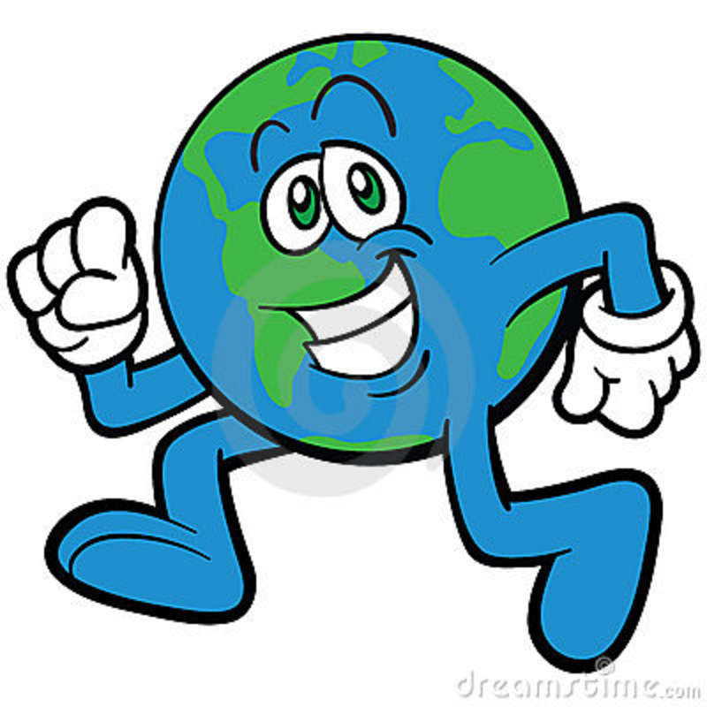 Good Luck
Teacher: Mariam Omar

