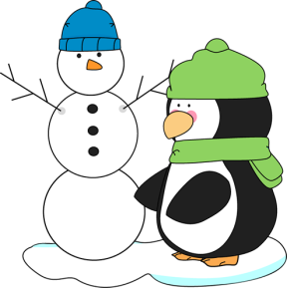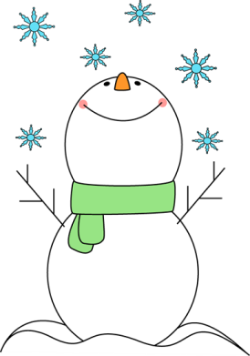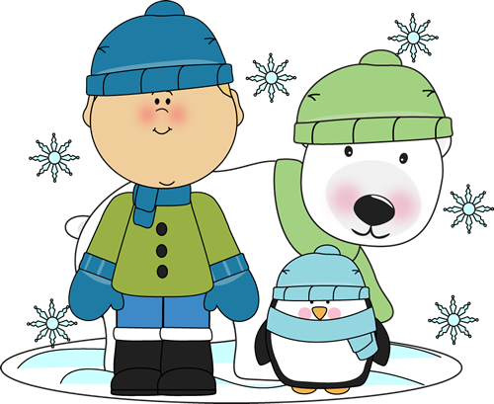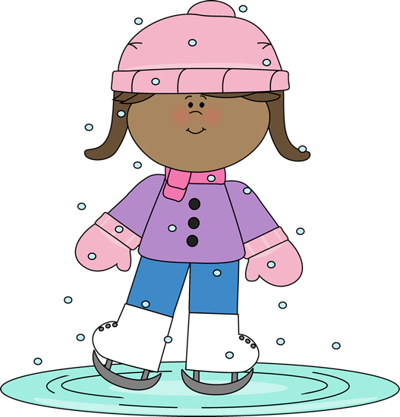







C:\Users\user\Dropbox\Dropbox\MyCuteGraphics\NUMBERS\cartoon-number-one.pngC:\Users\user\Dropbox\Dropbox\MyCuteGraphics\NUMBERS\cartoon-number-three.png



|  |  |  |
| --- | --- | --- |
|  |  |  |
| awesome | **more awesome than** | **the most awesome** |
| bad | **worse than** | **the worst** |
| big | **bigger than** | **the biggest** |
| cool | **cooler than** | **the coolest** |
| crazy | **crazier** | **the craziest** |
| disgusting | **more disgusting than** | **the most disgusting** |
| dumb | **dumber** | **the dumbest** |
| exciting | **more exciting than** | **the most exciting** |
| far | **farther/further than** | **the farthest/the furthest** |
| fast | **faster than** | **the fastest** |
| fat | **fatter than** | **the fattest** |
| funny | **funnier than** | **the funniest** |
| good | **better than** | **the best** |
| happy | **happier than** | **the happiest** |
| hard | **harder than** | **the hardest** |
| heavy | **heavier than** | **the heaviest** |
| hot | **hotter than** | **the hottest** |
| interesting | **more interesting than** | **the most interesting** |
| little | **less/littler than** | **The least/littlest** |
| noisy | **noisier than** | **the noisiest** |
| old | **older than** | **the oldest** |
| pretty | **prettier than** | **the prettiest** |
| scary | **scarier than** | **the scariest** |
| short | **shorter than** | **the shortest** |
| slow | **slower than** | **the slowest** |
| smart | **smarter than** | **the smartest** |
| thin | **thinner than** | **the thinnest** |
| thrilling | **more thrilling than** | **the most thrilling** |
| weird | **weirder than** | **the weirdest** |
| wet | **wetter than** | **the wettest** |
| pretty | **prettier than** | **the prettiest** |
|  |  |  |



