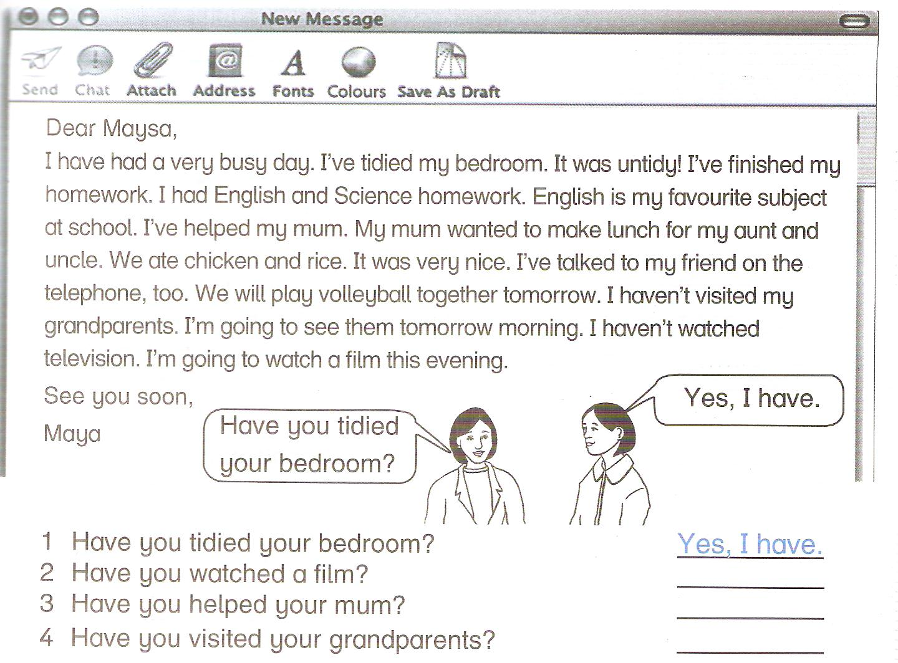
1) Read the text then answer the questions below.

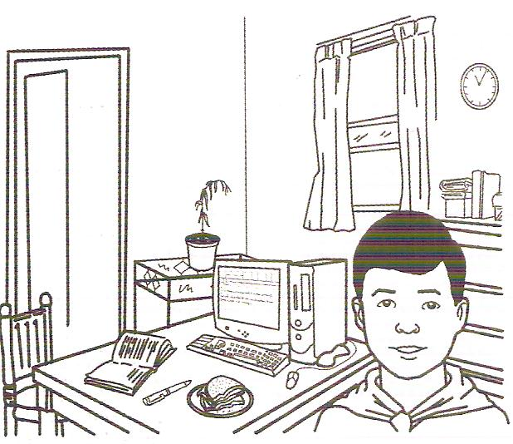
2)Look , read , put tick( ) or cross ( ) .
- I've tidied my bedroom. ________
- I've finished my homework. ________
- I've watered the plants. ________
- I've closed my bedroom window. ________
- I've finished the email to my cousin. ________
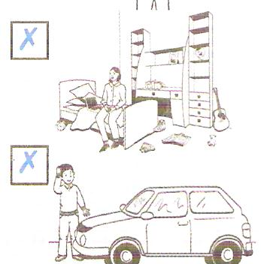
- I've prepared a sandwich. ________
3) Look and write using haven't +p.p. or hasn't + p.p.
- I _____________________________________________.
- He ___________________________________________.

4)Read and match.
1) My hands are dirty. a. I haven't been to the market.
2) There aren't any apples. b. I haven't eaten my lunch yet.
3) The television is on. c. I haven't combed my hair yet.
4) I'm hungry. d. I haven't washed them yet.
5) My hair is untidy. e. The detective film hasn't finished yet.

