بسم الله الرحمن الرحيم
( 2018 - 2019 )
Action Pack 12
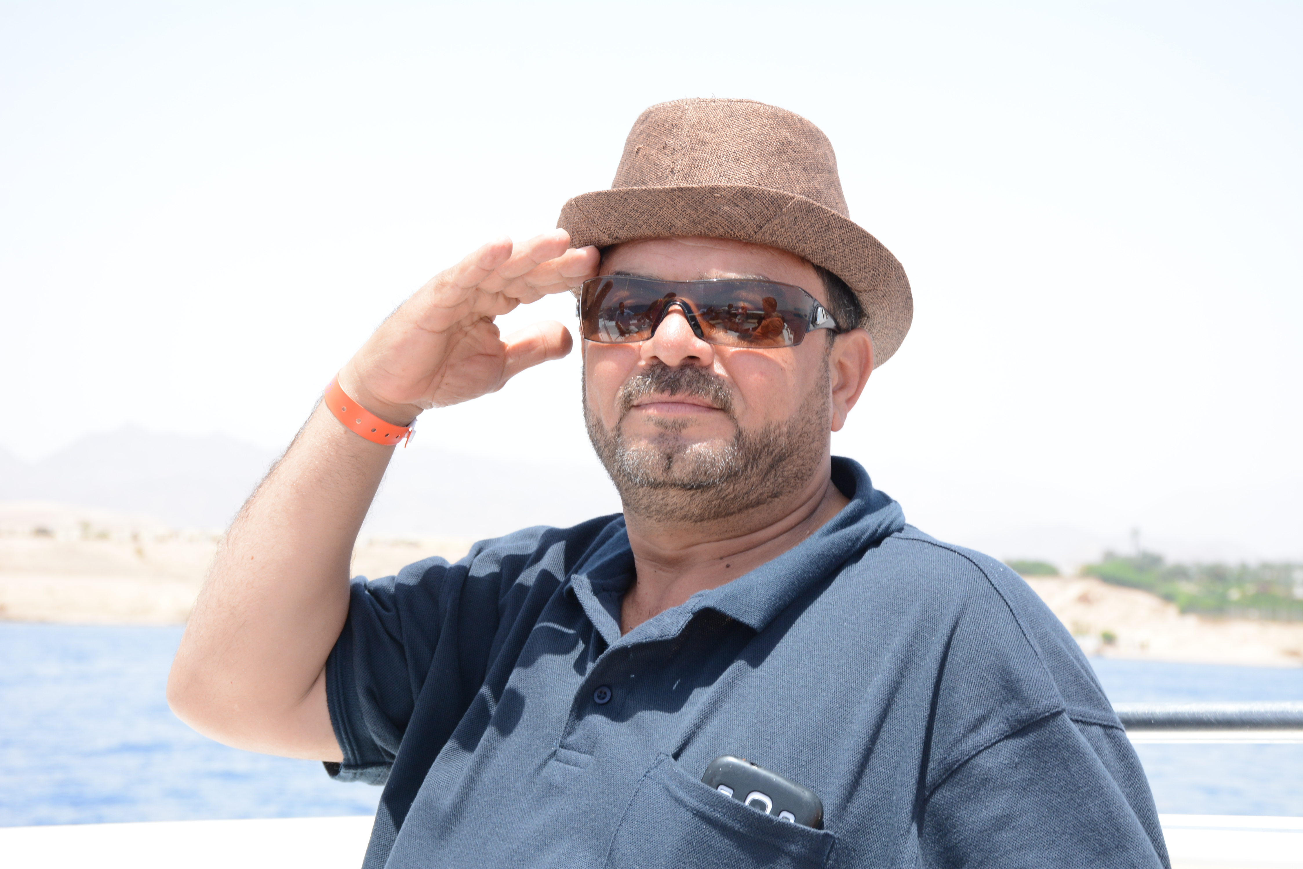
Unit - 4
ملخص اللغة الانجليزية - 2019
الدورة الصيفية
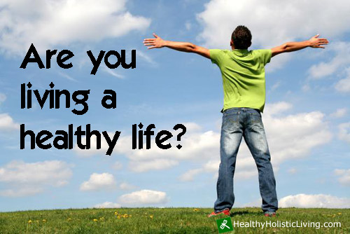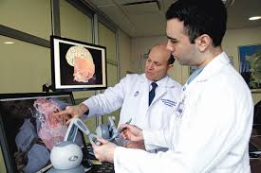
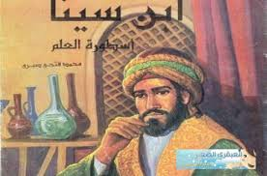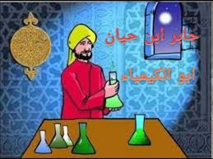

عماد ابو الزمر
مركز ابو الزمر الثقافي

The importance of Islamic achievements in history

Jabir ibn Hayyan (born 722 CE, died 815 CE)

The Arab world has many famous chemists in its history, but the person who is known as the founder of chemistry is probably Jabir ibn Hayyan. He is most well known for the beginning of the production of sulphuric acid. He also built a set of scales which changed the way in which chemists weighed items in a laboratory: his scales could weigh items over 6,000 times smaller than a kilogram.

1. Who is Jabir bin Hayyan ?
He is the founder of Chemistry . ( A famous Arab chemist )

2. Mention two of his achievements :
a. The production of sulphuric acid.
b. He also built a set of scales which changed the way in which chemists weighed items in a laboratory.

3. What are the features of scales in a laboratory ?

His scales could weigh items over 6,000 times smaller than a kilogram.

4. In which field was Jaber Ibn Hayyan famous for ? Chemistry
_______________________________________________________________________________________________________________________________________________________________________________________________________________

Ali ibn Nafi ’ (Ziryab) (born 789 CE, died 857 CE)

Ali ibn Nafi ’ is also known as ‘Ziryab’ (or ‘Blackbird’, because of his beautiful voice). He was a gifted pupil of a famous musician from Baghdad, and it was his talent for music that led him to Cordoba in the ninth century CE. He was the guest of the Umayyad ruler there. He is the person who established the first music school in the world in Cordoba, Al-Andalus, teaching musical harmony and composition. revolutionized musical theory, and is also the person who introduced the oud to Europe.

1. Mention two names for Ali bin Nafi' "
a. ‘Ziryab’
b. ‘Blackbird’

2. Why was he called " Blackbird" ?
Because of his beautiful voice .

3. Mention two of his achievements :
a. He established the first music school in the world in Cordoba, Al-Andalus.
b. He introduced the oud to Europe.

3. What is the purpose of establishing the music school?
Teaching musical harmony and composition.

4. Why did Ali Ibn Nafi' go to Cordoba ? What led him to Cordoba ?
His talent for music

Fatima al-Fihri (born early 9th century, died 880 CE)

Fatima al-Fihri was the daughter of a wealthy businessman. She used her father’s inheritance to build a learning centre in Fez, Morocco. This learning centre became Morocco’s top university, and it is where many students from all over the world come to study. Moreover, it was Fatima’s sister, Mariam, who supervised the building of the Andalus Mosque, which was not far from the learning centre.

1. What was the achievement of Fatima al-Fihri ?
She built a learning centre in Fez, Morocco. (Morocco's university)

2. What was the achievement of Fatima's sister Mariam ?
She supervised the building of the Andalus Mosque.

3. How did Fatma build the learning centre ? inheritance : Things you give others after death
She used her father’s inheritance.
_______________________________________________________________________________________________________________________________________________________________________________________________________________

Al-Kindi (born around 801 CE, died 873 CE)

Al-Kindi was a physician, philosopher, mathematician, chemist, musician and astronomer – a true polymath. He made ground-breaking discoveries in many of these fields, but it is probably his work in arithmetic and geometry that has made him most famous.

ج
1. What was AlKindi good at ?
Al-Kindi was a physician, philosopher, mathematician, chemist, musician and astronomer.

2. What made him most famous ?
His work in arithmetic and geometry that has made him most famous.

3. What is his achievement ?
He made ground-breaking discoveries in many fields.

4. Find a word in the text which means " someone who has a lot of knowledge about many different subjects”.
polymath

5. Quote the sentence which indicates that AlKindi has a lot of knowledge about many different subjects.
"
"Al-Kindi was a physician, philosopher, mathematician, chemist, musician and astronomer – a true polymath.

Arabic | Meaning in English | Key Word
الحساب | – the study of numbers | Arithmetic
الهندسة | the study of relationships and measurement of points, lines, curves and surfaces | Geometry
عالم رياضيات | a person who studies Mathematics to a very complex level | Mathematician
فيلسوف | someone who studies and writes philosophy professionally | Philosopher
فيزيائي | someone qualified to practice medicine, ( a doctor ) | Physician
متعدد الثقافة | someone who has a lot of knowledge about many different subjects - expert | Polymath
موهبة | Special ability | talent
مؤسس | The person who starts something new | founder
مقياس | An instrument to measure weight | scale
مختبر | A room for scientific experiment | laboratory
جذري - جديد | new | Ground-breaking

Masdar City – a positive step?

Mega projects are extremely large investment projects, which are designed to encourage economic growth and bring new benefits to cities. Although megaprojects vary in terms of size and cost, they are all, by definition, expensive, public projects that attract a high level of interest and media coverage. Projects range from motorways, airports, stations, tunnels, bridges, to entire city complexes. etc.

1. What are mega projects ( Definition ) ? They are extremely large investment projects

2. The writer states two benefits of creating megaprojects. Write them down.
a. They encourage economic growth.
b. They bring new benefits to cities.

3. What is the difference between all kinds of mega projects ? They vary in terms of size and cost .

4. What do mega projects have in common ? = disadvantages :
They are expensive, public projects.

5. The text provides many examples of mega projects . Mention two .
Motorways, airports, stations, tunnels, bridges and entire city complexes.
_______________________________________________________________________________________________________________________________________________________________________________________________________________

The concept of a megaproject is always based on the benefits it brings to a community. However, many megaprojects have been criticised because of their negative effects on a community or the environment. This essay will look at issues with regard to Masdar City, a megaproject in Abu Dhabi.

1. Advantage of mega projects :
The benefits it brings to a community.

2. Disadvantage of mega projects :
They have negative effects on a community and the environment. 2. expensive

3. Why are mega projects criticized ? Because of their negative effects on a community or the environment.

4. Quote the sentence which shows the main reason to criticize mega projects ?
"However, many megaprojects have been criticised because of their negative effects on a community or the environment."
_______________________________________________________________________________________________________________________________________________________________________________________________________________

Masdar City, which began its development in 2006 CE, will be the world’s first carbon-neutral, zero waste artificially-created city. Covering an area of six square kilometres, when it is completed in 2025 CE, it is expected to house more than 40,000 residents, 50,000 commuters, and 1,500 businesses involved in mainly environmentally-friendly products. The city will run entirely on renewable energy sources. It is built on an advanced energy grid which monitors exactly how much electricity is being used by every outlet in the complex.

1. What makes Masdar city environmentally-friendly city ?
a. Masdar City will be the world’s first carbon-neutral, zero waste artificially-created city.
b. Masdar City will have environmentally-friendly products.

2. What will run Masdar City ?
The city will run entirely on renewable energy sources.

3. Inhabitants (residents) = 40,000 commuters = 50,000 businesses = 1,500
_______________________________________________________________________________________________________________________________________________________________________________________________________________

Furthermore, in order to reduce its carbon footprint, Masdar City will be a car-free zone, designed to be pedestrian and cycle-friendly. Electric, driverless cars will operate as public transport vehicles, and the city will be connected to other locations by a network of roads and railways. .

1. There are many procedures that will be implemented to reduce carbon footprint in Masdar city. Mention two.
a. Masdar City will be a car-free zone, designed to be pedestrian and cycle-friendly.
b. Electric, driverless cars will operate as public transport vehicles.

2. Mention two ways that will connect Masdar City to other locations :
a. roads
b. railways
Energy will be provided by solar power and wind farms, and there are also plans to build the world’s largest hydrogen plant. A desalination plant will be used to provide the city’s water, with 80% of water used being recycled. Biological waste will be used as an energy source too, and industrial waste will be recycled. The current residents of Masdar City are all students at the Masdar Institute of Science and Technology, a university whose students are fully committed to finding solutions to the world’s energy problems. While the project has the support of many global, environmental and conservation Organisations, there is some criticism of it. It is felt that, instead of building an Artificial sustainable city, sustainability should be made a priority of existing cities.

1. Certain power resources will supply Masdar City with energy. Write down two of these resources .
1. Solar power 2. wind farms 3. a hydrogen plant 4. Biological waste.

2. Name two materials that will be recycled in Masdar city . recycle = reuse
1. water : 80% 2. industrial waste

3. Where does the city's water come from ?
A desalination plant

4. Who support the project ?
Many global, environmental and conservation Organisations.

5. Why is the Masdar City criticised?
It is felt that, instead of building an Artificial sustainable city, sustainability should be made a priority of existing cities.

6. What is Masdar Institute of Science and Technology ?
A university whose students are fully committed to finding solutions to the world’s energy problems.

7. Who is the present inhabitants (residents) of Masdar City ?
The current residents of Masdar City are all students at the Masdar Institute of Science and Technology
_______________________________________________________________________________________________________________________________________________________________________________________________________________
In conclusion, the benefits of Masdar City for the community and the environment greatly outweigh any disadvantages. If the aims of the developers are realised, Masdar City will be a blueprint for future urban planning that will inspire similar megaprojects in other countries.

1. What will happen if the aims of the developers are realized ?
Masdar City will be a blueprint for future urban planning that will inspire similar megaprojects in other countries.

2. What does the underlined word "outweigh" mean ?
To be more important than something else.
_______________________________________________________________________________________________________________________________________________________________________________________________________________

1. What are the disadvantages of the creation of Masdar City?
- It will not be fully environmental clean
- It is expensive - It costs a lot of money.

2. What makes Masdar city environmentally-friendly city ? Masdar City will :
- be carbon-neutral
- have electric driverless cars
- have renewable energy sources
- have environmentally-friendly products
- have recycling
- be zero waste

3. Do you think that Masdar City is a beneficial project or not? Give your reasons.
I think it is a beneficial project because it will bring modernization and benefits to the community.

خالي من النفايات | producing no waste | zero-waste
تحلية | The process of removing salt from sea water so that it can be used again | desalination
ينتقد | To evaluate or analyse – not approved | criticise
اعادة صناعة, تدوير | reuse | recycle

Ibn Bassal

Ibn Bassal was a writer, a scientist and an engineer who lived in Al-Andalus in the eleventh century CE. He worked in the court of Al-Ma’mun, who was the king of Toledo. His great passions were botany, which is the study of plants and agriculture. Although he was a great scholar, he was also a practical man and all of his writing came from his own "hands-on" experience of working the land.

1. What was Ibn Bassal interested in ? Writing - Science - engineering - botany

2. What is "botany" ? The study of plants and agriculture.

3. Who was Al-Ma'mun ? The king of Toledo.

4. practical means = hands-on
_______________________________________________________________________________________________________________________________________________________________________________________________________________

One of the many things which Ibn Bassal achieved was A Book of Agriculture. The book consisted of sixteen chapters which explain how best to grow trees, fruit and vegetables, as well as herbs and sweet smelling flowers; perhaps the most famous chapter of all was the one that described how to treat different types of soil. Ibn Bassal also worked out how to irrigate the land by finding underground water and digging wells. He designed water pumps and irrigation systems. All of these things were passed on through his writing.

1. Name two of Ibn Bassal Achievements ?
Writing a book of agriculture – designing water pumps – irrigation systems.
Finding underground water - digging wells

2. The book consisted of sixteen chapters about :
how best to grow trees, fruit and vegetables, herbs and sweet smelling flowers

3. The most famous chapter described : how to treat different types of soil.
___________________________________________________________________________________________________________________________________________________----------------------------------------------------------------------------____________________________________________________________

The influence of Ibn Bassal’s book was enormous. As farmers down the generations followed his instructions and advice, the land became wonderfully fertile and produced more than enough food for the fast-growing population. The irrigation systems that he and his followers put in place are still in evidence in Spain. Although his name is not widely known, Ibn Bassal’s legacy to the world has been great.

1. Why did the land become fertile and produced more than enough food for the fast-growing population. ?
As farmers down the generations followed his instructions and advice

2. Why do you think the area around Toledo had "a fast-growing population"?
Because the area was producing a lot of food as a result of Ibn Bassel's irrigation system.

Arabic | Meaning in English | Key Word
يسقي | supply land with water | irrigate
ارض خصبة | produced more than enough food | fertile land
عمل يدوي | field working – working by hand | hands on
تركة | what someone leaves to the world after his death | legacy

Critical Thinking :

4. From India to Spain, the brilliant civilisation of Islam flourished . Bertrand Russell (1872 CE–1970 CE).
The quotation shows that Islam was leading the way in the world. showing how great a civilization at that time.
Vocabulary

Arabic | Collocations | Arabic | Collocations
أثار الكربون | carbon footprint | المواصلات العامة | public transport
النفايات البيولوجية | biological waste | التخطيط العمراني | urban planning
الاثار السلبية | negative effect | النمو الاقتصادي | economic growth

نفايات بيولوجية انبعاث الكربون نمو اقتصادي اثار سلبية تخطيط عمراني نقل عام
Public transport - Urban planning - Negative effect - Economic growth - Carbon footprint - Biological waste

1. When people talk about _____________________, they can mean either an improvement in the average standard of living, or an increase in the value of a country’s products.

2. Pollution has some serious __________ on the environment, such as the death of wildlife and plant life.

3. We can all work hard to reduce our ______________ by living a more environmentally-friendly lifestyle.

4. If we take _________ more often, there will be fewer cars on the roads,
which will result in cleaner air in our cities.

5. Hospitals need to dispose of a lot of __________ , and it should be carefully
managed because it can be dangerous.

6. The need for more effective ___________ is evident when we consider modern day problems like traffic.
Answers: 1. economic growth 2. negative effects 3. carbon footprint 4. public transport 5. biological waste 6. urban planning
__________________________________________________________________________________________________________________________________

نفايات متجدد طاقة مشاة محايد صديق خالي انبعاث مزارع فائدة
benefit – farms – footprint – free – friendly – neutral – pedestrian – power – renewable – waste

1. In hot countries, solar------------------------- is an important source of energy.

2. Green projects are environmentally ------------------------

3. Wind -------------------------- are an example of --------------------------------------- energy.

4. If a city recycles everything and doesn't throw anything away, it is zero ----------------------

5. We burn carbon whenever we use oil, coal or gas. This is known as our carbon ----------------------

6. If we replace as much carbon as we burn, we are carbon----------------------------.

7. A place where no cars are allowed is a car ---------------. Zone, and it is -------------------- friendly.
Answers : 1 power 2 friendly 3 farms; renewable 4 waste 5 footprint 6 neutral 7 free; pedestrian

__________________________________________________________________________________________________________________________________

طبيب عالم رياضيات هندسة عالم كيمياء متعدد الثقافة حساب فيلسوف
Philosopher – arithmetic – Polymath – chemist – geometry – Mathematician – physician

1. My father teaches Maths. He's a ---------------------------------------------------------------------------------

2 You must not take in medicine without consulting a --------------------------------------------------

3 We learn about shapes, lines and angles when we study ----------------------------------------------

4 Mr Shahin is a true , working in all kinds of creative and scientific fields--------------------------

5 Ramzi is very good with numbers and calculations. He always scores high in --------------------

6 A is someone who thinks and writes about the meaning of life---------------------------------------
Answers : 1- mathematician 2- physician 3- geometry 4- polymath 5- arithmetic 6- philosopher
__________________________________________________________________________________________________________________________________

Guided Writing
Mahmoud Darwish | Name
1942 - 2008 | Date (born and died)
Poet and author | Profession
- Leaves of Olives and Wingless Birds | Achievements

Mahmoud Darwish, who was a poet and an author, was born in 1942 and died in 2008. There are many achievements for Mahmoud Darwish such as "Leaves of Olives and Wingless Birds".
( He wrote " Leaves of Olives and Wingless Birds.")

Najeeb Mahfouth | Name
Cairo , 1911 | Place/ Date of birth
Cairo, 2006 | Place/ date of death
Novelist | Proffession
- Awarded the Nobel Prize for literature  - Father of modern Arabic Literature | Achievements

Najeeb Mahfouth, who was a novelist, was born in Cairo in 1911 and died in Cairo in 2006. He was awarded Nabel Prize for Literature and considered (called ) the father of modern Arabic Literature.

Write two sentences about Qasir Bashir
Jordanian Desert | Location
beginning of the 4th century | Date of construction
protection of the Roman borders | Purpose of building
huge towers, 23 rooms | Description of the building

Qasir Bashir , which is located in the Jordanian Desert, was built / constructed at the beginning of the 4th century. It was built to protect the Roman borders. Also, it has huge towers and twenty-three rooms.

Ibn Bassal | Name
11th century BC | Date
AlAndalus | Location
Writer, scientists, engineer | Profession
Botany and agriculture | interests
A book of agriculture – water pumps – irrigation system | achievements
Advice and instructions to farmers | legacy

Ibn Bassal , who lived in AlAndalus in the eleventh century, was a writer , a scientist and an engineer. He was interested in botany and agriculture , so he made many achievements such as writing a book about agriculture and designing water pumps and irrigation systems. Ibn Bassal's legacy was great because all the farmers followed his advice and instructions.

Derivation

Arabic | Adjective | Noun | Verb | Arabic | Adjective | Noun | Verb
الجبر | algebraic | algebra |  | ينتجly - | productive | production -product | produce
يؤلف |  | composition | compose | دواء – طبly- | medical | medicine
ينتقد | critical | criticism / critic | criticise | تسعة | ninth | nine
يحلي |  | desalination | desalinate | يرث | inheritable | inheritance | inherit
هندسة – ly | geometric | geometry |  | اصلly - | original | origin
يروي |  | irrigation | irrigate | يخترع - |  | invention | invent
رياضيات | Mathematical | Mathematics |  | يكتشف - | discovered | discovery | discover
عزف | harmonious | harmony | harmonise | يؤثر على - | influential | influence | influent
فلسفة | philosophical | philosopher | philosophise | عادةly - | traditional | tradition
يؤهل | qualified | qualification | qualify | يحيك |  | weaving / weaver | weave
يثور | revolutionary | revolution | revolutionise | ينشئ | created | creation | create
ينجحly - | successful | success | succeed | يجذبly - | attractive | attraction | attract

Complete the sentences with words formed from the words in brackets.

1. The Middle East is famous for the --------------------------- of olive oil.
(produce - productive - production)

2. Ibn Sina wrote ------------------------- textbooks.
(medicine - medical - medically)

3. Fatima al-Fihri was born in the ---------------------- century.
(nine – ninth )

4. My father bought our house with an ---------------------------- from his grandfather.
(inherit – inherited - inheritance)

5. Scholars have discovered an ------------------- ------- document from the twelfth century.
(origin – original – originally )

6. Do you think the wheel was the most important ------------------------------- ever?
(invention – invented - invent )

7. Al-Kindi made many important mathematical ------------------------------.
(discover – discovery – discoverer )

8. Who was the most -------------------------- writer of the twentieth century?
(influence – influent – influential )

9. Developing ---------------------- thinking is being encouraged at schools in Jordan.
(create - creative – creation )

10. When we go to on school trips, we always learn new things because the trips are --------- .
(education – educational - educate)

11. Sheep’s wool, and goat and camel hair are used by Bedouin tribes to ---------- ---- rugs.
(product – production - productive)

12. There is a particular Bedouin style of -------------------------- .
(weave – weaver - weaving)

13. There is a particular Bedouin style of weaving that buyers find very --------------- .
(attraction – attractive – attract ).

14. The craft that is practiced in Madaba is the ----------------------- of ceramic items.
(creative – creation – create )

15. Maha shows great --------------------------- for her new job as a lawyer .
(enthusiasm - enthusiastic - enthusiastically )

الجمل المنقسمة – المشتقة Cleft Sentences :

Sami (who) bought a car (which) from Amman (where) yesterday (when ) ( in which)
The person who ------------------------------------- ( is – was ) + Sami

The thing which ----------------------------------- ( is – was ) + a car

The place where ------------------------------ ---- ( is – was ) + Amman

The time / year / day when -------------------------- ( is – was ) + yesterday

The way in which ------- / The reason why ----------

Sami ( is– was ) the person who

A car ( is– was ) the thing which / that

باقي الجملة باستثناء الجزء المكتوب / المحدد Amman ( is – was ) the place where +

Yesterday ( is –was ) the time when

It ( is –was –) Sami who

It ( is –was –) a car which

باقي الجملة باستثناء الجزء المكتوب / المحدد It ( is –was –) Amman where that +

It ( is –was –) yesterday when

الاسم المحدد What + ------------------------------------------------------------ + ( is - was ) +

1. He has written many books , but his final book made him famous all over the world .
He has written many books, but it -------------------------------------------------------------------------------------------------------------

2. The Olympic Games were held in London in 2012 CE.

The event --------------------------------------------------------------. The time ----------------------------------------------------------------

3. The Egyptians built the pyramids. It -----------------------------------------------------------------------------------------------------

4. The Great Mosque in Cordoba was built in 784 CE by Abd al-Rahman I. ( passive)
The person ----------------------------------------------------------------------------------------------------------------------------

5. I would like to go to London next year.
What -----------------------------------------------------------------------------------------------------------------------------------

6. Queen Rania opened the Children’s Museum of Jordan in 2007 CE.
It was ----------------------------------------------------------------------------------------------------------------------------------

7. Petra was made a World Heritage Site in 1985 CE.
The year-------------------------------------------------------------------------------------------------------------------------------

8. It stopped working at 11 p.m.
It was-----------------------------------------------------------------------------------------------------------------------------------

9. My father has influenced me most.
The person----------------------------------------------------------------------------------------------------------------------------

10. I like Geography most of all.
The subject----------------------------------------------------------------------------------------------------------------------------

11. The heat made the journey unpleasant.
It was-----------------------------------------------------------------------------------------------------------------------------------

12. The first athletic event for disabled athletes took place in 1948 CE.
The year ------------------------------------------------------------------------------------------------------------------------ 2016

13. Taha Hussein is especially famous for his work in literature .
It is ------------------------------------------------------------------------------------------------------------------------------- 2016

14. Petra was made a World Heritage Site in 1985 CE.
The year ------------------------------------------------------------------------------------------------------------------------- 2017

15. My neighbours' generosity impresses me more than anything else.
The thing that ------------------------------------------------------------------------------------------------------------------ 2017

16. The Second World War ended in 1945 in Europe .
The year ----------------------------------------------------------------------------------------------------------------------- 2018

17. I would like to visit Petra next month.
What ---------------------------------------------------------------------------------------------------------------------------- 2018

23. Relative Clauses : ( who / which / that / where / when / whose )

جمل الوصل المحددة Defining clauses : Necessary to the meaning of the sentence .
e.g. : There are many animals which have four legs .

Non-defining clauses : Add extra information - Not necessary - ( has a comma after the main clause . )
جمل الوصل المحددة e.g. : Ali , who lives in Aqaba , is my friend .

Sentences |  | Relative words
I told you about the man who lives next door . | 1. Who : Ahmad , Salma , the person , the man , the scientist
Do you see the tiger which is lying on the roof ? | 2. which / that : the thing , the car , the lion , the event
I met the man whose daughter is a doctor | 3. whose : the man whose + n
The city where we met Ali is very beautiful . | 4. Where : the place where / Amman where + n +v / Amman which + V
I remember the day when we entered the school. | 5. When : the time / year / day / period / week

1. London is a huge city. It’s the capital of the UK.
London--------------------------------------------------------------------------------------------------------------------------------

2. The Giralda tower stands 104 metres tall. It is one of the most important buildings in spain.
The Giralda Tower, -----------------------------------------------------------------------------------------------------------------------------

3. Ibn Sina's friends advised him to relax. They were worried about his health.
Ibn Sina's friends, ------------------------------------------------------------------------------------------------------------------

4. The students ----------------- cleaned the street are from our school. ( which - who - when - whose ) 2018

5. The prize ------------------------- Huda won last year was for Art . ( when - where - which - who ) 2018
__________________________________________________________________________________________________________________________________

Functions

Cleft Sentences
1.to emphasize certain pieces of information .
- Ahmad is the person who ……

Defining relative clauses
1.to identify which particular person, place or thing is being talked about . –
There are many animals which have four legs.

Non-defining relative clauses
1.to give more detail about a particular person, place or thing that is being talked about.
The Sahara desert, which is in Africa, is very hot.

