بسم الله الرحمن الرحيم
( 2018 - 2019 )
Action Pack 12
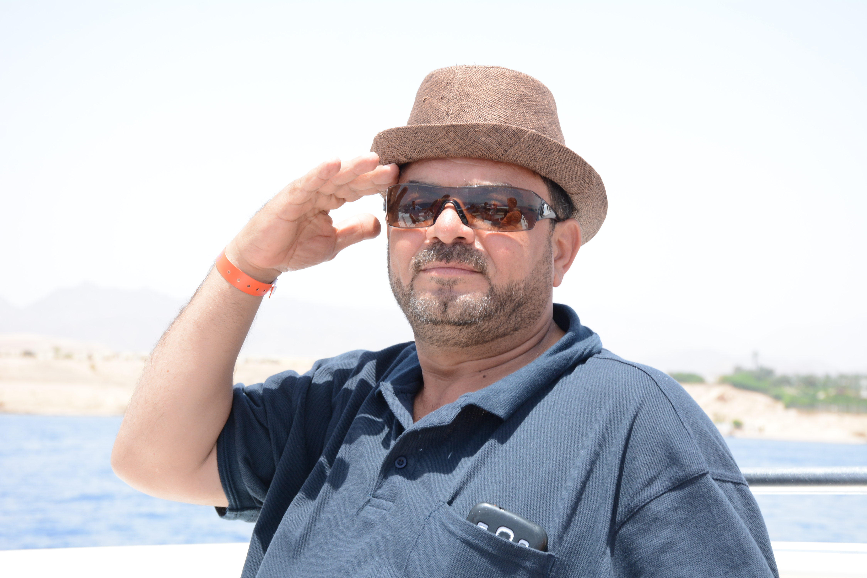
Units 1 - 4
ملخص الوحدة الثالثة - 2019
الدورة الشتوية
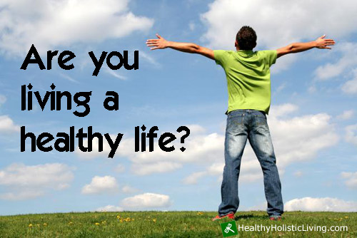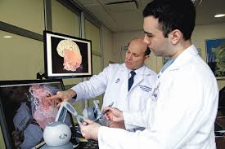
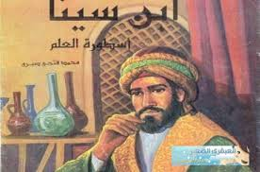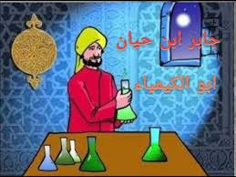

عماد ابو الزمر

Young Emirati inventor is going to travel the world

Ten-year-old Adeeb al-Balooshi, from Dubai, is going to travel to seven countries on a tour which has been organised and funded by Sheikh Hamdan bin Mohammad, Crown Prince of Dubai. The boy caught Sheikh Hamdan’s attention with his invention – a prosthetic limb for his father.

1. Who organized and funded Adeeb's tour ? (fund = sponsor)

Who was the supporter of Adeeps journey?

Sheikh Hamdan bin Mohammad, Crown Prince of Dubai.

2. What caught Sheikh Hamdan's attention ?

Why was Sheikh Hamdan interested in helping Adeeb?
Because of the boy's invention – a prosthetic limb for his father. (prosthetic = artificial)
( The invention = a prosthetic limb for his father. )
________________________________________________________________________________________________________________________________________________________________________________________________________________

The Sheikh has taken a special interest in the boy, and hopes the tour that he is sponsoring for Adeeb will give the young inventor more self-confidence and inspire other young Emirati inventors. Adeeb got the idea for a special kind of prosthetic leg while he was at the beach with his family.

4. What are the two results (benefits) for the tour ?

Why did he offer Adeeb the gift of a world tour?
a. The tour will give the young inventor more self-confidence.
b. The tour will inspire other young Emirati inventors.

5. How did Adeeb got the idea (inspiration) for a special kind of prosthetic leg ?
While he was at the beach with his family.
________________________________________________________________________________________________________________________________________________________________________________________________________________

His father, who wears an artificial leg, could not swim in the sea as he could not risk getting his leg wet. This inspired Adeeb to invent a waterproof prosthetic leg. Adeeb is going to visit the USA, France, the UK, Ireland, Belgium, Italy and Germany, where he will be staying with relatives. However, while he is in Germany, Adeeb will not be spending all his time sightseeing.

1. Why couldn't Adeeb's father swim in the sea ?
As he could not risk getting his leg wet.

2. What inspired Adeeb to invent a waterproof prosthetic leg ?
Because his father could not swim in the sea as he could not risk getting his leg wet.

3. Where will Adeeb stay in Germany ? What will he do there ?
With his relatives. He will not be spending all his time sightseeing.

He will be working with a specialist doctor to build the appendage. He will also be attending a course on prosthetics and learning about different kinds of medical apparatus.

1. Mention three things (activities ) that Adeeb will be doing in Germany ?
a. He will be working with a specialist doctor to build the appendage.
b. He will also be attending a course on prosthetics
c. He will be learning about different kinds of medical apparatus.
________________________________________________________________________________________________________________________________________________________________________________________________________________

Adeeb has invented several other devices, including a tiny cleaning robot and a heart monitor, which is attached to a car seat belt. In the case of an emergency, rescue services and the driver’s family will be automatically connected with the driver through this special checking device. He has also invented a fireproof helmet. This special equipment, which has a built-in camera system, will help rescue workers in emergencies. It is for these reasons that Adeeb rightly deserves his reputation as one of the youngest inventors in the world.

1. Mention three other inventions (devices ) for Adeeb .
a. A tiny cleaning robot d. a prosthetic limb (leg)
b. A heart e. monitor a. waterproof prosthetic leg
c. A fireproof helmet.

2. Why is the heart monitor attached to the car seat belt ?
In the case of an emergency, rescue services and the driver’s family will be automatically connected with the driver.

3. What is the benefit of the fireproof helmet ?
It will help rescue workers in emergencies.

4. What does the suffix ( -proof ) mean ?
To monitor those with a heart problems in the car.

5. What is the purpose of the in-car heart monitor?
Why do you think that it is built in the seat-built ?
To provide protection against.

6. Find the synonyms for the following words :

artificial - appendage - apparatus .

prosthetic - limb - equipment

Arabic | Meaning in English | Key Word
جهاز | equipment or machinery | apparatus
طرف | a body part, such as an arm or a leg, | appendage
صناعي | made by human beings (man-made) | artificial
طرف | arm or leg of a person | limb
بديل - صناعي | artificial | prosthetic
يدعم | to financially support a person or an event – / fund – pay for | sponsor

Medical Advances

We will be able to have an operation to increase our intelligence. 2018

Scientists have already developed brain implants that improve vision or allow disabled people to use their thoughts in order to control prosthetic limbs like arms, legs or hands, or operate a wheel chair. In 2012 CE, research on monkeys showed that a brain implant improved their decision-making abilities. How will humans benefit from this research? Scientists hope to develop a similar device to help people who have been affected by brain damage, which could be caused by dementia , a stroke or other brain injuries.

1. There are two benefits for developing brain implants. Mention them . ( their = disabled people )

a. improve vision
b. allow disabled people to use their thoughts.

2. Brain implants helps disabled people to use their thoughts in two ways :
a. To control prosthetic limbs like arms, legs or hands
b. To operate a wheel chair

3. What was the result of research on monkeys in 2012 ?
In 2012 CE, research on monkeys showed that a brain implant improved their decision-making abilities.

4. There are many reasons (factors) for brain damage. Mention two of them.
a. dementia b. a stroke c. other brain injuries.

5. How will humans benefit from brain implants in the future ? What do scientists hope to do ?
a. Scientists hope to develop a similar device to help people who have been affected by brain damage.

6. Mention two examples from the text about prosthetic limbs.
Arms, legs or hands, or operate a wheel chair.
_____________________________________________________________________________________________________________________________________________________________________________

Doctors will be able to communicate with people in a coma.

In 2010 CE, neuroscientists confirmed that it was possible to communicate with some patients in a coma, by using a special brain scanner called an MRI. They suggested that, in the future, more meaningful dialogue with patients in a coma would be possible. Two years later, it has finally happened. The scanner, used on a man who has been in a coma for more than twelve years, proves that he has a conscious, thinking mind – a fact that had previously been disputed by many. Doctors plan to use similar brain-scanning techniques in the future to find out whether patients are in pain, or what they would like to be done in order to improve their quality of life.

1. How did neuroscientists confirm that it was possible to communicate with some patients in a coma in 2010 ?
By using a special brain scanner called an MRI.

2. What was the result of using the scanner on a man who has been in a coma
for more than twelve years in 2012 ? The scanner proves that he has a conscious, thinking mind.

3. Doctors plan to use similar brain-scanning techniques in the future. Mention two reasons.
a. To find out whether patients are in pain.
b. To find out what they would like to be done in order to improve their quality of life.

A new drug will help to treat certain types of cancer almost instantly.

A new cancer drug is being trialed in Plymouth, UK, which doctors hope will extend the lives of cancer patients and reduce their symptoms overnight. It is taken as a single pill every morning, and so far patients have shown none of the usual side effects such as the sickness and hair loss that are experienced when undergoing other forms of cancer treatment. The new treatment works by blocking a protein which causes cancerous cells to grow. It will improve patients’ life expectancy and quality of life much more quickly than any other treatment. The patients were interviewed a year after starting the treatment and are fit and well, saying that they are definitely going to continue the trial. They have every reason to believe the new drug is going to work. Doctors at Plymouth Hospital hope that it will help patients from all over the world.

[
1. Mention two benefits for the new cancer drug for patients .
What do doctors hope the new drug will do ?

a. It will extend the lives of cancer patients
b. It will reduce patients' symptoms overnight.
c. It will improve patients’ life expectancy.
d. It will improve patients’ quality of life much more quickly than any other treatment.
e. It will help patients from all over the world.

2. Mention two side effects that are experienced when undergoing other forms of cancer treatment.
a. sickness b. hair loss

3. Quote the sentence which shows the way in which the new cancer drug work.
" The new treatment works by blocking a protein which causes cancerous cells to grow."

4. Quote the sentence which indicates that patients are convinced with the new cancer drug.
They have every reason to believe the new drug is going to work.

5. Find a word in the text that means ' tablet" . pill

6. Mention three medical advances doctors hope to be in the future.
a. An operation to increase our intelligence. (brain implants)
b. Communicate with patients in a coma.
c. A new cancer drug

Arabic | Meaning in English | Key Word
غيبوبة | an unconsciousness state | coma
جنون - خرف | a mental illness with memory | dementia
دواء - عقار | a medicine | drug
زراعة عضو | object implanted in the body. | Implant
تجريبي | Trial to evaluate the effectiveness and safety of medications – special test | medical trial
قرص | a small round piece of medicine to be swallowed – tablet | pill
جهاز تخطيط | a medical instrument that uses radiography to produce images of the inside body | scanner
اثار جانبية | Effects of medicine on your body | side effects
سكتة دماغية | an illness when a blood tube in your brain burst or blocked | Stroke
اعراض | signs of illness | symptoms
MRI : (Magnetic Resonance Imaging)

The King Hussein Cancer Center

The King Hussein Cancer Center (KHCC) is Jordan’s only comprehensive cancer treatment centre. It (KHCC) treats both adult and paediatric patients. As the population of the country increases, more and more families will rely on the hospital for cancer treatment. Patients come not only from Jordan but also from other countries in the region, as they (patients) are attracted by its excellent reputation, lower costs, and cultural and language similarities.

1. What is KHCC ? Why is it important ?
KHCC is Jordan’s only comprehensive cancer treatment centre.

2. There are two kinds of people that The King Hussein Cancer Center treats . Mention them.
a. Adult patients
b. Paediatric patients (children) = opposite to "adults"

3. What is the reason that will make more families rely on the hospital for cancer treatment ?
As the population of the country increases.

4. Mention three reasons (factors) why patients from other countries visit the centre.
a. excellent reputation
b. lower costs
c. cultural and language similarities.

5. Why do patients come from Jordan and other countries in the region to the centre ?
As they are attracted by its excellent reputation, lower costs, and cultural and language similarities.

6. Why does the hospital need to expand?
Because there is more demand for treatment,
_____________________________________________________________________________________________________________________________________________________________________________

In order to cope with the increase in demand for treatment, the KHCC has begun an expansion programme. Building started in 2011 CE . The hospital will have more than doubled its capacity by 2016 CE, increasing space for new cancer cases from 3,500 per year to 9,000. By then, they will have added 182 extra beds, along with bigger units for different departments, including radiotherapy. New adult and pediatric wards will have opened. Additionally, they will have built a special ten-floor outpatients’ building, with an education centre which will include teaching rooms and a library.

1. The expansion programme for the hospital has two aims. What are they ?

a. In order to cope with the increase in demand for treatment.
b. The hospital will have more than doubled its capacity by 2016 CE.

2. What is the space for new cancer cases in 2011 CE and in 2016 ?
a. In 2011 , the new cancer cases were 3,500 per year.
b. In 2016 , the new cancer cases will be 9, 00 per year.

3. What are the new facilities that will have been added to the hospital by 2016 ?
a. They will have added 182 extra beds
b. They will have added bigger units for different departments, including radiotherapy.
c. New adult and pediatric wards will have opened.
d. They will have built a special ten-floor outpatients’ building with an education centre .

4. Mention two things that the education centre will include .
a. Teaching rooms
b. A library.

5. Quote the sentence which indicates the date when the expansion of the KHCC will have finished.

" The hospital will have more than doubled its capacity by 2016 CE, increasing space for new cancer cases from 3,500 per year to 9,000. "

Many cancer patients live far away from Amman, where the KHCC is located, and the journey to and from the hospital is often difficult. For this reason, there are plans to extend cancer care facilities to other parts of Jordan. In the near future, King Abdullah University Hospital in Irbid hopes to set up radiotherapy machines, so that cancer patients from northern Jordan will not have to go to Amman for radiotherapy treatment.

1. Mention the disadvantages of the KHCC for patients who live far from Amman?
The journey to and from the hospital is often difficult.

2. Quote the sentence that indicates the reason to build other parts of The King Hussein Cancer Center .
Many cancer patients live far away from Amman, where the KHCC is located, and the journey to and from the hospital is often difficult.

3. What plans are there for increasing cancer care facilities in other parts of Jordan?
King Abdullah University Hospital in Irbid hopes to set up radiotherapy machines.

4. What is the result for set up radiotherapy machines in Irbid in the future ?
Cancer patients from northern Jordan will not have to go to Amman for radiotherapy treatment.

Arabic | Meaning in English | Key Word
اطفال | children, the opposite of adults | pediatrics
سمعة | fame | reputation
علاج اشعاعي | Using radiation to treat disease , especially cancer | radiotherapy
مريض غير مقيم | someone who goes to a hospital for treatment but does not stay for the night | outpatient
___________________________________________________________________________________________________________________
Critical Thinking

1. The article suggests that people's perception of complementary medicine has changed over time .
Why do you think this is the case ?
Because of more information being freely available on the internet .
Additionally, more research may have been done on the effects of complementary medicine.

2. If you want to have a good health you have to support network of family and friends, and an optimistic outlook on life. Think of these statements and in two sentences write down your opinion.

I think this statement is true because good family and friends relationship leads to healthy and better life leads to success . Also, if you are successful, you will enjoy everything you do in your life.

3. According to the text the writer states that we have to teach children to develop positive thinking Explain this statement, suggesting three ways to develop positive thinking.

I suggest : 1. Doing more exercises 2. Family supporting 3. Having enough sleep.

4. Do you think that computers will replace books one day ? Why ? Why not ?
Although computers are incredibly useful, I don't think they will replace books because, for many people, reading is a very personal experience that doesn't feel the same when it is done on a computer.

5. Spending too much time online is a serious problem nowadays.
Explain this statement, suggesting three ways for avoiding this phenomenon.
I think spending too much time online is a serious problem nowadays , but we can avoid this problem by many ways such as: - controlling our time . - visiting friends - doing exercises – watching TV – walking .. etc.

Accident victim tests first artificial limb

Scientists have successfully invented a prosthetic hand with a sense of touch. It is an exciting new invention, which they plan to develop. It is possible that, in the not-too distant future, similar artificial arms and legs will have taken the place of today’s prosthetic limbs.

1. What is the feature of the new prosthetic hand invented by scientists ?
What is special about it ?
It has a sense of touch.

2. artificial = prosthetic / limbs = arms and legs
_______________________________________________________________________________________________________________________________________________________________________________________________________________________________________________________________________________________________________________________________________________________

Dennis Sorensen, a 39-year-old from Denmark, was the first person to try out the new invention. After losing his left hand in an accident, he had been using a standard prosthetic hand for nine years.

1. Who was the first person to try out the new invention ? Dennis Sorensen

2. Why did Dennis Sorenson use (need) a standard prosthetic hand ?
Because he lost his left hand in an accident.

3. How long had he been using the standard prosthetic hand ? For nine years.
_______________________________________________________________________________________________________________________________________________________________________________________________________________________________________________________________________________________________________________________________________________________

The new hand, which was developed by Swiss and Italian scientists, was a huge improvement. With it, Sorensen could not only pick up and manipulate objects, but he could also feel them. "When I held an object, I could feel if it was soft or hard, round or square", he explained. He said that the sensations were almost the same as the ones he felt with his other hand. Unfortunately, Sorensen was only taking part in trials, and the equipment is not ready for general use yet. He was only allowed to wear it for a month, for safety reasons.

1. Who developed the new hand ?
Swiss and Italian scientists (them = objects )

2. Mention three characteristics for the prosthetic hand.
a. pick up objects . b. manipulate objects c. feel objects

3. Who do the bold pronouns ‘I’ refer to ? Dennis Sorensen

4. What is the difference between the new prosthetic hand and Sorenson's other hand ?
The sensations were almost the same as the ones he felt with his other hand.

3. Why was Sorenson only allowed to wear the prosthetic hand for a month ?
For safety reasons.
_______________________________________________________________________________________________________________________________________________________________________________________________________________________________________________________________________________________________________________________________________________________

So now he has his old artificial hand back. However, he hopes that soon he will be wearing the new type of hand again. He is looking forward to the time when similar artificial limbs are available for the thousands of people who need them. He will have helped to transform their lives.

1. Which hand is he wearing now? Why?
His old artificial hand because he was only taking part in trials, and the equipment is not ready for general use yet.

2. Quote the sentence which indicates that Sorenson would be happy if the new type of hand became true.
He is looking forward to the time when similar artificial limbs are available for the thousands of people who need them.

3. Find a word that is the opposite of 'natural' . artificial

Vocabulary

ضد الماء دقيق اعتماد على النفس حزام امان يخاطر سمعة يراقب يشجع خوذة
helmet – inspire – monitor – reputation – risk – seat built – self-confidence – tiny – waterproof

1. You can wear your watch when you go swimming if it's ----------------------------.
2. It's amazing how huge trees grow from -------------------------- seeds.
3. The Olympic Games often --------------------- young people to take up a sport.
4. Please hurry up. Let's not --------------------- missing the bus.
5. You must always wear a ------------------------ in a car, whether you are the driver or a passenger.
6. When my grandfather had a heart attack, the doctors attached a special --------------- to the chest.
7. It's important to encourage young people and help them develop ------------------------.
8. Petra has a ---------------------- as a fascinating place to visit.
Answers : 1 waterproof - 2 tiny - 3 inspire - 4 risk - 5 seat belt - 6 monitor - 7 self-confidence – 8 reputation
__________________________________________________________________________________________________________________
Collocations

Arabic | Collocations | Arabic | Collocations
يمضي الوقت | spend time | يجلب الانتباه | catch attention
يحضر دورة | attend a course | يلتقط فكرة | get an idea
 |  | يهتم بشخص او شيء | take an interest

Complete the following sentences with the correct words :

( attend - catch - carbon footprint - urban planning )

1. Brilliant students always ----------catch------------ their teachers' attention with their remarkable answers.

2. Fatima plans to --------attend------------ several courses on prosthetic with specialized people.

3. Replace the underlined misused verb with the appropriate collocation :
I like to attend time learning foreign languages . 2018 spend
______________________________________________________________________________________________
Editing :

Imagine you are an editor in the Jordan Times. You are asked to edit the following lines that have four mistakes ( one grammar mistake, one punctuation mistake and two spelling mistakes.) Find out these four mistakes and correct them.

ركز على تبديل الحروف التالية في الكلمات 1. b-p / c-k / j-g / s-t / i-e / s-z / o-u / f-v

2.Capital letter , comma, full stop, question mark ( a-A / , / ? / : / ; )

3. One grammar mistake . (will have helped = will help)

Edit the following text. There are two grammar mistakes and three spelling mistakes. Find and correct them.

In the near future, a new ‘bionic eye’ will have helped people with failing eyesite to see again. A devise inside the eye picks up an image from a small camera attached to a pair of sunglasses and send it to the brian, which interprets it as vision.

1. ------------------------------ 2. --------------------------- 3. --------------------------- 4. -------------------------

المستقبل المستمر 1. The Future Continuous :
Key words

at + time + future / Will – still / tonight at 5 pm. / in an hour  in …. time / the exact time later / This time tomorrow ) | Subject + will (won't) be + V-ing

1. This time next year (In two days), They -------------------------------------------------- for the final exam. (prepare)

2. It's a very long course, so I ------------------------------------------------ in seven years' time . ( still study )

3. Can I call you tonight after 6 pm or you----------------------------------- dinner with your family then . (have

4. Will it still ------------------------------------- this evening ? (rain)

5. If you need to contact me next week, we'll ----------------------------------------------- at a hotel in Aqaba. ( stay )

6. I can't call my dad right now. He'll ---------------------------------------- the plane. It takes off in an hour. ( board)
____________________________________________________________________________________________________________________________________________________

12. The Future Perfect : ( next month , …….. for ) Let's celebrate

Key words | 1. ( Subject + will have + V-3 ) - for + time
-by + future / by the time + v1 / by.. tomorrow,  -by next …/ by then / by three years from now /  -by the end of this year / before long )  - (This time tomorrow ....... for + time ) | 2. ( Subject + won't have + V-3 )
 | 3. By + time (future) = By 2020 , will have + V3
 | 4. By the time + V1 , will have + V3
5. By the time + V2 , had + V3 / had been + V-ing . (be,v)
( Past Perfect )

1. By 2029 CE, the new motorway ---------------------------------------------------------------- . (open)

2. Next month, we ----------------------------- in this house for a year. Let's celebrate. ( live )

3. Next month, our family --------------------------- in this house for a year. (have, live)

4. This time next month, my parents ---------------------- married for twenty years. ( be )

5. This time tomorrow, we'll be celebrating because we ---------------------- our exams. ( finish )

6. Will you ---------------------------- your homework by seven o'clock ? ( do ) 2016

7. In thirty years' time , scientists ------------------ a cure for cancer. ( found - find - will have found – were finding ) 2018

8. By the time we get to the station, the train ------------------------------------------------------. (not, go)

9. By the time we got to the station, the train ------------------------------------------------------. (not, go)

Complete the mini-dialogues using the future continuous :

1. A : Can I call you tonight after 6 pm or --------------------- ( you have ) dinner with your family then .
2. B : No, I ----------------- ( not have ) dinner at that time. I ------------------- ( watch ) the news.
My mother ------------------- (prepare) dinner ,because we usually eat at about 7 pm.

3. A : What do you think ---------------------------- ( you do ) in two years time ?
------------------- ( you work ) , or --------------------- ( you do ) a university degree ?
4. B : I certainly -------------------- ( not work ) because I want to do a degree in medicine.
It's a very long course, so I --------------------------- ( still study ) in seven years' time .

Choose the correct form of the verbs :

1. If you need to contact me next week, we'll ------------------ at a hotel in Aqaba. ( stay – be staying )
2. If you need to help to find a job, I will --------------------- you. ( help – be helping )
3. I can't call my dad right now. He'll ------------------- the plane. It takes off in an hour. ( board – be boarding)
4. We won't be home tomorrow night. We'll -------------------- the football match at the stadium. ( watch – be watching )
5. Do you think you'll ------------------- your school friends when you go to university ? ( miss – be missing )

Complete the sentences with the future perfect form of the verbs in brackets :

1. This time tomorrow, we'll be celebrating because we ------------------ our exams. ( finish )
2. This time next month, my parents ---------------------- married for twenty years. ( be )
3. The books that you ordered ------------------- by the end of the week. ( not arrive )
4. By next year, --------------- you ---------------- England ? ( visit )

There is one mistake in each of the conversations below. (Activity Book p.16)
Underline the mistake and write the verb in the correct tense :

A : What do you think you will be doing in two years' time ?
B : I think I will be in Karak and I will study Geography . ----------------------------------------------------------

A : Don't phone me at seven. I'll have dinner with my family. ------------------------------------------------------
B : OK. I'll phone at nine.

A : What time will you get here tomorrow ?
B : At about three, I think. I'll be texting you the exact time later. --------------------------------------------------

A : Please be quiet when you come home tonight . The baby will sleep. -------------------------------------------
B : Don't worry. I won't forget.

Complete the sentences in the Future Perfect or the Future Continuous :

1. Next month, we ----------------------- in this house for a year. Let's celebrate. ( live )
2. Next Monday, I ------------------------- in my new job. ( work )
3. You ---------------------- all your homework by eight o'clock . ( do )
4. It's three o'clock now, so Miriam's flight ----------------------- at Queen Alia International airport, ( arrive)
5. You -------------------------- at the library this afternoon. ( meet us )
6. You can borrow this book tomorrow. I ------------------------ it by then . ( finish )

Make correct sentences about the future Examples: (Student’s Book p.23)

1. ( I , we , you , they ) + hope , plan , intend + to + V-inf.
الجملة الخبرية
2. ( he , she , it ) + hopes , plans , intends + to + V-inf.
الجملة الخبرية
3. Do + ( I , we , you , they ) + hope , plan , intend + to + V-inf. ?

4. Does + ( he , she , it ) + hope , plan , intend + to + V-inf. ?

5. Wh- + do +( I , we , you , they ) + hope , plan , intend + to + V-inf. ?

6. Wh- + does + ( he , she , it ) + hope , plan , intend + to + V-inf. ?

e.g. I hope to go to Australia next year.

e.g. I plan to learn French soon.

e.g. I intend to go shopping at the weekend.

1. He / hope / become a teacher one day.
----------------------------------------------------------------------------------------------

2. I / intend / apply for a job when I finish university.
----------------------------------------------------------------------------------------------

3. Many hospitals / plan / use robots to help nurses in the future.
----------------------------------------------------------------------------------------------

4. How / you / intend / solve the problem?
----------------------------------------------------------------------------------------------

5. Our school / hope / raise enough money to build a new library.
----------------------------------------------------------------------------------------------

6. You /intend / buy tickets for the play?
----------------------------------------------------------------------------------------------

Answers:
1. He hopes to become a teacher one day.
2. I intend to apply for a job when I finish university.
3. Many hospitals plan to use robots to help nurses in the future.
4. How do you intend to solve the problem?
5. Our school hopes to raise enough money to build a new library.
6. Do you intend to buy tickets for the play?

