English World 7

This is what to do
Unit 7

Name:…………………………….
Seventh grade (………)

lesson 1 :
Keep these new words by your heart:
New Words | English Meaning | Arabic Meaning
fridge |  | ثلاجة
ingredients |  | مكونات
prepare |  | إعداد
refrigerate |  | برد
crush |  | سحق
beat |  | تغلب
fry |  | يقلى
recipe |  | وصفة
method |  | طريقة
pan |  | مقلاة
preheat |  | سخن
prepay |  | الدفع المسبق
predict |  | تنبؤ
preview |  | معاينة
sculpture |  | نحت
furniture |  | أثاث المنزل
adventure |  | مغامرة
culture |  | حضاره
herbs |  | أعشاب
thyme |  | زعتر
garlic |  | ثوم
minced beef |  | لحم البقر المفروم
parsley |  | بقدونس
pepper |  | فلفل
onion |  | بصلة
mixture |  | خليط
chop |  | يقطع
taste |  | المذاق
delicious |  | لذيذ
Lesson 2: working with words
- Language development
Adjectives: the past participle
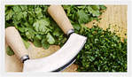
These are herbs. هذه اعشاب
They have been chopped.تم قطع هذه الاعشاب
نستطيع دمج الجملتين بجملة واحدة باستخدام الفعل (الحالة الثالثة ) كصفة .. كالتالي:
These are chopped herbs.

These are broken windows.

- making new words
prefix ( pre - )this means before تعني هذه الاضافة (قبل-)
preheat : قبل التسخين
prepay : دفع الثمن مقدم

- spelling
words ending ( - ture) this syllable is pronounced like /t∫ǝ/
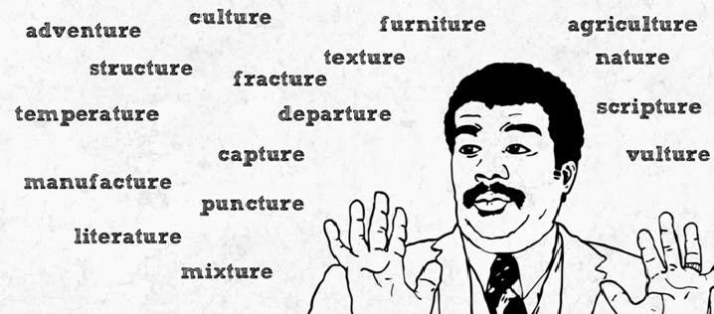
for examples: Future, capture, vulture, nature

In zero conditional sentences we use the present tense in both clauses when we are talking about general truths and scientific facts.

Let’s remember simple present tense:
 | Simple present
uses | -daily routines or habits للعادات و الروتين اليومي  -facts للحقائق  -permanent situationsللاوضاع الدائمة
keywords | Usually - sometimes - daily - always - every +time - never - often
Affirmative form | للمفرد(he, she , it) + v +es /s  للجمع(we , they , you , I ) + v
Negative form | للمفرد(he, she , it) +doesn’t + v  للجمع(we , they , you , I ) + don’t + v
Question form | Does +للمفرد(he, she , it) + v ….?  Do + للجمع(we , they , you , I ) + v

- If temperatures …………….. below zero, water ………….. .( drop , freez)
- It ……..helpful to cooks If recipes ……..easy to follow. (be , be)

We use some , many , a few , any , lots of and a lot of for countable nouns.

We use some , much , a little , any , lots of and a lot of for countable nouns.

