[**[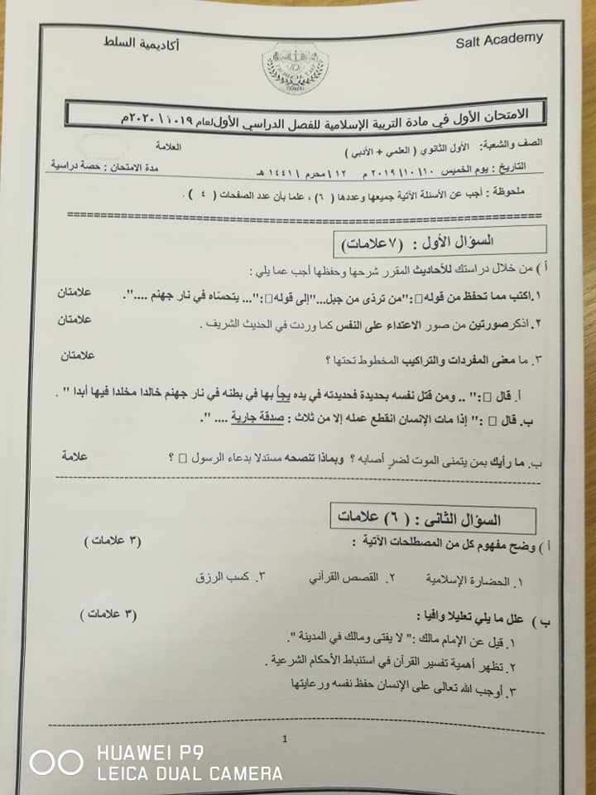](https://www.jnob-jo.com/vb)**](https://www.jnob-jo.com/vb) **[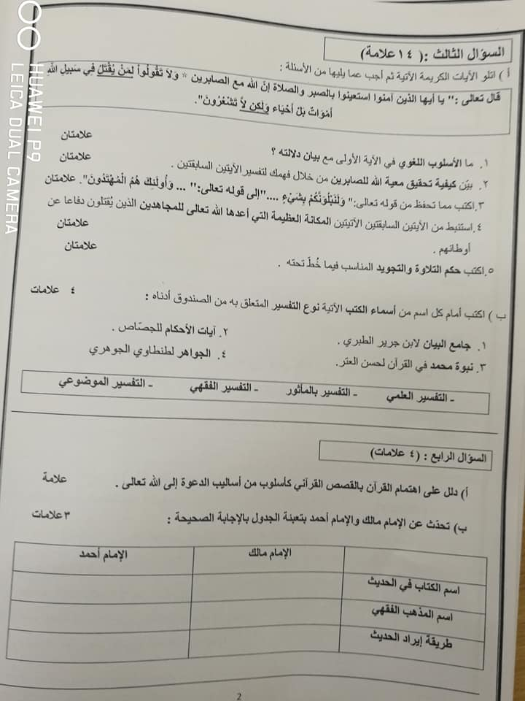](https://www.jnob-jo.com/vb)  
  
[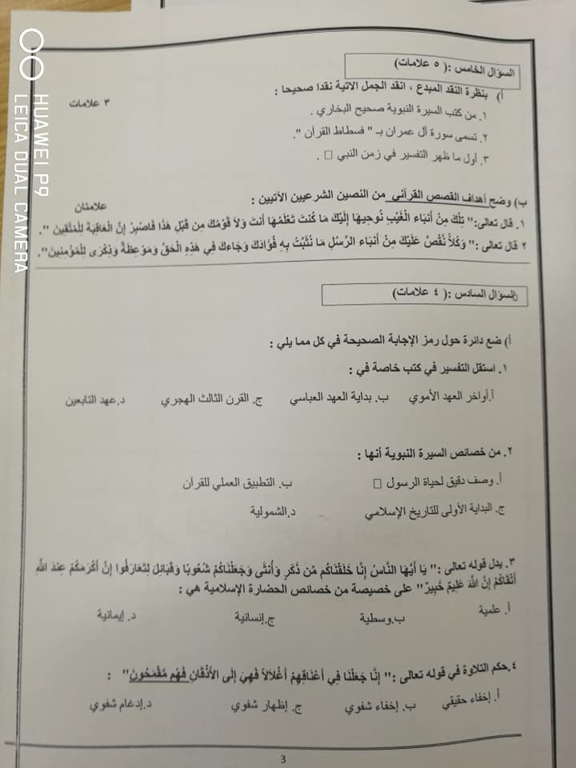](https://www.jnob-jo.com/vb)  
[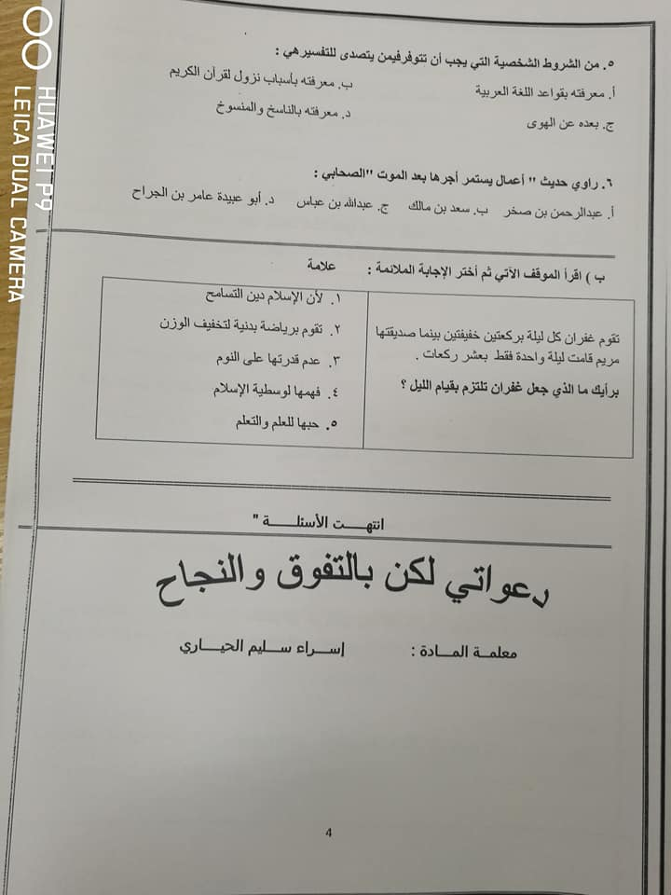](https://www.jnob-jo.com/vb)**