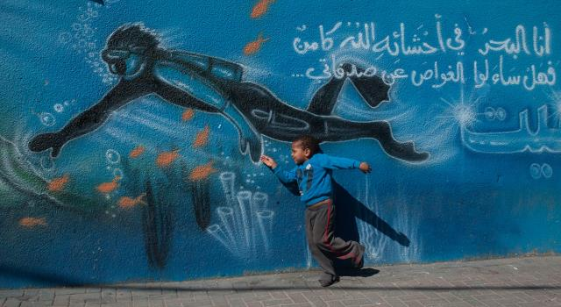
دوسية بحر الدر
رويدة محمد الفرارجة
اللغة الإنجليزية / توجيهي / الفصل الثاني
Grammar
Ruwaidah Mohammad al-Fararjeh
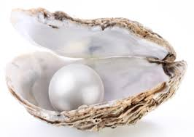
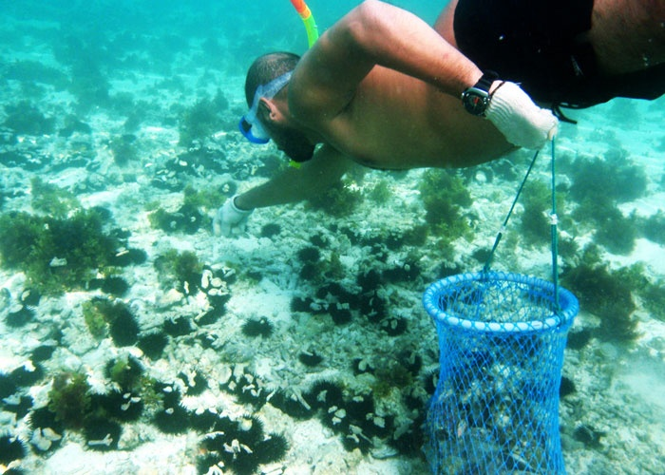
فهل سألوا الغواص عن صدفاتي
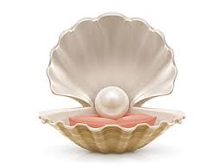

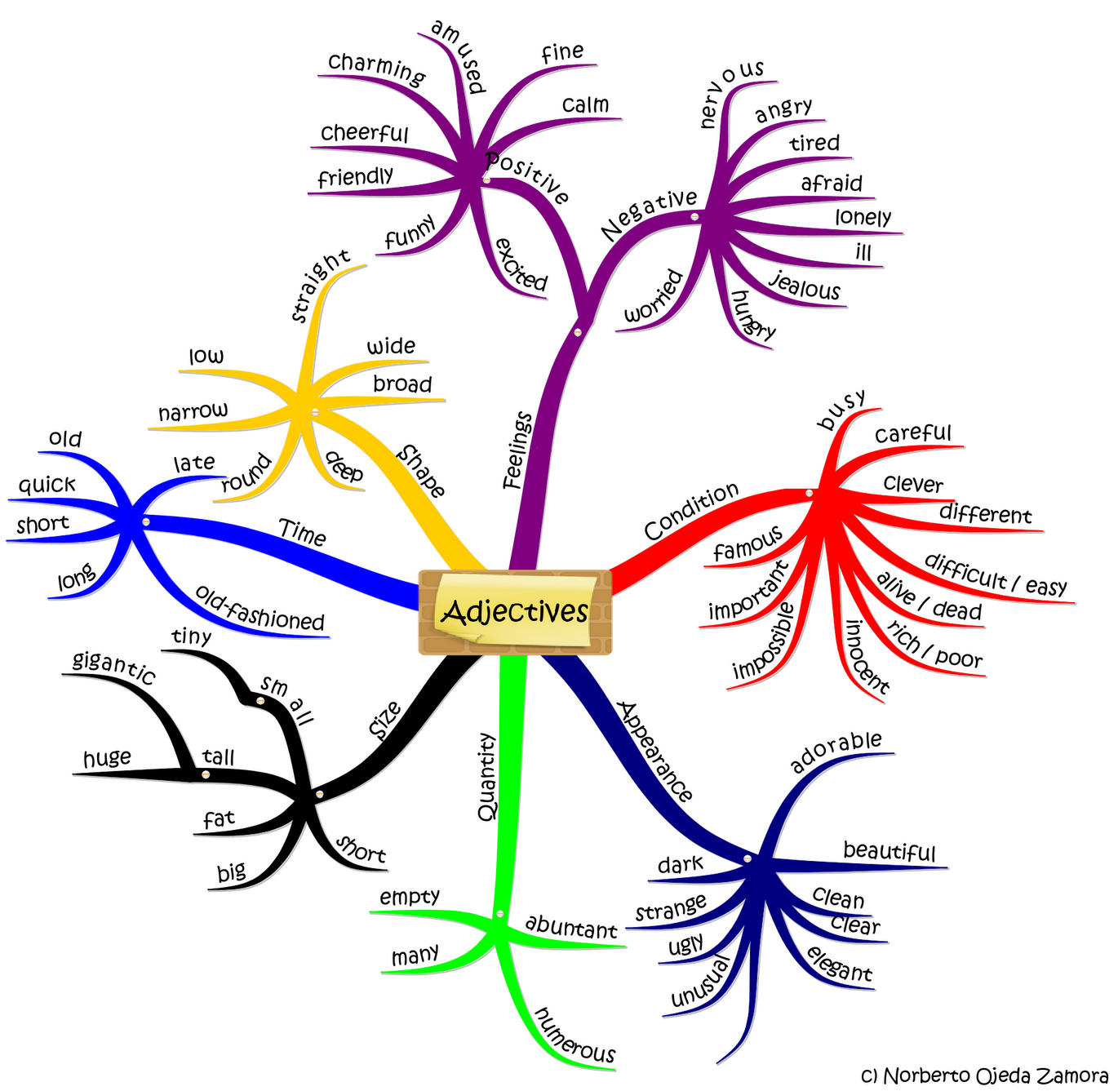
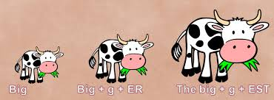
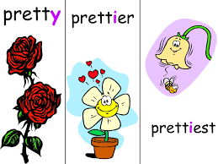
Comparison ( UNIT 6 )

*من الضروري أن يتعلم الطالب كيفية عد المقاطع في الكلمة قبل أن يتعلم طرق عمل المقارنات .
How many syllables does the word have ?
كم عدد المقاطع في الكلمة ؟
How many beats does the word have ?
كم عدد الإيقاعات في الكلمة؟
*Every syllable has a vowel sound . So we count the vowel sounds not the vowels .
*نعد المقاطع حسب أحرف العلة ( فعليا أصوات العلة هي التي تحسب وليس الأحرف ) :-
( a , e , i , o , u )
أحرف العلة المتتابعة تعتبر مقطع إلا في بعض الحالات-
حرف العلة غير الملفوظ لا يحسب-
) أشباه العلة تعتبر مقطعw , y ) -
*ملاحظة :- نواة المقطع هو صوت العلة , قد يكون لوحدة أو قد يكون محاط بأحرف صحيحة .

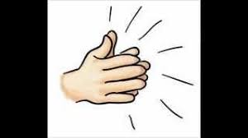
Clap the syllables to make sure .
صفق المقاطع لتتأكد .
tall , short ,strong ,weak,beautiful,pretty,ugly,safe,dangerous , wonderful,amazing ,careful ,careless, wide ,narrow ,holy ,interesting ,clever,stupid, quiet,noisy, comfortable, loved ,bored ,simple , gentle, easy, difficult , ill ,sick ,red ,orange

كيف أميز الصفات القصيرة من الصفات الطويلة ؟
الصفات القصيرة :-
1 – الصفات ذات المقطع الواحد
2- الصفات ذات المقطعين المنتهية بشبه علة ( , ) أو المنتهية ب ( ). الصفات الطويلة :-
1- الصفات ذات الثلاثة مقاطع أو أكثر
2- الصفات ذات المقطعين غير المنتهية بشبه علة ( , ) أو ( ) .

Remember, two syllables means two rules.

*الصفات القصيرة تأخذ بعدها ( ) عند عمل المقارنة و ( ) عند عمل التفضيل بينما الصفات الطويلة أضع قبلها كلمة ( ) عند عمل المقارنة واضع قبلها كلمة ( ) عند عمل التفضيل ولكن تذكر دائما بان كل قاعدة لها شواذ .

- Equal comparison

* استعمل المماثلة عندما أقول بأن شخصين أو شيئين أو مجموعتين يتماثلان بنفس الصفة أو الظرف (زي بعض) .
Ali is as tall as Ahmad . (as + adjective + as)
Farah speaks as quickly as Hala . (as + adverb + as)
ملاحظات :- as….as*
ممنوع منعا باتا وضع مقارنة أو تفضيل بين آز....آز*
الصفة بينهما يجب أن تكون بشكلها المجرد ( بدون أي إضافات قبلها أو بعدها )
الصفة بينهما ممكن أن تكون قصيرة أو طويلة
الظرف بينهما ممكن أن يكون منتظم أو غير منتظم
*ممنوع منعا باتا وضع اسم لحاله بين آز....آز
ممكن أن يأتي بينهما اسم ولكن يجب أن يكون مسبوق ب ( ) أو ( )

2-Unequal comparison

* استعمل عدم المماثلة عندما أقول بان شخصين أو شيئين أو مجموعتين لا يتماثلان بنفس الصفة أو الظرف (مش زي بعض) .
Mohammad is not as tall as Hamid .(not + as/so + adjective + as)
Haneen doesn't speak as quickly as Ghadah .(not + as/so + adverb + as)
*عدم المماثلة يجب أن تتحول إلى مقارنة
Dana is not as slow as Leen.
Leen is slower than Dana.
Dana is faster than Leen.
Areej doesn't walk as slowly as Nour.
Nour walks more slowly than Areej .
Areej walks faster / more quickly than Nour .

*الظروف عادة أضع قبلها كلمة ( ) عند عمل المقارنة وكلمة ( ) عند عمل التفضيل إلا إذا كانت مقطع واحد تأخذ بعدها ( ) عند عمل المقارنة وتأخذ بعدها ( ) عند عمل التفضيل .
صفات أل ( ) وصفات أل( ) استعمل معها ( ) أو ( ) *

3-Comparative

* أستعمل المقارنة عندما أقارن بين شخصين أو بين شيئين أو بين مجموعتين في صفة معينة أو بين اسمين في الكمية أو العدد أو عندما أقارن الشخص بنفسه أو الشيء بنفسه في فترات زمنية مختلفة ومع الظروف أقارن كيفية أداء فعل معين .
يفضل أن لا استعمل النفي مع المقارنة*
*الصفات القصيرة أضع لها ( ) عند عمل المقارنة ثم أضع بعدها كلمة ( ) أما الصفات الطويلة فأضع قبلها كلمة ( ) ثم أضع بعدها كلمة ( ) .

Dyala is cleverer than Aya .
Yasmeen is more beautiful than Ruba .

*مثل هذه الجمل الأفضل أن تحول من المقارنة إلى عدم المماثلة لأن عكس الصفة سيغير المعنى .
*المقارنات المتتابعة :- مقارنتين ورا بعض بينهم فاصلة ولا أضع معها كلمة ( ) وعادة ما تكون مسبوقة بأداة التعريف ( ) .
The longer you study , the better you do in final exams.
The earlier you start in the morning the , the more beneficial your revision will be.
1-more x less (adjectives /adverbs)
2- more x less (uncountable nouns)
3- more x fewer (countable nouns)
I have more books than you (have).
You have fewer books than me / I have .
They have more information than Malak .
Malak has less information than them / they have .
*يتبين لنا من الأمثلة السابقة بان المقارنات لا تقتصر على الصفات والظروف فهنالك مقارنات للأسماء أيضا .
I don't speak French as well as you (do).
You speak French better than me / I do.
Ala' doesn't eat as much as Mohammad.
Mohammad eats more than Ala' .
Ala' eats less than Mohammad .

*ملاحظة :- مع مقارنة الأسماء والظروف دائما كلمة ( ) يتبعها إما اسم أو ضمير مفعول به أو ضمير فاعل متبوع بفعل مساعد .
* تذكر دائما بان الصفة تصف اسم لكن الظرف يصف فعل أو صفة أو ظرف آخر أو جملة .
Ala' is not as tall as Ahmad.
Ahmad is taller than Ala'.
Ala' is shorter than Ahmad.

إذا تغير الفاعل في الجملة الجديدة احذف علامة عدم المماثلة ..............*
ثم أحول الصفة للمقارنة حسب القواعد السابقة .
إذا لم يتغير الفاعل في الجملة الجديدة احذف علامة عدم المماثلة ...........*
ثم اعكس الصفة الموجودة وأحولها للمقارنة حسب القواعد السابقة .
4-Superlative

* استعمل صيغ التفضيل عندما أفضل شخص على مجموعة أشخاص أو شيء على مجموعة أشياء أو مجموعة على عدة مجموعات في صفة معينة أو ظرف معين أو اسم معين .
يفضل أن لا استعمل صيغ النفي مع التفضيل .*
الصفات القصيرة أضع بعدها ( ) أما الصفات الطويلة فأضع قبلها ( )*

Suhad is the tallest doctor in the hospital.
Wala' is the most beautiful girl in our family.
Kifaya is my best friend .
*لاحظ بأننا يجب وضع أداة التعريف ( ) قبل صفات التفضيل أو ضمير ملكية متصل .
*لاحظ بان صفات التفضيل عادة ما تكون متبوعة بأحرف جر مثل ..........

*هنالك عبارات معينة قد تكون موجودة في الجملة وتدل على انه يجب أن أعيد كتابة الجملة باستخدام صيغ التفضيل .
- I have never seen such a powerful car .
This is the most powerful car I have ever seen .
- There is no chef in town as skilful as Bayan .
Bayan is the most skillful chef in town .
- No other school subject is as interesting as English.
English is the most interesting school subject .
*إعادة الكتابة ممكن أن تكون من صيغ تفضيل إلى صيغ تفضيل على النحو التالي :-
The safest place is your home.
The least ……………………………………………………………………………
The easiest school subject is English.
The least ……………………………………………………………………………
The ugliest animal is the donkey.
The least ……………………………………………………………………………
*تذكر بان اغلب ظروف الحال تتكون من الصفة مضافا لها ( ) ولكن هنالك ظروف لا تتبع هذه القاعدة وتعتبر شاذة .
skillful + ly = skillfully
wonderful + ly =wonderfully
تذكر بان بعض الصفات تنتهي ب ( )*
مثل
lovely, friendly, likely, holy, lonely …….etc.
---------------------------------------------------------------------------------

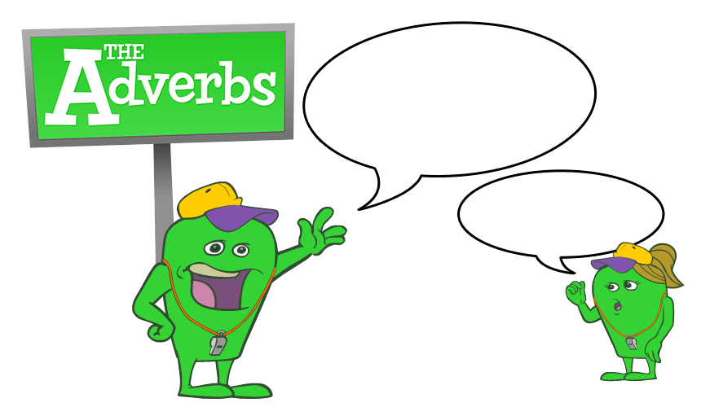
Irregular adverbs

adjective adverb
good well
fast fast
hard hard
early early
late late
high high
…………………………………………………………………………………………..
Irregular comparisons

word comparative superlative

good better the best
well better the best
bad /*ill worse the worst
badly worse the worst
…………………………………………………………………………………………
little less the least
few fewer the fewest
much more the most
many more the most
…………………………………………………………………………………………
far farther the farthest
further the furthest
old older the oldest
elder the eldest

Spelling rules
قواعد إضافة أل( ) وأل( ) للصفات
1- الصفات التي تنتهي بحرف صحيح يسبقه حرف علة واحد اضعف الحرف الصحيح عند إضافة المقطع المبدوء بحرف علة .
e.g. big + er = bigger , big + est = biggest
ما عدا الكلمات التي تنتهي ب( ) أو ( ) أو ( ) لا تضعف إذا سبقها حرف علة واحد بل تبقى كما هي .
narrow + er = narrower , narrow + est = narrowest
2- الصفات التي تنتهي بحرف صحيح يسبقه حرفا علة , لا اضعف الحرف الصحيح عند إضافة المقطع المبدوء بحرف علة .
cheap + er = cheaper , cheap + est = cheapest
3- الصفات التي تنتهي بحرفان صحيحان لا اجري أي تغيير عند إضافة أي مقطع لها .
cold + er =colder , cold + est = coldest
4- الصفات التي تنتهي ب ( ) فقط أضيف لها ( ) أو ( )
safe + r = safer , safe + st = safest
5-الصفات التي تنتهي ب( ) وسبقت بحرف صحيح تحول إلى ( ) ثم نضيف لها المقطع المناسب .
angry + er = angrier , angry + est = angriest
*أما إذا سبقت أل ( ) بحرف علة مثل ( ) فلا تتغير وتبقى كما هي عند إضافة أي مقطع لها 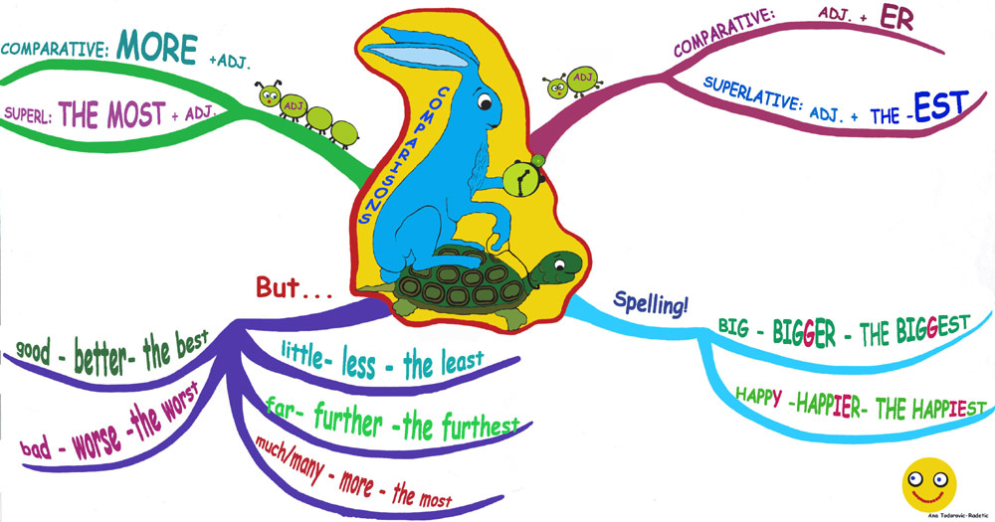
Quantifiers to make comparisons

المحددات الكمية والعددية لعمل المقارنات
We can use:- نستطيع أن نستعمل
- more / less …………than أكثر / أقل من ... للمقارنة (للصفة الطويلة)
- as….as تماما ... مثل.... (للمماثلة)
- the most / least الأكثر / الأقل ... للتفضيل (للصفة الطويلة)

- To compare adjectives and adverbs. (language function)
لكي نقارن الصفات والظروف .

e.g. Which subjects are the most popular , and which

are the least popular ?
e.g. Do you think geography is more interesting than history , or less interesting ?
e.g. Is Maths as popular as Science ?
- We can also use as ……….as to compare adverbs.
نستطيع أيضاً أن نستعملها لمقارنة الظروف. as….as
e.g. I can't run as fast as you (do).
(3) We can also use as ……… as adverbially.
نستطيع أيضاً أن نستعملها ظرفيا. as.…as
e.g. * I don't like running as much as I like swimming.
e.g. We practice our English as often as possible .
We use : - نحن نستعمل
    - as much +( uncountable noun) (تصل الكمية إلى + اسم غير معدود
    - as many + (countable plural noun) (يصل العدد إلى ) + اسم معدود
(4) To compare quantities and numbers. (language function)
لكي نقارن الكميات والأرقام

e.g. There are not as many people in our class as in yours.
There are fewer people in our class than in yours.
many X few , much X little
not many = few , not much = little
*ملاحظة :- وجود الكلمات التالية في بداية الجملة غالبا ما يدل على مقارنة أسماء
There is / There are

e.g. I don't eat as much fast food as my brother(does).
My brother eats more fast food than me / I do.
I eat less fast food than my brother does.
+ SBP.45 ex.5 + ABP.31 ex.4 + ABP.32 ex.5
1- There's less information on the website than there is in the book. (as much)
There……………………………………………………………………………………
2- The cheapest thing on the menu is orange juice.
The least ……………………………………………………………………………

Rewrite the following sentences.
- There are not as many students studying Science as Maths .
There are ……………………………………………………………………………..
- Maths is more popular than science but less popular than English .
Science is ……………………………………………………………………………
- Students don't like doing Music and Art as much as they like doing Maths .
Students like ………………………………………………………………………..
- Portuguese children have to go to school for longer than children in Japan .
Japanese children ………………………………………………………………
5-In Jordan , children start school a year later than English children .
English children …………………………………………………………………..
- Jordanian children can leave school one year earlier than English children .
English children ……………………………………………………………………
- Not as many people applied for law in 2014 CE as in 2013.
- In 2013 ……………………………………………………………………………
b- ……………..children applied……………………………………………….
- Law is more popular than Medicine and Dentistry .
Medicine and Dentistry ……………………………………………………….
- Engineering is less popular than Visual Arts .
Visual Arts is ………………………………………………………………………..
- 11% more people applied for Engineering in 2014 CE than in 2013 CE .
In 2013 CE 11 % …………………………………………………………………
أسئلة وزارة
*نستطيع أن نتعرف بسهولة على سؤال هذه القاعدة في الوزارة وذلك بوجود شكل من أشكال المقارنة أو عدم المماثلة أو التفضيل في الجملة الأصلية
Rewrite the following sentences.
- Neither Maths nor Science is as popular as English. S2016
English …………………………………………………………………………………
- Jordanian children start school a year later than English children. W2017
English children ……………………………………………………………………
3-Studying Physics is not as popular as studying Biology in Britain. S2017
Studying Biology ………………………………………………………………….
4-There is no threat to our environment as serious as pollution .2016/2017 تجريبي وزاري
Pollution is …………………………………………………………………………..
5-The electronic newspapers are not as acceptable as the ordinary ones .W2018
The ordinary newspapers …………………………………………………….
6-These new shoes are not as comfortable as my old ones .S2O18
My old shoes ……………………………………………………………………
7-Manar is not as active as Khalida .W2019
Khalida …………………………………………………………………………………
8-Reading a novel is not as interesting as watching a movie . S2019
Watching a movie ……………………………………………………………
Choose the suitable item.
1-I'm not interested in football as …………….as you. S2019
(many , more , much , less)
2-The bus is too late. We'll have to wait in the station a little………………… S2020
A)the longest B)longer than C)longer D)longest
3-Niether Maths nor Biology is as interesting as English. This means…………….. S2020
A)English is less interesting than Maths and Biology.
B)Maths and Biology are more interesting than English.
C)English is not as interesting as Maths and Biology.
D)Maths and Biology are less interesting than English.
4-My watch is less attractive than your watch.
The sentence which has a similar meaning to the one above is: S2020
A)My watch is more attractive than yours.
B)My watch is not as attractive as yours.
C)My watch is as attractive as yours.
D)My watch is the most attractive one.
5-The lunch is not ready yet. We'll have to wait a little…………
A) long B)the longest C)longer D)the longer W2021
6-Yahya didn't enjoy the book. In fact it was……..…..interesting story he has ever read. W2021
A)the less B)the most C)the more D)the least
7-Learning Medicine is more difficult than learning Biology and Chemistry. W2021
A)Learning biology and chemistry is not as difficult as learning medicine.
B)Learning medicine is less difficult than learning biology and chemistry.
C)Learning biology and chemistry is more difficult than learning medicine.
D)Learning medicine is as difficult as learning biology and chemistry.
8-There's less information on the website than there is in the book. W2021
A)There isn't as many information in the book as on the website.
B)There isn't as much information on the website as in the book.
C)There isn't as many information on the website as in the book.
D)There isn't as much information in the book as on the website.
9-The cheapest thing on the menu is lemon juice. W2021
A)The less expensive thing on the menu is lemon juice.
B)The most expensive thing on the menu is lemon juice.
C)The expensive thing on the menu is lemon juice.
D)The least expensive thing on the menu is lemon juice.

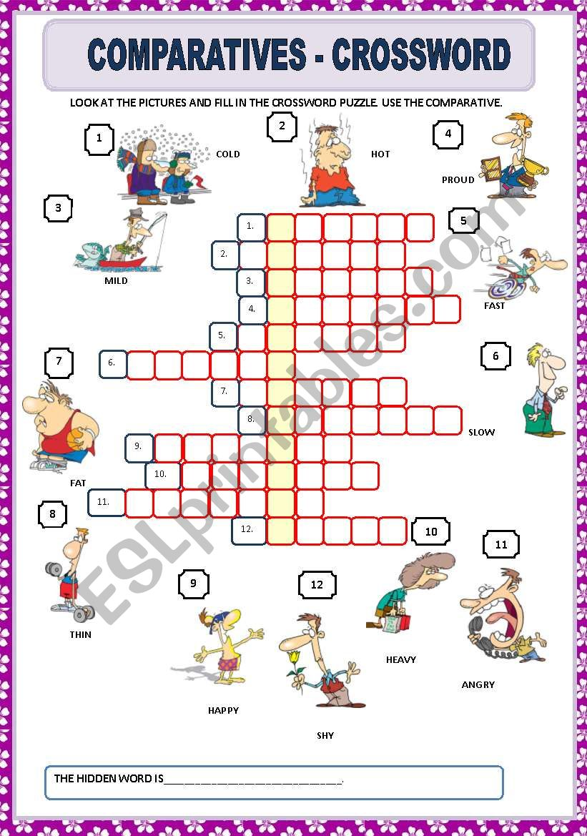

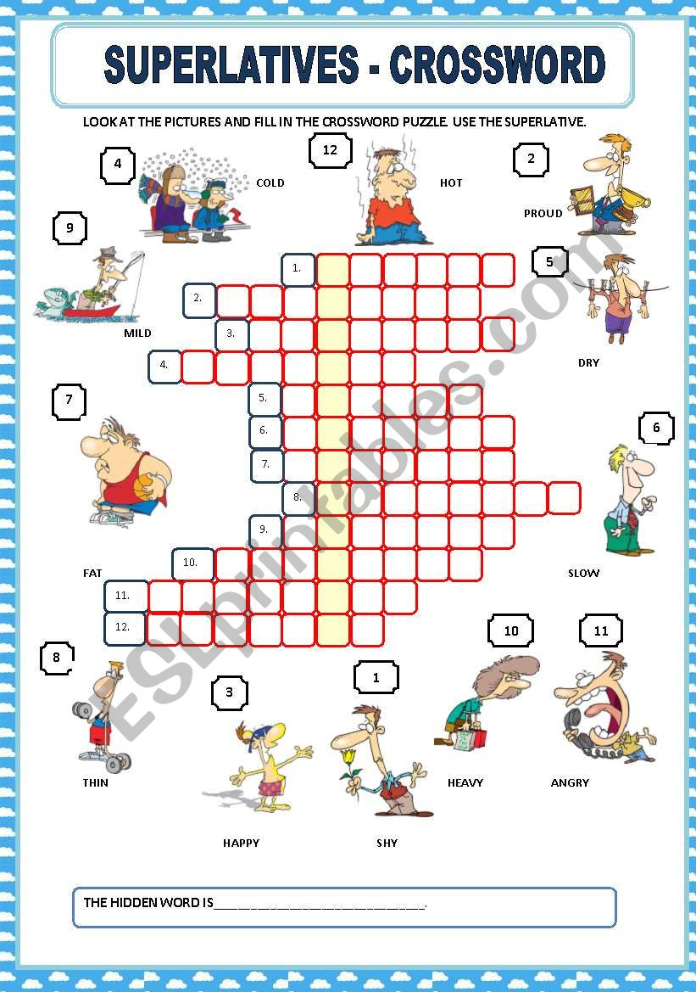

( UNIT 6 )
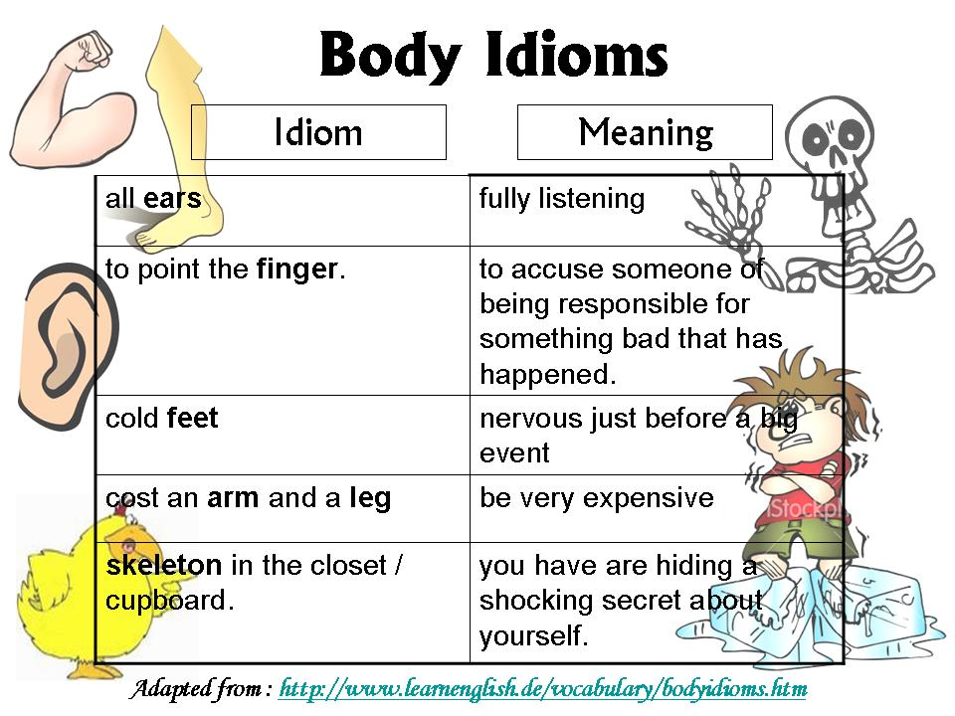

- Put my back into it :- tried extremely hard . يبذل جهده
- Have a head for figures :- to have a natural mental ability for maths / numbersلديه قدرة عقلية للرياضيات .
- Keep chin up :- to remain cheerful in difficult situations ; an expression of encouragement.
يحافظ على رباطة جأشه / يبقى مبتهجاً في المواقف الصعبة
- Play it by ear :- to decide how to deal with a situation as it develops. S2017 يقرر كيف يتعامل مع موقف أثناء حدوثه
- Get it off your chest :- to tell someone about something that has been worrying you. يريح الشخص نفسه بإخبار شخص آخر عما يزعجه يفضفض
- Get cold feet :- to lose your confidence in something at the last minute .يجبن / يفقد ثقته بنفسه S2016
*Study the following sentences and answer the question that follows . Write the answer down in your ANSWER BOOKLET.
I'm not sure if it will be warm enough to have a barbecue. We will have to keep our chin up.
Replace the underlined body idiom with the correct one.
*Study the following sentences and answer the question that follows . Write the answer down in your ANSWER BOOKLET.
1-I don't think I'd be a very good accountant . I don't really get cold feet .

Replace the underlined body idiom with the correct one. W2019

2-Replace the following underlined phrase with the correct body idiom.
I can't tell you what to expect . Don't worry. I'll keep my chin up .
The correct expression is " play it by ear ".
3-The sentence that has been written correctly is: S2020
A)Keep up your chin everything I'm sure will be fine in the end.
B)Keep your chin up ; I'm sure your chin will be fine in the end.
C)Keep your chin up! I'm sure everything will be fine in the end.
D)Keep your everything up: I'm sure chin will be fine in the end!

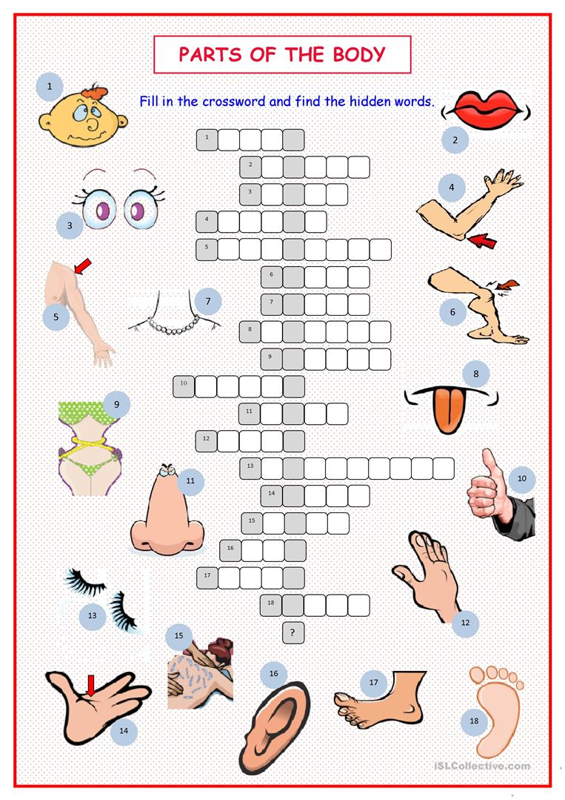

Indirect questions ( UNIT 7 )
We can use indirect questions to ask questions in a polite , formal way. (language function)
*نستطيع أن نستعمل الأسئلة غير المباشرة لكي نسأل أسئلة بطريقة مهذبة و رسمية.
*الأسئلة على الطريقة المصرية ( ممكن أسال سعادة سيادة حضرتك سؤال يا هانم / يا بيه ؟ ) Egyptian style
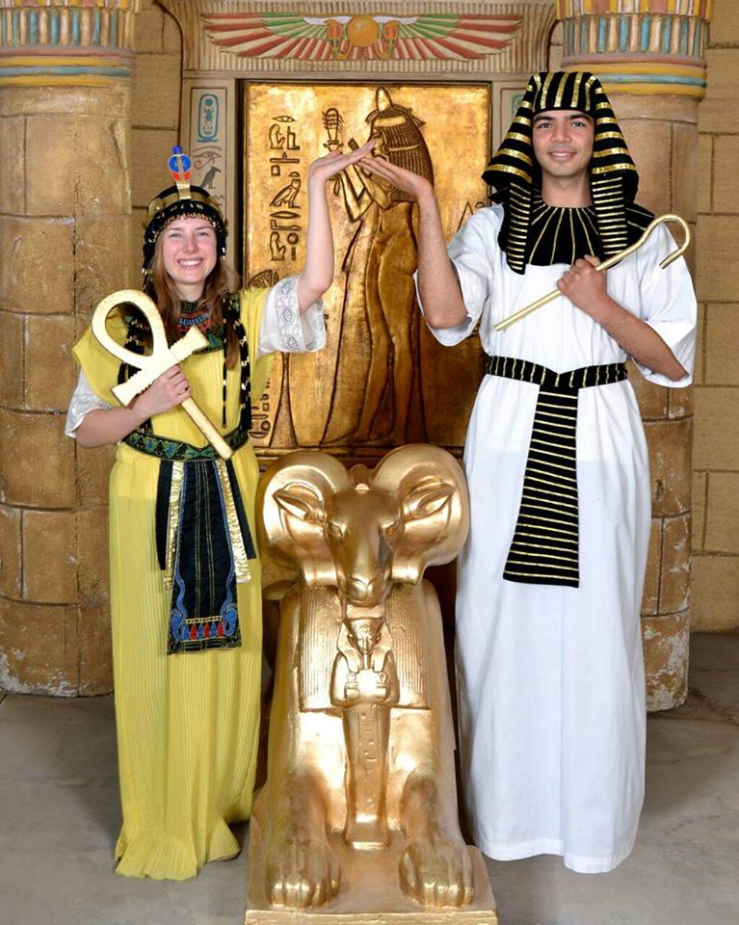
When we ask for information we can begin indirect questions with expressions like :-
*عندما نسأل عن المعلومات نستطيع أن نبدأ الأسئلة غير المباشرة بعبارات افتتاحية مهذبة مثل:-
 | Could you tell me…? | هل تستطيع إخباري ؟
 | Could you explain…? | هل تستطيع أن توضح ؟
 | Do you mind telling me…? | هل تمانع لو أخبرتني ؟
 | Do you know …? | هل تعرف ؟
 | Would you happen to know…? X | هل لديك أي فكرة ؟
 | I wonder …. . | أنا أتسائل ... .

*البناء اللغوي و ترتيب الكلمات بعد العبارة الافتتاحية المهذبة للسؤال يكون بنفس ترتيب الكلمات في الأسئلة المنقولة ( فاعل ثم فعل ).
Unlike reported questions, the sentence ends with a question mark.
*بعكس الأسئلة المنقولة هذا النوع من الأسئلة ينتهي بعلامة سؤال و ليس بنقطة كما هو الحال في الأسئلة المنقولة إلا مع آخر عبارة التي تبدأ بفاعل ثم فعل ومن نغمة الصوت نستدل على أنها سؤال غير مباشر .
  - Yes / No questions are introduced with if or whether .
عند الحل : أسئلة النعم واللا يجب أن نبدأها بكلمة ( ) / ( )
ملاحظة :- يجب استعمال كلمة ( ) في الأسئلة التي تحتوي على كلمة ( )
e.g. Is there a postbox near here ? (simple question ) واحد دفش

Do you know if / whether there is a postbox near here , please?

مصري نغش
* خطوات حل أسئلة النعم واللا :-
( if )أو ( whether1- وضع (
2- تقديم الفاعل على الفعل بحركة ال ( قلب ) إلا في حالة السؤال عن الفاعل لا استعمل القلب
( كفعل مساعد ) إلا في حالة وجود النفيdo /does /did3- دمج الفعل مع
في نهاية السؤال زيادة في التهذيب , please ? وضع كلمة 4-
5- اختم بعلامة سؤال مش بنقطة ما عدا مع اخر حالة
6- في هذا النوع من الاسئلة المنقولة ما بغير زمن الفعل ولا الضمائر ولا الظروف ديروا بالكم ما تتخربطوا مع الاسئلة المنقولة العادية !!!!!!
  - Wh-questions are introduced with (what , who , why , when , which , where , how ,…etc.)
*ملاحظة :- انتبه لأداة السؤال الطويلة لان الأسئلة التي تبدأ بأدوات السؤال التالية تأخذ دائما الاسم الذي يتبعها قبل بداية الحل ومن الممكن وجود أكثر من اسم بعدها ومن الممكن أيضا أن تتبع أدوات السؤال بصفات أو ظروف وتكون جزء منها .
) How much + n. , How many + n. , How + adj. , How + adv. , What + (n.) + (n.) ,Which +( n.)+(n.)
*ملاحظة :- أيضا الفاعل ممكن أن يكون طويل وذلك بان يكون مسبوق بصفات ومحددات أو أن يكون له ملحقات مثل أحرف الجر بعده متبوعة بعبارة اسمية أو أدوات ربط مثل ( ) أو إحدى أخواتها متبوعة بشبه جملة .
Where does the man with glasses live ?
Where does the man who bought my car live ?
e.g. Where has Maher gone ? (simple / direct question)

- Do you know where Maher has gone ?

( do / does / did* انتبه للأسئلة التي تحتوي على الأفعال المساعدة (

- What time does the film begin?

Do you know what time the film begins ?

- Does the exam start at ten or half past ten?
Do you know whether the exam starts at ten or …..?

- How much sleep do teenagers of our age need?

Could you tell me how much sleep teenagers of our age need , please?

- What do you mean by 'mnemonics' ?فن الاستذكار
Could you explain what you mean by 'mnemonics', please?
5-Why doesn't Mariam help her mum ?
Do you mind telling me why Mariam doesn't help her mum ?

* خطوات حل Wh-questions
1-أضع أداة السؤال وتوابعها مباشرة بعد العبارات الافتتاحية المهذبة
ويجب ملاحظة أن أداة السؤال تنتهي قبل بداية الفعل
2-أقدم الفاعل على الفعل واستدل عليه بأنه يأتي بعد الفعل المساعد مباشرة
3-في حالة وجود do / does / did كفعل مساعد ادمجهم مع الفعل إلا إذا كانت منفية استعمل القلب بدون دمج
4-أضع بقية كلمات الجملة
5-أضع كلمة , please ?) ) في النهاية زيادة في التهذيب
6-انهي بعلامة سؤال (؟) إلا مع آخر حالة
* ( إضافية ) :- هنالك حالة واحدة فقط لا اجري فيها عملية القلب وذلك عند السؤال عن الفاعل سواء كان عاقل أو غير عاقل
Who broke the vase ?
Do you know who broke the vase ?
Who was singing at the party ?
Do you mind telling me who was singing at the party ?
*جمل الأمر والطلب المهذب يمكن تقديمها أيضا بطريقة أكثر تهذيباً وذلك
باستعمال هذا التركيب اللغوي قبلها فقطDo you mind + v.ing…? وتأتي على عدة أشكال :-
1- Open the door.
2- Please , open the door .
3- Will you open the door , please ?
4- Can you open the door , please ?
Do you mind opening ………………………………………..……?
  - Suggest a healthy breakfast.
Do you mind suggesting a healthy breakfast , please ?
*هل لاحظت بان الأسئلة التي لا تحتوي على ( ) في جملتها الافتتاحية تكون متبوعة بمفعول به فقط .
Please , tell me where you found that information.
Do you mind telling me where you found that information, please?
- لاحظ بأننا ختمنا جملة الأمر بنقطة لكن الجملة التي تبدأ بــ
Do you mind + v.ing…..? انتهت بعلامة سؤال .

- لاحظ بأن زمن الجملة لا يتغير و كذلك الضمائر و ظروف الزمان والمكان تبقى كما هي .
- لاحظ الاختلاف في طريقة الحل إذا بدأنا السؤال غير المباشر بجملة ابتدائية وليس بصيغة سؤال.

- Why did Ann leave early ? (normal question)

I wonder why Ann left early .
*انتبه لعلامة الترقيم كيف تغيرت
+ SBP.51 ex.5, ABP.35 ex.4, ABP.36 ex.5, ex.6
ترجيع من سؤال غير مباشر إلى سؤال مباشر(احتياط)
*في حالة وجود فعل مساعد استعمله لتكوين السؤال حسب القواعد المعروفة أما في حالة عدم وجود فعل مساعد استخرجه من الفعل الرئيسي وذلك بفك الفعل
1-Could you tell me where I can find the post office ?
Where……………………………………………………………….
2-Do you mind typing this research ?
Will you……………………………………………………………..
3-Do you know if Samia goes to school on foot ?
Does…………………………………………………………………
4-Could you tell me whether he wrote a letter or an essay ?
Did…………………………………………………………………..
5-Could you explain if your father has travelled recently ?
Has…………………………………………………………………..

SBP.51 ex.4

أسئلة وزارة*
من السهل جدا التعرف على سؤال هذه القاعدة في الوزارة بدلالتين الأولى أن الجملة الأصلية تكون سؤال أو جملة أمر والثانية أن الجملة الجديدة تبدأ بإحدى العبارات المهذبة الخمسة التي تعرفنا عليها سابقا.
1- How can I get to Queen Alia Airport by public transport ? W2016
Could you tell me…………………………………………………...
2- Is there a connection between the amount of TV people watch and how fit they are ? S2016
Do you know………………………………………………………
3-Are students allowed to navigate the internet during the open exam ? W2017
Do you know ……………………………………………………?
4-How did people travel in the past ? 2016/2017 تجريبي وزاري
Could you tell me …………………………………………………..
5-'What can't we bring onto the plane?' W2018
Could you tell me …………………………………………………..
6-How can I fix this smartphone ? S2018
Could you tell me …………………………………………………..
7-How much sleep do teenagers of our age need ? W2019
Could you tell me …………………………………………………..
8-How much does the cotton shirt cost ? S2019
Could you tell me…………………………………………………...
9-What should I do the day before the exam? S2020
The correct indirect question of the one above is?
A)Could you explain I should what do on the day before the exam?
B)Could you explain what I should do on the day before the exam?
C)Could you explain should I do what on the day before the exam?
D)Could you explain I what should do on the day before the exam?
10-Do you know………………………………………….? S2020
A)where are your classmates B)where your classmates are
C)where classmates are your D)where classmates your are

( UNIT 7 )
المبني للمجهول غير الشخصي The impersonal passive

الوظيفة اللغوية Language function :-
The impersonal passive is a formal way of reporting thoughts , sayings , beliefs and opinions .
- المبني للمجهول غير الشخصي هو طريقة رسمية لنقل الأفكار والأقوال والاعتقادات و الآراء .
    - We can use the impersonal passive with say , think , claim , know , prove , assume, estimate and believe .

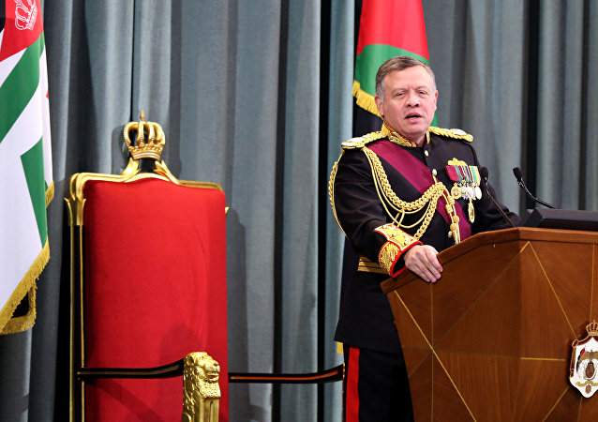

*نستعمل المبني للمجهول غير الشخصي (الباسف في الجمل الابتدائية) مع أفعال معينة دالة تسمى أفعال الاعتقاد (verbs of perception)
say , think , claim , know , prove , assume ,estimate and believe .
من الضروري معرفة التصريف الثالث لهذه الأفعال
said , thought , claimed , known , proved , assumed, estimated , believed
*Some verbs are intransitive which means that they don't have objects ,so they can't be used to form personal passive . If we want to use these verbs in passive voice we use the impersonal passive .

*1- الشكل الأول للباسف في الجمل الابتدائية يكون على النحو التالي :-
- It + passive verb + that + the rest of the sentence.

be v.3
* الأزمنة التي تم التركيز عليها في الكتاب هي المضارع البسيط والماضي البسيط والمضارع التام وفعل المودلز
1- It + is / was / has been / (modals +be) + v3 + that + the rest of the sentence .
S.1 V.1 S.2
1-Scientists say that [ dolphins are highly intelligent ].
It is said that dolphins are highly intelligent.

- The impersonal passive can also be formed with the object + to + infinitive.
*2- الشكل الثاني للباسف في الجمل الابتدائية تبدأ جملته بالفاعل الثاني الموجود في الجملة الأصلية ثم أحول فعل الاعتقاد الموجود في الجملة الابتدائية إلى باسف مع الانتباه إلى زمن الفعل عند التحويل ثم وضع( ) ثم الفعل المجرد ثم أكمل الجملة.
2- Subject 2 + is/are , was/were , has been/have been , modals + be + v3 + to + infinitive
1-Scientists say that [ dolphins are highly intelligent ].
Dolphins are said to be highly intelligent.

*قواعد مهمة لتحويل الفعل عندما نحل على الطريقة الثانية :-
        - V.1…….to + inf.
        - am /is/ are ……..to + be
        - have/has/had +V.3…….to + have +V.3
        - don't/doesn't +inf. ……..not + to +inf.
…………………………………………
        - was / were ……..to +have +been
        - V.2 ……….to + have + V.3
        - didn't + inf. ……….not +to +have +V.3

نطوا جنوا نطوا جنوا نطوا نطوا*
Rewrite the following sentences in two ways.

S.1 M.1 S.2 X
  - Scientists ( used to think) that the Earth was flat.

  - It used to be thought that the Earth was flat.

  - The Earth used to be thought to have been flat.
S.I V.1 S.2 X
  - Grammarians believe that learners will absorb the grammar as they learn the vocabulary.
- It is believed that learners will absorb the grammar as they learn the vocabulary.
- Learners are believed to absorb the grammar as ……… .
S.1 V1. S.2 V.1
  - People know he is talented. (without that)
- It is known that he is talented.
- He is known to be talented.
S.1 V2. S.2 V.2
  - They believed that the story was true.
- It was believed that the story was true.
- The story was believed to have been true.
S.1 V1. S.2
  - People think that learning new languages also presents the brain with unique challenges.
- It is thought that learning new languages also presents the brain with unique challenges.
- learning new languages is also thought to present the brain with unique challenges.
*إذا شكيت وما عرفت انه الفاعل في جملة الحل رح يحتاج لفعل مفرد أو فعل جمع , من المفيد انك ترجع إلى الجملة الأصلية وتشوف كيف تعامل فيها الفاعل .
S.1 V1. S.2
  - They say that students who study foreign languages do better , on the whole , in general tests.
- It is said that students who study foreign languages do better , on the whole , in general tests.
- Students who study foreign languages are said to do better , on the whole , in general tests.
8. They said that the thief had killed the old man before the arrival of the police.
a. It was said that the thief had killed the old man before the arrival of the police.
b. The thief was said to have killed the old man before the arrival of the police.
9.People believe that students don't prefer studying for long hours .
a. It is believed that students don't prefer studying for long hours .
b. Students are believed not to prefer studying for long hours .
10.Scienists believed that cave people didn't live long.
a. It was believed that cave people didn't live long.
b. Cave people were believed not to have lived long.

* أسئلة إعادة الكتابة ممكن أن تأتي أيضا من الشكل الأول للمبني للمجهول غير الشخصي إلى الشكل الثاني أو بالعكس .
a. It was believed that Thomas Edison and his friends invented the light bulb.
b. Thomas Edison and his friends were believed to have invented the light bulb.
a. Marah and her sister are said to have passed their exams.
b. It is said that Marah and her sister have passed their exams.

Rewrite using an active form which is less formal. SBP.53 ex.4
  - Speaking a foreign language , it is claimed , improves the functionality of your brain in several different ways.
بعد ترتيب الجملة حسب النموذج المألوف تصبح الجملة
It is claimed that speaking a foreign language improves the functionality of your brain.
V.1 الفاعل مُعطى
People claim that speaking a foreign language ….
2.It is believed that language learning can also improve your decision-making skills .

V1 الفاعل مُعطى
They believe that language learning can also …
*بعرف انه مطلوب مني إني ارجع جملة الباسف غير الشخصي إلى جملة مبني للمعلوم لما أشوف الفاعل الموجود في جملة الحل مش موجود في الجملة الأصلية أما إذا كان الفاعل الثاني موجود في بداية جملة الحل عندها بكون مطلوب إني أحول من الشكل الأول للشكل الثاني للإمبيرسونال .
+ ABP. 36 ex.7
*أسئلة وزارة
استطيع التعرف على المبني للمجهول غير الشخصي بسهولة في امتحان الوزارة إذ تحتوي الجملة الأصلية على فعل من أفعال الاعتقاد الدالة التي سبق ذكرها على الأغلب متبوعا بكلمة ( ) وتكون الجملة الجديدة مبدوءة بأحد أشكال الإمبيرسونال باسف .
1- People believe that eating almonds reduces the risk of heart disease.W2016
Eating almonds………………………………………………………...
2-Doing regular exercise is believed to reduce the risk of several disease. S2016
People believe that…………………………………………………….
3-They assumed that the last Olympic Games were a great success .W2017
It ……………………………………………………………………….
4-People claim that children are not afraid of cats. 2016 / 2017 وزاري تجريبي
Children ……………………………………………………………….
5-My English teacher says that English clubs are essential for learning English . W2018
English clubs …………………………………………………………..
6-Linguists have proved that learning some languages is helpful for the learners . S2018
Learning some languages ……………………………………………
7-Teachers believe that working in groups improves students' awareness . W2019
Working in groups …………………………………………………….
8-People believe that the heavy rainfall caused the devastating of the dam . S2019
The heavy rainfall …………………………………………………
9-People think that solving mathematical puzzles keeps the brain active. S2020
The sentence that has a similar meaning to the one above is:
A)Solving mathematical puzzles is thought keep the brain active.
B)Solving mathematical puzzles is thought keeps the brain active.
C)Solving mathematical puzzles is thought to keep the brain active.
D)Solving mathematical puzzles is thought to keeps the brain active.
10-People believe that exercise makes a huge difference to the way we feel. S2020
The sentence which has a similar meaning to the one above is:
A)It is believed that exercise to make a huge difference to the way we feel.
B)It is believed that exercise make a huge difference to the way we feel.
C)It is believed that exercise have made a huge difference to the way we feel.
D)It is believed that exercise makes a huge difference to the way we feel.

Wishes and regrets ( UNIT 9 )
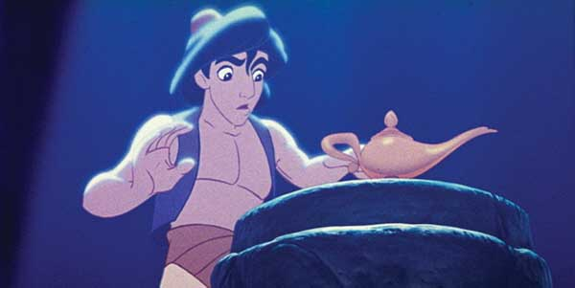
*يمكن استعمال الماضي البسيطdidn't + inf. / weren't) / ( v.2 , were ) ) أو الماضي التام hadn't + v.3 / had + v.3 ) ) للحديث عن الأمنيات بعد عبارات
معينة مثل If only …. I wish …
القاعدة العامة :- ممنوع منعا باتا استعمال فعل مضارع مع الأمنيات .

*من الضروري جدا تحديد زمن الأمنية قبل بداية الحل .
*أمنيات الحاضر فعلها ماضي بسيط وأمنيات الماضي فعلها ماضي تام .
*عند تحويل الجملة الأصلية إلى جملة أمنيات اعكس ما بين الإثبات والنفي إلا في بعض الحالات .
One step back in time (back shifting)

- I wish + past simple for present wishes
- I wish + past perfect for past regrets

language function:-
  - To express wishes about the present that are impossible or very unlikely to happen.
  - To express regret about the past.

- Present wishes:-

*يوجد لدينا ثلاث تراكيب لغوية محتملة للتعبير عن الأمنيات في الحاضر ( دائماً الأمنيات تكون عكس الأوضاع الحالية. )
1- I wish + subject + v.2 present wishes

تستعمل للتعبير عن الأمنيات في الحاضر و للتعبير عن الأحلام المستحيلة

1-negative fact positive regret
2-positive fact negative regret
x x x
e.g. I regret that (we don’t have a lot of money.)
I wish we had a lot of money. ( أعكس بين الإثبات و النفي )
(+) x
e.g. (I am too old) to wear make up .
(-)
I wish I wasn't /weren't so old.
(+)
I wish I was / were younger. أو أعكس الصفة و أضعها في صيغة المقارنة

*تذكر دائما بان الأمنيات تفضل صيغ المقارنة إلا إذا سبق الصفة ظرف كما إنها تفضل صيغ الجمع
2- I wish + subject + could + inf.
تستعمل عند تمني قدرة (مادية أو جسدية أو عقلية) في الحاضر
e.g. (I can't drive a car) and I regret that .
I wish I could drive a car.
* وجود هذه الأفعال في الجملة want , would like , would love , can't
يدل على استعمال ( )
3- I wish + subject + would + inf.
هذا التركيب يستعمل عندما أعبر عن انزعاج من وضع في الحاضر وتمني زواله في المستقبل ( annoyance = different subjects)
x x x x
e.g. (Haytham smokes a lot) and I hate that.
I wish Haytham would stop smoking.
وجود كلمة stop يمنع تحويل الجملة للنفي .
*We can also use (would) for wishes about the future which might come true .
I wish it would snow at Christmas.
- Present wishes ( negative)
مع الأفعال العادية 1- didn't + inf.
مع فعل 2- wasn't / weren't be
e.g. (I love sweets) and I regret that.
I wish I didn't love sweets.

e.g. (I am sick) and I regret that.
I wish I wasn't / weren't sick.
- هنالك كلمات معينة تدل على الانزعاج وعند التحويل استعمل معها على الأغلب القاعدة الثالثة (قاعدة would) إلا إذا كان الفعل الرئيسي be ) ) أو ( have).
annoy , upset , disappointed , unhappy , noise , smoke , loud music don't love , hate , don't like , dislike …etc.
- ملاحظات :-1- يفضل مع جمل الـ wish وضع were بدل was
wasn't weren't
- لا يجوز أبداً وضع should في نفس جملة الـ wish
- ممنوع في جمل الـ wish استخدم
would have been أو would have أو would be
could have been أو could have أو could be
- الجمل التي تحتوي على [ really , quite , very , too ]
تحوّل إلى so في جملة الـ wish بشرط عدم تحويل الصفة التي تليها للمقارنة و تحذف الظروف عند تحويل الصفة للمقارنة .
- عادةً عندما أحوّل إلى جمل الـ wish أعكس ما بين الإثبات والنفي إلاّ في حالة وجود would like to , would love to / want to والتي تحل على القاعدة الثانية قاعدة could)) (+)
e.g. (I want to buy this car) , but it is very expensive.
(+)
I wish I could buy this car , but it is so expensive.
- هنالك حالات لا أعكس فيها ما بين الإثبات والنفي ولكن أعكس معنى بعض الكلمات.
e.g. (I am not tall) and I'm unhappy about it.
(I am short) and I'm unhappy about it.
I wish I was / were taller.
Rules:-
- is / am wasn't/weren't
- are weren't
- v.1 didn't + inf.
- *have to / has to + inf. didn't have to + inf.
- am not / is not was/were
- don't / doesn't + inf. v.2 OR never v.1 v.2
- was/were hadn't been
- v.2 hadn't+v.3
- wasn't /weren't had been
- didn't + inf. had + v.3
- Adj. + enough comparative
- Should + verb0 v.2
- regret + v.ing , noun hadn't + v.3
- regret + not + v.ing had + v.3
e.g. (I have to clean all these dishes) which is very tiring.
I wish I didn't have to clean all these dishes.
*Note that sometimes the regret is for something in the past which is related to a present result.
e.g. I am hungry. I wish I had eaten.
I am very sleepy now . I wish I hadn't slept late last night .
If only …………………………………………………………… ملاحظة :- (If only = slightly more formal) لها نفس معنى I wish واستعمالاتها وممكن أن تحل محلها ،
ببساطة امسح I wish وضع If only مكانها .

- Past wishes:-
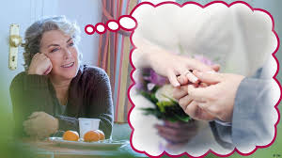
- e.g. I regret that (I didn't listen to your advice) . أعكس الإثبات والنفي
I wish I had listened to your advice.
e.g. (I drove fast) and I regret it now.
I wish I hadn't driven fast.
I wish I had driven (more) slowly.
- من الممكن أن لا أعكس ما بين الإثبات والنفي إذا عكست بعض الكلمات .
- regret + didn't + inf. wish + had + v.3
- regret + v.2 wish + hadn't + v.3
- regret + v.ing wish + had (not) + v.3
- regret + not +v.ing wish + had + v.3
I regret (not sleeping earlier). I wish I had slept earlier.
- ملاحظة (1) ( الجمل الشرطية النوع الثاني تتحدث عن أحلام و أمنيات الحاضر )
بينما ( الجمل الشرطية النوع الثالث تتحدث عن أمنيات الماضي ) .
- نستنج من الملاحظة السابقة بأنه يمكن تحويل الجمل الشرطية النوع الثاني إلى أمنيات الحاضر كما انه يمكن تحويل الجمل الشرطية النوع الثالث إلى أمنيات الماضي .
x x x
e.g. If I had a million dinar , I would buy a villa. (present wish)
If only I had a million dinar to buy a villa. (present wish)
x x x x
If I had won the lottery , I would have helped the poor. (past wish)
I wish I had won the lottery to help the poor. (past wish)
تحول لأمنيات الحاضر should +infinitive ملاحظة (2)
The police should arrest the criminal. He is dangerous.
I wish…………………………………………………….
should (not)+ have + v.3 ملاحظة (3 ) تستعمل للأمنيات وللندم عن الماضي
e.g. I should have worked harder. (past wish /regret)
I wish…………………………. . (past wish /regret)
I shouldn't have left school. (لا أعكس الإثبات والنفي)
I wish I hadn't left school.
*ببساطه احذف كلمة ( ) وأحول الفعل اللي بعدها لتصريف ثاني مع الاحتفاظ بالنفي إذا كان موجود .
ملاحظة ( 4) :- هنالك بعض الكلمات في الجملة تدل على ندم على شيء فعلته / لم
أفعله في الماضي مثل :-
it's a pity , it's a shame , sorry for , regret (that was a mistake , that's a pity).
هذه الكلمات يجب أن تحذف عند التحويل
e.g. (Ali didn't take medicine) which was a mistake.
Ali wishes he had taken medicine.
I didn't have many apples to make an apple pie yesterday.
I wish I had enough apples to make an apple pie yesterday.
I didn't have much sugar to make strawberry jam last week.
I wish I had enough sugar to make strawberry jam last week.
هل لاحظت بأننا حولنا كلمة ( ) وكلمة ( ) إلى ( ).
*كيفية التعرف على هذه القاعدة في الامتحان تكون الجملة الأصلية تعبر عن أسف أو حزن أو ندم على شيء في الحاضر أو في الماضي وغالبا ما تحتوي الجملة على سبب ونتيجة ويكون الندم على السبب لان النتيجة غير مرضيه وتكون الجملة الثانية المطلوب تحويلها تبدأ ب I wish / If only
*ولكن عليك أن تكون حذرا إذا بدأت الجملة الثانية ب If فهذه أمنيات وليست جملة شرطية يجب عليك أن تضع كلمة only وتكمل الحل حسب القواعد المعروفة .
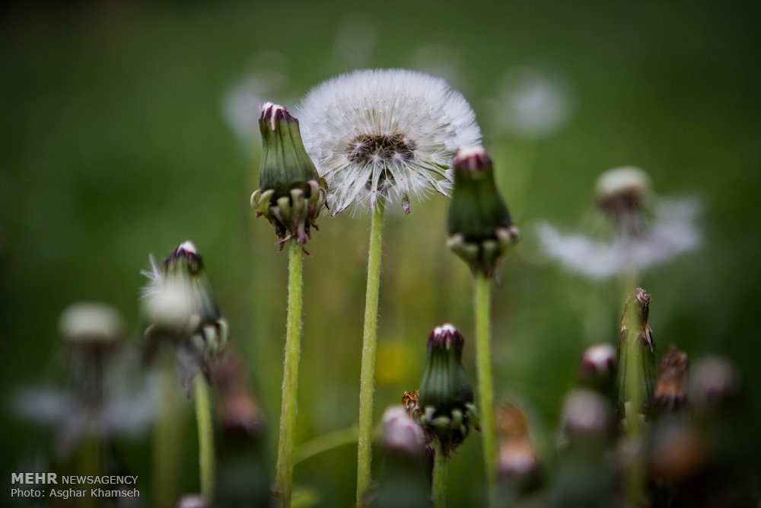

أسئلة وزارة
*Complete each of the following items so that the new item has a similar meaning to the one before it , and write it down in your ANSWER BOOKLET .
1-Jamal didn't prepare well for the exam . He didn't get a good mark . AS2019
If only ……………………………………………………………..
2-I am sorry that I didn't do my homework. VS2019
I wish………………………………………………………………
Choose the suitable item .
1- I'm sorry I made you angry last night . I wish I ………….at you.
( hadn't shouted , hasn't shouted , am not shouting , don't shout)
2-I wish I ………my pencil case ; I had to borrow pens all day.
( hadn't forgotten , hasn't forgotten , have forgotten )
3-Maha regrets being angry at breakfast time. S2020
The sentence which has a similar meaning to the one above is:
A)If only Maha had been angry at breakfast time.
B)If only Maha hasn't been angry at breakfast time.
C)If only Maha has been angry at breakfast time.
D)If only Maha hadn't been angry at breakfast time.
4-I ate too much and now I have stomachache. I wish… S2020
A)I hadn't eaten so much. B)I had eaten so much.
C)I has eaten so much. D)I have eaten so much.

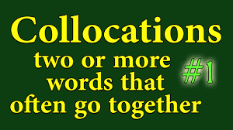
( UNIT 7 )

  - Draw up a timetable: write a schedule يعمل جدول
  - Do exercise: keep fit يتمرن
  - Make a start: begin يبدأ
  - Take a break: relax يرتاح
  - Do a subject: study يدرس
  - Make a difference: change something يحدث فرق S2019

( UNIT 9 )

- make small talk تُجري حوار صغير
- cause offence يسبب الأذى
- make a mistake يرتكب غلطة
- earn respect يحظى بالاحترام
- shake hands يصافح
- ask questions يسأل أسئلة
- join a company يلتحق للعمل بشركة

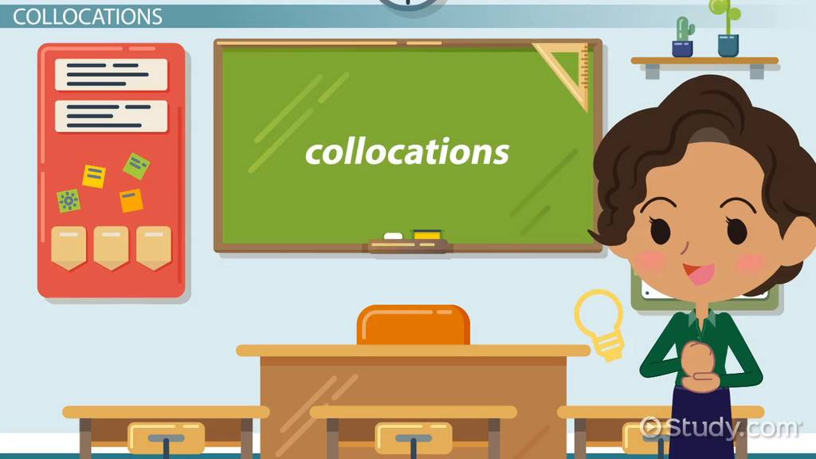
( UNIT 10 )
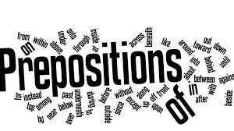
- work as + job يعمل كذا ( اسم مهنة )
- decide on يتفق على
- translate (sth.) into يترجم إلى
- talk about يتحدث عن
- ask (sb.) about يسأل عن
- good at + n. / v.ing ماهر بـِ

Conditionals ( UNIT 10 )
Zero conditional is used to describe something that always happens after a certain action or event.
- استعمل الجمل الشرطية النوع (zero) للحديث عن الحقائق (facts) وهي لا تعتبر شرط حقيقي و يمكن تبديل if بwhen
If the sun rises , the snow melts.
If = When
نتيجة مؤكدة (وليست محتملة) حالة / سبب
If plants don't get enough sun light , they die.
مضارع بسيط (مثبت) مضارع بسيط (منفي) = When

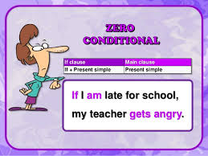

First conditional is used to describe a possible future outcome
of a certain future action or event.
- الجمل الشرطية النوع الأوّل تدل على أن الفعل ممكن الحدوث في المستقبل .
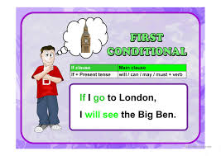
v.1 m.1 inf.
If you study hard , you will pass the exams .
- نفي المضارع البسيط يكون باستعمال don't , doesn't + inf.
If you don't study hard , you will fail .
If he doesn't study hard , he will fail .
مستقبل بسيط مضارع بسيط (منفي)
شبه جملة رئيسية شبه جملة شرطية
reason / condition possible result
النتيجة المحتملة الحالة / السبب
- الجمل الشرطية النوع الأوّل ممكن أن تستخدم لتقديم النصائح و عندها يجب أن تكون شبه الجملة الرئيسية مبدوءة بفعل أمر أو تكون شبه الجملة الرئيسية مبدوءة بـ you should

v.1 inf.
If you want to get high marks , study harder .
فعل أمر/ اقرب للمستقبل مضارع بسيط
v.1 inf.
If you want to get high marks , you should study harder .
ماضي غير حقيقي
Second conditional is used to talk about dreams , wishes or imaginary situations about the present (imaginary present) . It can also be used for giving advice or impossible conditions .
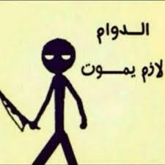
- في الجمل الشرطية النوع الثاني أنا لا أتكلم عن الماضي و لكنني أتكلم عن وضع معاكس للحاضر .
- يمكن استعمال الجمل الشرطية النوع الثاني للحديث عن الأحلام و الأماني و الخيالات في الحاضر .
v.2(+) m.2 (+)
If I had a million dinar , I would buy a villa . (عكس الحاضر)
( - ) (-)
I don't have a million dinar , so I will not buy a villa .
(-) (-)
Because I don't have a million dinar , I will not buy a villa .
(عكس الحاضر) (-) m.2
If I didn't love my house , I would buy a villa .
v.1 (+) ماضي ماضي منفي
I love my house , so I will not buy a villa .
v.1
Because I love my house , I will not buy a villa .

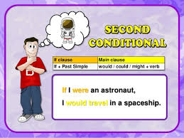
(حالة متخيلة عن الحاضر ونتيجة متخيلة عن الحاضر أيضا) .
- استعمل الجمل الشرطية النوع الثاني لتقديم النصائح .
I think that you should buy a new car .
If I were you , I would buy a new car .

- في الجمل الشرطية النوع الثاني إذا جاءت be على جهة الإف أضع were بغض النظر عن الفاعل .
- دائما الأمنيات تفضل صيغ الجمع .

If it was / were sunny , we would go for a picnic .

Rewrite :- Type (2) (عكس الحاضر )
v.2 m.2 (+)
If I studied hard , I would pass the exams .
Because I don't study hard , I will not pass the exams .
I don't study hard , so I will not pass the exams .
Third conditional is used to imagine past situations .
These past situations are impossible , and did not happen .
(عكس الماضي) (+) (+)
If you had studied hard , you would have passed the exams .
(-) (-)
Because you didn't study hard , you didn’t pass .( أبو خمس أفعال )
(-) (-)
You didn't study hard , so you didn’t pass .

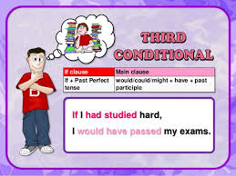

حالة متخيلة عن الماضي ونتيجة متخيلة عن الماضي أيضاً

*استعمل الجمل الشرطية النوع الثالث للحديث عن :-
- Late advice النصائح المتأخرة
- Criticizing / Criticism النقد
- Blame اللوم
- improbability عدم الاحتمال
- Regret الندم
- Relief ارتياح
- If I had saved money , I would have bought a car .
(-) (-)
If I hadn't studied , I wouldn't have passed . (مع النفي )
v.2(+) v.2 (+)
Because I studied , I passed .
I studied , so I passed.
Conditional markers
*أدوات الشرط = ( even if, unless, provided that, as long as, when )
as if …… ماضي بسيط
بحلو محل بعض بدون أي provided that
تغيير أو تبديل على الجملة if = as long as

If
Unless = except if = not v.
never v.
negative no n.
prefix adj.
[ un- im- ir- dis-

even if استعمالها مختلف عنهم جميعهم حتى ولو =
I'll buy it even if it's expensive.
I will buy it. The price isn't important.
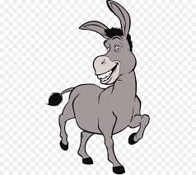
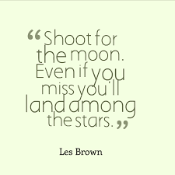

The third conditional with could and might

If + subject + had + v.3 , subject + could have + v.3
might
To talk about the imaginary past when we are less sure of the result of the impossible past situation.
If I had prepared better for the competition , I might have won the first prize . (not sure)
حالة متخيلة عن الماضي ونتيجة متخيلة عن الماضي أيضاً
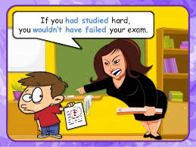
- If I had slept better the night before the exam , I would have concentrated .
- If I had slept better the night before the exam , I could have concentrated .
- Which sentence indicates that the speaker is less sure of the result of the impossible past situation ? B
- When the phone rings , I will answer it .
- If the phone rings , I will answer it .
- Which sentence indicates that I am expecting a phone call and I am sure about that ? A
- Which sentence indicates that I am unsure that the phone will ring ? B

Unless لم ما Expressing warning
- تحذر من خطر محتمل أو من نتائج سيئة .
- لا يمكن أبداً أن تكون جملتها منفية و جملتها دائماً تكون مثبتة .
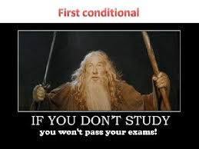
................................................................................................................
( اضافي )
  - If you don't help him , he will not pass .

Unless you help him , he will not pass .
If not does take
  - Unless she takes a taxi , she will be late .
If she doesn't take a taxi , she will be late .
If she takes a taxi , she will not be late .

+
  - If you attend the lectures irregularly, you will be dismissed.
Unless you attend the lectures regularly, you will be dismissed.
can not do not

  - We can't leave if we don't complete the test.

Unless we complete the test , we can't leave .
If we complete the test , we can leave .
- إذا طلب مني إعادة الكتابة من If إلى If أتلاعب بالنفي والإثبات ، المثبت يصبح منفي والمنفي يصبح مثبت .
+
  - I will buy that book if it isn't expensive .

Unless that book is expensive , I will buy it .

+ not + not
  - You will pass the exam if you study more.
Unless you study more , you won't pass the exam .
Unless you study more , you will fail the exam .

  - If nobody helps me , I will not finish early .
Unless somebody helps me , I will not finish early .
If somebody helps me , I will finish early .
If not +does have can not

  - Unless she has a passport , she can't travel .
If she doesn't have a passport , she can’t travel .
If she has a passport , she can travel .
ملاحظة :- be محترمة سواء جاءت فعل مساعد أو فعل رئيسي بتشتغل ( بتحمل نفي و بتكوّن سؤال) لكن have إذا جاءت فعل مساعد بتشتغل آما إذا جاءت فعل رئيسي أشتق لها المساعد و ذلك بفك الفعل .
+ x
  - I would tell the truth as long as it didn't hurt anyone .

Unless the truth hurt someone , I would tell it .
…………………………………………………………………
  - You can camp in my field provided that you leave no mess .
If you leave no mess , you can camp in my field .

  - The children can stay here as long as they don’t make any noise .
If the children don't make any noise , they can stay here.
التحويل من جمل السبب والنتيجة الى جمل شرطية
التحويل من جمل الـ because واخواتها وجمل الـ so واخواتها إلى جمل الـ if
*ملاحظة :- أحيانا الجملة الأصلية لا تحتوي على أدوات سبب أو أدوات نتيجة ومن المعنى نحدد جملة السبب وجملة النتيجة عند التحويل إلى جملة شرطية .
Type (3) ماضي فعل سبب , نتيجة
- I didn't finish my work , so I couldn't go to the park .
If I had finished my work , I could have gone to the park .

Type (3)فعل ماضي سبب + , نتيجة
- She slept , so she couldn’t hear the phone .
If she hadn’t slept , she could have heard the phone .

Type (3)فعل ماضي نتيجة + , سبب

- They were late because they didn't go the right way .
If she had gone the right way , they wouldn't have been late .

- They got wet since they didn’t have their umbrellas.
If they had had their umbrellas , they wouldn’t have got wet .

*ملاحظة :- في حالة وجود ( ) أو ( ) في الجملة الأصلية استعملهم بدل ( ) في الجملة عند إعادة الكتابة وأحيانا السؤال يلزمك باستعمالهم وذلك بوضعهم بين أقواس .
*ملاحظة :- في حالة وجود ( ) في الجملة الأصلية تحذف عند إعادة الكتابة وتعوض ب ( ) .
………………………………………………………………………………………………………
- (إضافي) جمل السبب والنتيجة التي تحتوي على كلمات احتمال وتكون مثبتة تحول الى جمل شرطية النوع الاول ومعها لا أعكس الاثبات والنفي .
نتيجة سبب
I may visit the book shop and buy you a dictionary .
If I visit the book shop , I will buy you a dictionary .
النتيجة الحالة
X x
Perhaps the sun will come out , I will take a sunbath .
If the sun comes out , I'll take a sunbath.
- ممنوع وضع will على جهة الإف .
ملاحظة :-
- إذا جاءت كلمات الاحتمال بحالة الإثبات نحل على Type(1) وعندها لا أعكس ما بين الإثبات والنفي .
- أمّا إذا جاءت كلمات الاحتمال بحالة النفي نحل على Type(2) و أعكس ما بين الإثبات والنفي .
Type (2) (-)
نتيجة سبب
Ali may not come today, so I will go alone .
If Ali came today , I wouldn't go alone .

Type (2) (- نتيجة سبب
I don't think [it will rain , so I will go out] .
If it rained , I wouldn't go out .

Type (2) (-) نتيجة سبب
I don't (-) know the answer , therefore ; I can't tell you .

If I knew the answer , I could tell you .

Type (2) (-) نتيجة سبب
I can't visit you because my father is sick .
If my father wasn't sick , I could visit you .
weren't would
……………………………………………………………………………………………..
أسئلة وزارية
Rewrite the following sentences.
1.Saleem left his wallet at home , so he wasn't able to purchase his necessary items . (could) W2016
If………………………………………………………………………………………………
2.I studied really hard the day before the final exams . I achieved the first rank in my class . (might not) W2016
If………………………………………………………………………………………………13.Sami didn't apply immediately for the scholarship ,so he didn't get it . (if/could) S2016
…………………………………………………………………………………………………
4.Marwan worked really hard the day before the exam . He got top marks . (if/might not)
………………………………………………………………………………………………….
5.You should do a lot of research during the day. VS2019
If I were…………………………………………………………………………………….
6.I didn't know your phone number , so I wasn't able to contact you . VS2019
If ………………………………………………………………………………………………
Correct the verb between brackets.
1.Provided that it………..…….. , we will have a picnic next week . (not , rain) W2016
Choose the suitable item.
1-…………….you stop smoking , you will have serious health problems. S2019
(Even if , Unless , If , Provided that)
2-If babies are hungry , they ………………….. . VS2019
( cry , cries , cried )
3-Amer would have arrived on time if he ……………faster . VS2019
( has run , have run , had run )
4-If Salma had stayed at home that day , she ……………………the celebration . VS2019
( would have missed , have missed , would miss)
5-Oil and water don't mix. ……………you shake them together , they separate into two layers . VS2019
( Even if , Unless , Provided that )
6-If I had slept better the night before the exam , I ………….have concentrated . VS2019
( could , can , may )
7-You can go out to play football………………you have finished all your homework . VS2019
( even if , unless , provided that )

Derivation

Number | Noun | Verb | Adjective | Adverb
 | education | educate | educational | educationally
 | success | succeed | successful  V2019 | successfully  S2019
 | achievement | achieve
 | organisation | organise | organised
 | development | develop | developed  developing
 | circulation | circulate
 | dehydration | dehydrate
 | advice/advisor | advise | advisable
 | concentrateion | concentrate | concentrated
 | experience | *experience | experienced
 | dominance | dominate | dominant
 | depend ence | depend | depend ent
 | repetition | repeat | repeated  repetitive
 | correction | correct | correct  corrected
 | qualifycation | qualify S2019 | qualified  V2019
 | recommendation | recommend | recommended
 | youth |  | young
 | awareness | aware | aware of
 |  |  | particular | particularly
 | competition | compete | competitive
 | knowledge | Know | Known
 |  |  | ideal | ideally
 | creation  creator | create | creative | creatively
 | teaching | teach
 | business |  | busy
 | economy |  | economic  economical | economically
 | critic | criticize | critical | critically
 | memory | memorise | memorable
 | nutrition |  | nutritious
 | nutrients
ABP.31 ex.3
ABP.36 ex.8
ABP. 44ex.3
ABP.61ex.B (Test B)
SBP.53ex.8
SBP.79 ex.3
+TB
Number | Noun | Verb | Adjective | Adverb
 | calculation  calculate or | calculate
 | installation | install | installed
 | agreement | agree
 | equipment | equip | equipped
 | extraction | extract | extracted
 | nerve |  | nervous
 |  |  | deep | deeply
 | care |  | careful  careless  caring | carefully
 | instruction  instructor | instruct
 | answer | answer
 | confidence |  | confident
 |  |  | previous | previously
 | discuss ion | discuss
 | fright | frighten | frightened
 | design | design

Language functions
Giving advice
تقديم النصائح
- You should / shouldn't + inf.
- If I were you , I would + inf.
- It would be a good idea for you to + inf.
- You could + inf.
- You ought to + inf.
- Have you thought about + noun / v.ing ….?
- My main recommendation is that you ….
- You need to + inf.
- You had better + inf. (strong advice)
- Don't + inf. (strong advice)
- Do something (imperative)
- You must + inf.
- I advise you to + inf.
- Try + v.ing
- I would recommend that …
- Take my advice and ….
- I would advise you to + inf.
- Why don't + S. +inf. …..?
Advice suggestion
طلب النصيحة Asking for advice
- What should I do?
- How can I (do) …?
- Where should I go / stay ?
Language Functions

- What is the function of using pronouns in the sentence?
Pronouns (subject, object, possessive, demonstrative).
It is away to link paragraphs or ideas.

- What is the function of using the linking words , such as because / as / since / because of / due to ……. etc.?
Indicating reason / Showing cause
ملاحظة :- أدوات السبب ليس لهم علامات ترقيم
- What is the function of using the linking words , such as .Therefore, / ,therefore / ,so / ;as a result, / .Consequently, because of that , ….etc.?
Indicating consequence / Showing result

ملاحظة :- انتبه لعلامات الترقيم الخاصة بكل أداة من أدوات النتيجة

4-Expressing opinion expression ,such as
- Personally, I think that ……………………..is right / wrong because ………….. good /bad.
- In my opinion, this shows ………
- It seems to me that, this …. is right / wrong because ……….
- I'm in favour of ……
- I am against ……………..
- I think you are right / wrong because ……
- Actually, I don't think that …….
- I think that / I don't think that ……
- I believe that / I don't believe that …….
- I totally agree.
- I completely disagree.
- I think it's a very good idea.
5-Expressing preference:-
- I like + n. / v.ing.
- I don't like / dislike + n. / v.ing.
- I would like + to + inf.
- I would prefer + to + inf.
- I would rather + to + inf.
- I prefer + v.ing / n.
- I enjoy + v.ing.
- I hate + v.ing /n.
*Complete the mini dialogue by using one of the……………..
…………………………………………………………………………………………

Guided Writing (A)

Reasons that make people use internet websites
- buy things
- book holidays
- transfer money
- pay bills
…………………………………………………………………………………………………………………………………………………………………………………………………………………………………………………………………………………………………………………………………………………………………………

Reasons that make animals migrate
- find food
- raise their young
- find more temperate weather .
…………………………………………………………………………………………………………………………………………………………………………………………………………………………………………………………………………………………………………………………………………………………………………

Country people
- Live in houses
- shop in small shops
- grow their own vegetables
- have friendly neighbours .
…………………………………………………………………………………………………………………………………………………………………………………………………………………………………………………………………………………………………………………………………………………………………………

4-
Why do people use internet websites?
- book holidays
- transfer money
- pay bills
………………………………………………………………………………………………………………………………………………………………………………………………………………………………………………………………………………………
……………………………………………………………………………………………..
5-
How to live a healthy life?
- do regular exercise
- have a healthy diet
- get enough sleep
- exercise our brains
……………………………………………………………………………………………………………………………………………………………………………………………………………………………………………………………………………………………………………………………………………………………………………………..
6-
City people | buy vegetables from shops , don't know their neighbours
Country people | grow their own vegetables , have friendly neighbours .
……………………………………………………………………………………………………………………………………………………………………………………………………………………………………………………………………………………………………………………………………………………………………………………………………………………………………………………………………
7-
Car journey | Train Journey
- expensive  - fast  - stop at a station | - cheap  - slow  - drive right to the place you want
…………………………………………………………………………………………………………………………………………………………………………………………………………………………………………………………………………………………………………………………………………………………………………………………………………………………………………………………………………………
8-
City | more facilities , better means of transport , modern houses
Country | green fields , clean environment , attractive scenes
……………………………………………………………………………………………………………………………………………………………………………………………………………………………………………………………………………………………………………………………………………………………………………………………………………………………………………………………………
9-
Technological criminals
- order goods and services without paying
- move money to their own account
- send viruses
……………………………………………………………………………………………………………………………………………………………………………………………………………………………………………………………………………………………………………………………………………………………………………………
10-
Advantages | Disadvantages
find better jobs | experience different culture
have better education and medical care | leave your family
……………………………………………………………………………………………………………………………………………………………………………………………………………………………………………………………………………………………………………………………………………………………………………………………………………………………………………………………………
11-
The rainforest of the Amazon
- cover five percent of the world's land surface .
- is home to at least 30 percent of the world's animals
- is also the home of 220,000 people
………………………………………………………………………………………………………………………………………………………………………………………………………………………………………………………………………………………………………………………………………………………………………………………………………….
12-
What should happen to motorists who break the speed limit?
- ban from driving
- fine for driving fast
- put In prison
………………………………………………………………………………………………………………………………………………………………………………………………………………………………………………………………………………………………………………………………………………………………………………………………………….
GUIDED WRTTING (B) الكتابة الموجهة
* يطلب منا في هذا السؤال استخدام صندوق معلومات لكتابة عدد من الجمل وعادة لا يحدد عدد الجمل في حالة كون الموضوع عن سيرة حياة شخص وكم المعلومات المعطاة هو الذي سيحدد عدد الجمل ويطلب منك استخدام أدوات ربط مناسبة لربط الجمل ببعضها البعض . لاحظوا أعزائي الطلبة اختلاف الكتابة باختلاف الصناديق .
أولاً : كتابة سيرة حياة شخص :- (Biography )
- Read the information below , and then in your ANSWER BOOKLET write a brief biography using all the given notes below about IbnBassal. Use an appropriate linking words.
Name | Ibn Bassal
Date | lived in the eleventh century CE
Location | Al-Andalus
Occupation and interests | writer, scientist, engineer / interested in botany and agriculture
Achievements | a Book of Agriculture / water pumps and irrigation systems .
Legacy | agricultural instructions and advice

Ibn Bassal lived in Al-Andalus in the eleventh century CE . He was a writer , scientist and an engineer as well as being interested in botany and agriculture . Also, he wrote a Book of Agriculture ,and he designed water pumps and irrigation systems .His legacy is his agricultural instructions and advice.

- Read the information below , and then in your ANSWER BOOKLET , write a brief biography using all the given notes below about Ali Bin Nafi'. Use an appropriate linking words .

Name | Ali Bin Nafi'
Place / Date of Birth | Iraq , 789 CE.
Place/ Date of Death | Spain , 857 CE.
Occupation | gifted pupil of a famous musician from Baghdad
Achievements | - established the first music school in the word .  - The person who introduced the oud to Europe .

Ali Bin Nafi' was born in Iraq , in 789 CE and died in Spain , in 857 CE. He was a gifted pupil of a famous musician from Baghdad. Also, he established the first music school in the word and was the person who introduced the oud to Europe.

- Read the information below , and then in your ANSWER BOOKLET , write a brief biography using all the given notes below about Jabir Ibn Hayyan . Use an appropriate linking words .

Name | Jabir Ibn Hayyan
Place / Date of Birth | 722 CE.
Place/ Date of Death | 615 CE.
Occupation | famous chemist
Achievements | -the founder of chemistry .  -built a set of scales that could weigh items over 6000 times smaller than a kilogram .
………………………………………………………………………………………………………………………………………………………………………………………………………………………………………………………………………………………………………………………………………………………………………………………………………………………………………………………………………………………………………………………………………………………………
- Read the information below , and then in your ANSWER BOOKLET , write a brief biography using all the given notes below about Al-kindi . Use an appropriate linking words .
Name | Al-kindi
Place / Date of Birth | 801 CE.
Place / Date of Death | 873 CE.
Occupation | physician /philosopher /mathematician / chemist /musician/astronomer .
Achievements | -made ground-breaking discoveries in many of these fields
………………………………………………………………………………………………………………………………………………………………………………………………………………………………………………………………………………………………………………………………………………………………………………………………………………………………………………………………………………………………………………………………………………………………
- Read the information in the table below , and then in your ANSWER BOOKLET , write a brief biography using all the given notes below about Ibn Rushd. Use an appropriate linking words .

Name | Ibn Rushd
Place / Date of Birth | Cordoba , Al-Andalus , the twelfth century
Occupation | a famous Islamic polymath .
Achievements | -contributed to astronomy by teaching and writing many books.

……………………………………………………………………………………………………………………………………………………………………………………………………………………………………………………………………………………………………………………………………………………………………………………………………………………………………………………………………………………………………………………………….
- إذا لم يكن هناك كلمة جمع تنتهي ب (s) في الجدول فيجب ن تأتي بكلمة جمع تناسب الموضوع الذي نتكلم عنه مثل مميزات لشخص أو شيء ما أو انجازات ( qualities ، achievements انجازات )
- Read the information below , and then in your ANSWER BOOKLET , write two sentences about the advantages of smartphones . Use the appropriate linking words , such as : and, too, also, ………etc.

The King Hussein Cancer Center
- has excellent reputation .
- has lower costs
- has cultural and language similarities .
…………………………………………………………………………………………………………………………………………………………………………………………………………………………………………………………………………………………………………………………………………………………………………

- Read the information in the tablebelow , and then in your ANSWER BOOKLET , write two sentences about Ali Ibn Nafi'. Use the appropriate linking words , such as : and, too , also , ………etc.
Ali Ibn Nafi'
- establish the first music school in the world .
- introduce the oud to Europe
- revolutionise musical theory.
…………………………………………………………………………………………………………………………………………………………………………………………………………………………………………………………………………………………………………………………………………………………………………
جدول بالشكل الآتي يتضمن معلومات لوصف مكان أو معلم من معالم الدولة مثل مركز الملك الحسين للسرطان فتكتب عن الموقع (location ) وطاقم العمل (staff) والمرافق فيه (facilities )
8-
The King Hussein Cancer Centre
Facilities | radiotherapy machines , efficient emergency , available medicine.
Staff | skillful doctors , devoted nurses .
Location | Amman , Jordan .
…………………………………………………………………………………………………………………………………………………………………………………………………………………………………………………………………………………………………………………………………………………………………………
-----------------------------------------------------------------------------

Guided writing (C) :
ABP.31 ex.4
-This chart shows data about obligatory education in different countries .It is obvious that Portuguese and Turkish children have the most compulsory schooling.
In England , children start school a year earlier than children in other countries. Portuguese children have to go to school for longer than English children.
We can see that , in Jordan, children start school a year later than English children. However, Jordanian children can leave school one year earlier than English children.
AB P.32 EX.5
-This chart shows current data about some of the most liked university courses studied at British universities.
The most popular subject is Business Studies while the least popular subject is Computer Science. The fastest growing subject is Computer Science ,whereas the slowest growing subject is Law .We can see that Law is more popular than Medicine and Dentistry. Engineering is less popular than Visual Arts. Physics isn’t as popular as Biology.
As we can see from the list that not as many people applied for Law in 2014 CE as in the previous year. Also , it is crystal clear that 11% more people applied for Engineering in 2014 CE than in 2013 CE.
SB P.45 EX.5
-This pie chart shows after-school classes in a country. As we can see from the diagram English is the most studied subject while Music and Art are the least studied subjects. Also , it is crystal clear that Math is more popular than Science , but less popular than English. It is clearly evident that students don’t like doing Music and Art as much as they like doing Math. As you can notice that there are not as many students studying Science as Math. I have to mention that neither Math nor Science are as popular as English.

SB P.67 EX.7
-This pie chart indicates exports from Jordan to the EU. As you can see from the graph that the most exports are chemicals with 37.2 % while the least exports is machinery with only 7.4%. Also, you can notice that the second biggest proportion is other with 21.8%.
The section called metals is bigger in size with 16.8% more than the other section which is called manufactured goods.
SB P.67 EX.7
-This bar chart shows exports from the EU to Jordan.
As you can see from the graph the most exports is machinery with 37.8% while the least exports is the section called other with 2.6%. Jordan exported more chemicals than food and live animals ,but less than manufactured goods.
It is crystal clear that Jordan exported less metals than machinery.

Unit (6)
How to write a good e-mail message
From : ben @ e.chat .com
To : ahmed @ fast line. com
(2)Subject : football

Dear Ahmed ,
(3) Thank you for the e-mail you sent larst week. The answer to your question is 'yes! 'yes. I am going to the football game tomorrow and yes, I would like to meet you there.

(4) BTW, I saw M-yesterday and he wants to come along, too, I (5) HOPE THAT'S O.K.

Well, it's ten o'clock, now. Past my bedtime! 1-0
(7) So CU tomorrow (fingers crossed we win!)

Ben
(6)

This e-mail has some mistakes. Study the following tips to write a good email message.
- An e-mail is more like a note than a letter. Keep it short and simple.
- Write the subject of your message here. Make it clear what the message is about.
- Be polite. Try to answer an e-mail message right away , at least by the next day.
- Try not to send a rude or angry message. You might be sorry later on!
- Don't write your message in capital letters. In an email this is like SHOUTING!
- You can use a 'smiley ' to show your feelings. This one means ' winking ': ;-). Here are some more.

Happy

sad
:') joking
:-@ screaming
:-D laughing
- yawning
:'( very sad
- You can use abbreviations to make your message shorter ( but don't use these when you write a letter ! )

BTW | By the way
IOW | In other words
FC | Fingers crossed
TIA | Thanks in advance
LOL | Laughing out loud
NRN | No replay necessary

- Check your spelling. You can copy your message into a program like WORD first and use your spell check . Then paste it back into a new e-mail window .
Note:- emails can be formal , informal or neutral , and each kind has its own language .
………………………………………………………………………………………………………
The following is a good example of informal emails.
Hi Marwan ,
How are you today ? I hope the summer vacation is going well. Have you decided which school you will join next year ?

I've decided to join Space School. Studying there is a dream of my life because I'm interested in Science and Technology . I know there are many streams of secondary education , but obviously this is a new type of learning that keeps up with space and technology industries. The subjects that I'll be studying are quite different than the traditional ones , such as Astronomy and Astrophysics.

It might be a better idea to join such schools so that we can take any number of different career paths and it can lead to a variety of career opportunities .

I'm really looking forward to attending this school.
See you soon,
Eliss

Informal letter
Personal letter
عنوان المُرسل
ص P.O. Box…
م مجموع في كلمة صمدت Amman
د Jordan

ت التاريخ يكتب كما هو موجود 14 October, 2021
في ورقة الامتحان October 14, 2021

الاسم الأول/ صلة القرابة
Dear name ,

I am writing to you this letter to express my warm and deep feelings towards you.
أكتب لك هذه الرسالة لكي أعبر عن عواطفي الدافئة والجياشة تجاهك .
I miss you a lot.
أنا مشتاق لك كثيراً .
I'm sorry that I haven't written for you for a long time.
أنا آسف أنني لم أكتب لك منذ مّدة طويلة.
Lots of things have happened since I last wrote to you.
أشياء كثيرة حدثت معي منذ أن كتبت لك آخر مّرة.
Let me briefly tell you what I did for the last two weeks.
دعني باختصار أخبرك ماذا حدث معي آخر اسبوعين .
بداية الفقرة الثانية
First of all , I would like to tell you what I did last week.
أوّلأً أريد أن أخبرك ماذا حصل معي الأسبوع الماضي .
On Sunday , I attended a conference about [Education in Jordan].
[الموضوع الرئيسي المطلوب ]
يوم الاحد حضرت مؤتمرا عن (التعليم في الاردن).
It was very interesting , and many issues have been discussed.
كان ممتعاً جداً ومواضيع كثيرة نوقشت .
During the meeting , a data show has been displayed about [ schools and universities in Jordan ].فرع من الموضوع .
عرض خلال الاجتماع عرض تقديمي عن (المدارس و الجامعات في الاردن) .
It was really fantastic and enjoyable to discuss this important issue in groups to see different points of view .
لقد كان شيئاً رائعا وممتعاً أن نناقش ( الفكرة الرئيسية من الموضوع ) في مجموعات لرؤية وجهات النظر المختلفة .
It was a workshop which I will never forget.
كانت ورشة عمل لن أنساها أبداً .

بداية الفقرة الثالثة
How wonderful it is to be a good citizen building up a strong generation on which the prosperity of our nation depends!
يا له من شيء رائع بأن تكون مواطن صالح يبني جيل قوي والذي عليه يعتمد ازدهار بلدنا
So sorry! I have to finish now because I have no time to tell you what I did the week before which is even more challenging but I promise to phone you later.
أنا آسف جدّاً يجب أن أنهي الرسالة لأنه لا يوجد لدي وقت لكي أخبرك ماذا فعلت الأسبوع الذي سبق هذا الأسبوع والذي يعتبر محفزاً أكثر ولكنني أعدك بأن أتصل بك فيما بعد.
Wish you all the best, تحية الختام
Signature التوقيع
Name الاسم
( استعمل الاسم المعطى لي في الرسالة ).
يمكن وضع ملاحظة أخيرة في نهاية الرسالة بعد التوقيع والاسم بهذه الطريقة.
P.S. I look forward to hearing from you very soon.
أتطلع بشوق لسماع أخبارك قريباً جداَ .
R.F أوقع باستخدام الأحرف الأولى فقط .
طبعاَ حسب الاسم المعطى لي في الرسالة
A persuasive letter
Write a persuasive letter to convince students at your school to study a subject of your choice at university.
Be direct and state the problem in the first sentence.
Don't forget to suggest a solution or to agree to compromise and don't demand too much.
Writing steps
Stage (1) : Start with a greeting.
Dear fellow students,
Stage (2) : Introduction
State your reason for writing.
{ I am writing in view of our upcoming graduation and looking ahead towards university specializations. Taking into account that finding future employment can be very difficult , I believe that the future lies in a degree in languages. }
Stage (3) : The body
In two or more paragraphs , write your persuasive argument .
{ There are a lot of subjects that are available at universities. However , graduates face the problem of unemployment , so by learning a new language you can improve your skills and your ability to deal with others and get the desired job.
In addition to this , learning a foreign language improves your chances of success in other subjects . Therefore , the importance of learning a foreign language can't be ignored. }
Stage (4) : Request
Ask for what you want (plea) . Show that you are flexible.
{ I hope you will take my letter into consideration when you decide your future subject at university. }
Stage (5) : Sign-off
Add a sentence of good wishes.
{ Wish you all the best. }
Stage (6) : Closing
End the sentence with
Yours sincerely,
Your name
Nadia Ahmad
Stage (7) : Check spelling , grammar and punctuation .

How to write a covering letter

A formal letter doesn't include short forms nor does it include expressions of courtesy. However, you should use well-selected vocabulary and should get to the point directly . Don't forget also that you need to include a CV with this covering letter .

Stages for writing
Stage (1) : Formal greeting
Dear Mr./Mrs./Dr. + surname
Stage (2) : The introduction
Introduce yourself . Give details of career so far. { I am writing to apply for the job of head of the English department at (school name). You will see from my CV that I have a Bachelor's degree in English and a PEP teaching qualifications as well as substantial teaching experience at (school name).}
Stage (3) : The body ; it can be made up of two paragraphs.
Paragraph (1) : Say why you are applying , and how you are suited to the job. { I am now looking for a new challenge as ( position name ) ,and I am interested in persuing my goal at your school . My developing leadership skills show that I am ready to advance in my teaching career and advertised position at your school as (name of position) is ideal.
Paragraph (2) : Give further details and describe your ambitions. {Well , I am dedicated to teaching and know that my students are of the highest importance , I make time to have an active and varied social and family life. This helps my approach to teaching and student welfare fresh.
Stage (4) : Closing paragraph
Please , contact me for a reference. I am looking forward to hearing from you regarding the next stage of my application.
Stage (5) : Sign off
Yours sincerely,
Your name
Stage (6) : Check spelling , grammar and punctuation.
Formal letter
A covering letter (UNIT 10)
A letter of application
رسالة لتقديم طلب وظيفة
عنوان المرسل
ص P.O. Box …….
م Amman
د Jordan

ت 14 October 2019
عنوان المرسل إليه
Mr. Jaber Ahmad
The Headmaster
The Private School for Boys,
Jabal Al- Hussein
Amman

Dear Sir / Madam [Mr./Mrs. /Miss /Ms.] + اسم العائلة ,
سيدي العزيز / سيدتي العزيزة :-
( البداية )I am writing this letter to you with regard to the post of ……. اسم الوظيفة .
أكتب لك هذه الرسالة بناءً على شاغر وظيفة . .....
I am 26 years old. (الفقرة الأولى )
عمري 26 سنة .
I graduated from Jordan University with the first degree in -------------- اسم التخصص
تخرجت من الجامعة الأردنية بدرجة البكالوريس في العلوم أو الآداب في ...

I have worked as اسم الوظيفة at a regarded ( firm / school / bank ) for two years.
لقد عملت ك .......... في شركة / مدرسة / مصرف محترم لمدّة سنتين .
I am good at English , French and Arabic.
أنا جّيد في اللغة الانجليزية واللغة الفرنسية واللغة العربية.
I have good knowledge of computer skills and public relations .
لدي خبرة جّيدة في مهارات الحاسوب والعلاقات العامة .
I relate well to people.
أنا أتواصل بشكل جيدّ مع الناس .
الفقرة الثانية
My current salary is 750 JD per month.
راتبي الحالي هو 750 دينار في الشهر .
I took several courses to develop my career , and I feel that I have the broad background necessary for the job.
أخذت عّدة دورات لكي أطوّر مهنتي وأشعر بأنه لدي الخلفية الواسعة الضرورية للوظيفة .

الفقرة الثالثة I wish to become a اسم الوظيفة at your اسم المؤسسة because I feel that my country is in need of faithful اسم الوظيفة , and I certainly would like to serve my country .
أنا أتمنى أن أصبح ...... في ................. لأنني أشعر بأن بلدي بحاجة إلى موظفين مخلصين وأنا بالتأكيد أريد أن أخدم وطني .
I would be most grateful if you could consider my application favourably and send me your brochure and application form.
سوف أكون ممتناً جداً إذا تعاملتم مع طلبي بجدية وأرجو أن ترسلوا لي نشرة إعلانية خاصّة بكم ونموذج لتقديم الطلبات .
I hereby enclose photocopies of my C.V. and qualifications.
لذلك أرسل لكم نسخ من سيرتي الذاتية ومؤهلاتي .
I hope I will be given the chance of attending an interview.
أتمنى بأن تتاح لي الفرصة بالتقدم لمقابلة عمل .
If I am given the post , I can assure you that I will do my best to fulfill the requirements of the post and to improve my performance.
إذا حصلت على الوظيفة أوكد لكم أنني سأبذل كل جهدي لتلبية متطلبات العمل ولتحسين أدائي .
I look forward to hearing from you soon.
أتطلع بشوق أن أتلقى الرد منكم قريباً .
Yours sincerely , مع الرسائل الرسمية وغير الرسمية ...
Yours faithfully , هذه الخاتمة توضع فقط في
التوقيع Signature الرسائل الرسمية التي لا نعرف
الاسم name فيها اسم المرسل إليه ويكون
Dear Sir / Dear Madam الخطاب فيها
P.S. If you require any details , I will be glad to supply them.
ملاحظة أخيرة :- إذا احتجتم أي تفاصيل أخرى سأكون مسرورا بتزويدكم بها.

Curriculum vitae (UNIT 10)

- Name : Ahmad Jaber
- Contact details : Block 24 , Tabaria Street Jabal Al-Hussein , Amman .
- Education / Qualifications and training :
- First degree in ………
- Several courses in …….
- Work experience: two years at a company.
- Skills and achievements :-
- Good at English , French and Arabic.
- Good computer skills
- Good public relations.
- Personal attributes:-
- Self confidence
- Enthusiastic
- Reference: Ruwaidah Al- Fararjeh , the director in my current job.
Formal letters
Letters of complaint
عنوان المُرسل
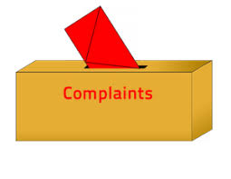
عنوان المُرسل إليه
Dear Sir / Madam ,
I am writing to you to express my dissatisfaction about services offered by your company .
سيدي العزيز / سيدتي العزيزة :-
أنا أكتب لكم لكي أعبّر عنَ عدم رضاي عن الخدمات التي تقدمها شركتكم .
I was disappointed to discover that [the watch] which I bought from your store last month on January 7 (bill N .1234) doesn't work properly.
لقد خاب أملي عندما اكتشفت بأن الساعة التي اشتريتها من محلكم الشهر الماضي بتاريخ 7 كانون الثاني فاتورة رقم 1234 لا تعمل .
I am sorry to tell you that I would be interested to know what excuse you can offer for such bad service.
يؤسفني أن أخبركم بأنه يهمني أن أعرف ما هو العذر الذي ستقدمونه لتبرير مثل هذه الخدمة السيئة .
Although I have phoned you a number of times and you promised to fix it , it is still broken down.
بالرغم من أنني اتصلت بكم عدّة مرّات وأنتم وعدتم باصلاحها لكنها لا تزال معطلة .
I enclose a copy of the receipt for E 300 , and I would be grateful for replacement or repair under the terms of guarantee.
أرفق لكم نسخة من الوصل الذي قيمته 300 باوند وسأكون ممتناً لكم إذا قمتم بتبديل السلعة أو اصلاحها بموجب الكفالة .
I am sure that was a mistake which I hope to be avoided next time.
أنا متأكد بأن هذه كانت غلطة وأرجو أن لا تتكرر في المّرة القادمة .
I hope this will never happen again.
أتمنى أن لا يحدث هذا الأمر مرّة أخرى.
Yours faithfully ,
R. F.
Ruwaidah Al-Fararjeh
P.S. I look forward to receiving your prompt reply.
ملاحظة أخيرة :- أتطلع بشوق إلى استلام الرد الفوري .

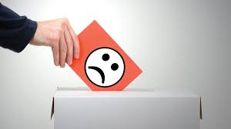
Writing a report
What do you think a good report would look like ? And what would it contain ?
The purpose of the report is to give accurate information. It should supply factual information.
A good report has certain characteristics , for instance :
- It is structured with a title and subheadings.
- It has an introduction stating what the report will show.
- It has a conclusion either summing up what has been shown or making recommendations , depending on its purpose.
- It uses formal language and straight forward sentences.
Q. Compare the two models on page 72 of you activity book. Which is better and why ?
Report number 1 is better in terms of structure , since :
- It has subheadings and clearer spacing ; its language is more formal ; it uses bullet points to make a few direct points.
- It has a title ; the title should be concise and informative .
- It has an introduction ; the introduction explains what information your report will include. Two or three sentences are enough.
- It has two subheadings ; the aim of these informative paragraphs is to cite percentages and fractions according to research.
- It has recommendations or conclusions ; this section sums up your findings and suggests next steps.
- The second model doesn't have any elements which the first model has .
- Most importantly , don't write your opinions.
- Use bullet points to illustrate separate points.

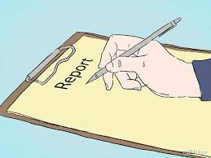

Writing a blog
This is a new form of writing . The blog is an on-line diary which is found on the Internet . It should include the following features .
- Giving information ; usually in the form of an anecdote or a story .
- Showing personal point of view ; often your opinion .
- Using informal language , such as idioms and contractions .
Stages of writing
Stage (1) : Decide on the subject
Stage (2) : Write a descriptive title and who the post is by
Stage(3) : Write a brief introduction that appeals to your readers ; start your blog using introductory phrases , such as " Do you know what …… ? " or " I would like to introduce you……….. , too. "
Stage(4) : State your blog post subject in more details ; use phrases , such as " I'd like to ……….…because ………………… .
Stage (5) : Conclusion ; restate your subject and ask readers to get involved . You can use phrases , such as , so can you help me with ……………………………………………………or We could start up a useful information about ……………….. .
Stage (6) : Check spelling , grammar and punctuation .

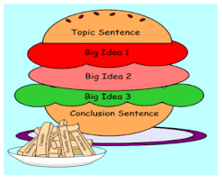

Writing a review
The main components of a review :-
1.Facts
2.Your opinion
The review is an informal writing ,and it should be a balance between these two components.
- Start your review with a general introduction.{ I recently went on holiday to the nature reserve in Ajloun .}
- After that go on to describe your personal experiences. { I loved the view from the window./ The food was cold.} Mention what you liked as well as what you didn't like.
- Next present some facts about the place. {The reserve is home to a variety of animals and birds. / Visitors are accompanied by specialist guides.}
- You can end your review with a short summary of your stay. { I enjoyed my experience here in spite of some inconveniences. / It wasn't an amazing experience , but I learnt some lessons along the way.}
- Finally , you can state your reasons for recommending or not recommending the place to your readers. { I recommend this place to nature lovers who enjoy green and wide open spaces. Moreover , if you are looking for a variety in your menu , I am afraid this is not the place for you.

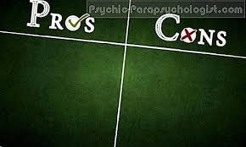

Writing a paragraph for giving advice
Question :- I often find it difficult to fall asleep the night before an exam . Do you mind giving me some advice , please.
- In informal style provide some tips and good reasons to persuade people to take the advice.
- Respond by using some of the giving advice constructions you have studied previously.
- Using modal verbs is useful for turning commands into requests.
- Don't forget to use a topic sentence which directly addresses the problem or the question.
- Also , remember to use the body of the paragraph to expand on the suggestions and the concluding sentence to pack up or restate the importance of the advice that had been given.
- Finally , link ideas by using conjunctive adverbs to help the reader follow the advice. We can summarize that using five stages.

Stages of writing
Stage(1) : Start by asking a question. { Do you find it difficult to fall asleep the night before an exam? }
Stage(2) : Give an explanation of why you are writing this paragraph. { Many students can't fall asleep which is why I 'm writing this paragraph. / Many people are suffering from………nowadays which is the reason behind writing this paragraph.}
Stage(3) : Introduce initial advice. { The best way to fall asleep is to stop drinking energy drinks that contain caffeine ,such as coffee, tea and cola. Another advice is to have dairy products to help you fall asleep. }
Stage(4) : State the final message to the reader.{ If you follow these tips I think you will sleep in the end.
Stage(5) : Check spelling , grammar and punctuation.
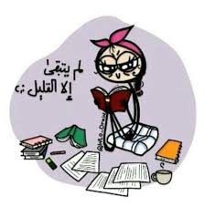

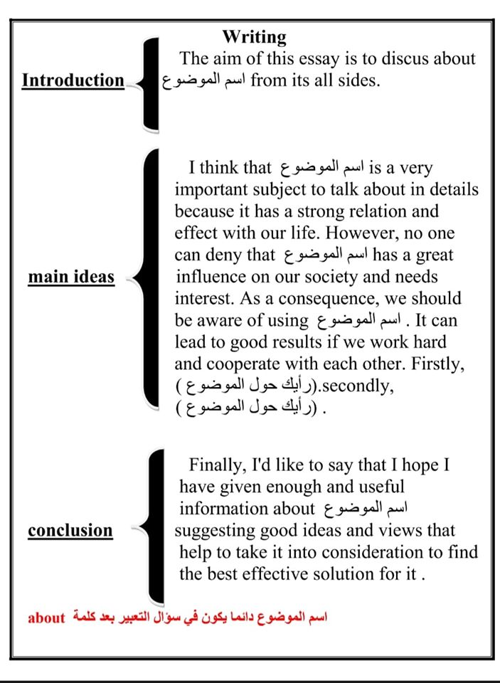

*عبارات مفيدة يمكن استعمالها في مواضيع الإنشاء
المواضيع السيئة / المواضيع الجيدة
I can't imagine life without…….. / with………. because every field of life can't run without……… / with………. اسم الموضوع , so it is the duty of all of us to find means and ways of improving………/ wiping out……………… .
الموضوع السيء / الموضوع الجيد
I think our world could be a simple picture of paradise with……… / without………. الموضوع ,so why don't we make our way of living easier and happier by developing……… الموضوع الجيد eradicating…… اجتثاث الموضوع السيء
Finally , Jordanians who have made great contributions to the progress of their country should be alert to keep up with the latest
developments in all fields of life.
------------------------------------------------------------------------------------
How wonderful it is to have a sense of belonging to your country by taking part in sustainable development!
I really like (community service) so that I can strengthen my sense of belonging to the Arab Islamic and International community.
------------------------------------------------------------------------------------
So why don't we say no to disease, no to ignorance , no to ………. and yes to love, yes to co-operation and happiness under the slogan 'Jordan First'.

Pronunciation: word stress (UNIT 6)
اللفظ : تشديد الكلمة

- How many syllables does the word have?
- How many beats are there in the word ?
- Clap the syllables to make sure.

- Every syllable has a vowel sound .So we count the vowel sounds not the vowels.
*كم عدد المقاطع في الكلمة ؟
هنالك طريقة بسيطة لمعرفة عدد المقاطع في الكلمة ، وذلك عن طريق أحرف العلة . (w,y) , (a , e, i, o,u) و أشباه العلة.
1. أحسب المقاطع حسب عدد أحرف العلة الملفوظة في الكلمة (أصوات العلة) .
2. أحرف العلة المتتابعة تعتبر مقطع إلاّ إذا ظهر أحدها لوحده عند اللفظ .
3. حرف العلّة غير الملفوظ لا يحسب.
4. أشباه العلّة تحسب مقطع .
*صوت العلة هو نواة المقطع قد يكون لوحده وقد يكون معه حرف صحيح أو أكثر
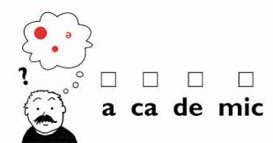

SBP.45 ex.7 (unit 6)
'secondary (4) com'pulsory (4) organi'sation (5(
de'velopment (4) tu'ition (3) a'cheivement (3)
aca'demic (4) contra'dictory (5)
In which syllable does the primary stress lie in the word?
على أي مقطع يكون التشديد الرئيسي في الكلمة؟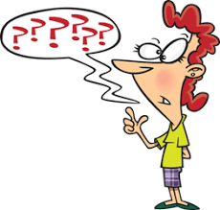

Primary stress means main stress /'/ (strong)
, whereas secondary stress /, / is (weak)

*التشديد الرئيسي يظهر بشكل قوي بينما التشديد الثانوي يظهر بشكل ضعيف وله إشارات مخصصة في الوصف الصوتي أما لاظهاره في الكلمات فيظهر بالخط الغامق.
highlighted in bold

قواعد مهمة للتشديد في الكلمة

- الأسماء التي تتكون من مقطعين التشديد الأقوى يكون على المقطع الأوّل (الثاني لأ).
- الأسماء التي تتكون من ثلاث مقاطع التشديد الأقوى يكون على المقطع الأوّل (الثاني والثالث لأ ).
- في الأسماء التي تتكون من ثلاث مقاطع أو أكثر وتنتهي بـ 'ion' او 'ity' يكون التشديد على المقطع الذي يسبقها مباشرة .
- عندما تضاف هذه المقاطع للاسم لتكون صفة يكون التشديد على المقطع الذي يسبقها مباشرةً.
ic , -ical , -cial , -tial , -cient , -cious , -tious)-)
- الفعل المكون من مقطعين التشديد قد يكون على المقطع الأوّل أو على المقطع الثاني حسب الجزء المحتوي على الجذر حيث يكون التشديد عليه.
- عادةً في الأسماء الطويلة أبدأ عد المقاطع من الخلف و أضع التشديد على المقطع الثالث من الخلف .
- الكلمات ذات المقطعين والتي هي نفسها تأتي اسم أو صفة أو فعل يكون التشديد على المقطع الأوّل إذا كانت صفة أو اسم ويكون التشديد على المقطع الثاني إذا جاءت فعل.
- الكلمات المركبة والمكونة من كلمتين اسماً وصفة يكون التشديد على المقطع الثاني إذا لم يكن متبوعاً بكلمات أخرى blackbird أمّا إذا تبع الاسم الموصوف بكلمات أخرى يصبح التشديد على المقطع الأوّل.
blackbird cage

Pronuncitation:Sentence Stress ( UNIT 9 )

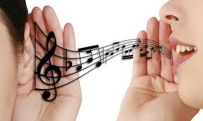
We generally stress content words and the structural words are not usually emphassized unless we are trying to emphasize a point.

The meaning of the sentence can change depending on how you stress certain words.
- معنى الجملة ممكن أن يتغير حسب الكلمة التي يقع عليها التشديد الرئيسي في الجملة.
Notice how the change of stress in different words in this sentence changes the meaning.
- لاحظ كيف أن تغيير التشديد على مختلف الكلمات في الجملة يغير معناها.
  - I never said he stole money.
  - I never said he stole money.
  - I never said he stole money.
  - I never said he stole money.
  - I never said he stole money.
  - I never said he stole money.
- By changing the stress on a specific word I mean that another word of the same class may replace it.
- عندما أشدد على كلمة معينة أعني بأن كلمة أخرى من نفس النوع كان من الممكن أن تحل محلها.
e.g. By stressing the subject pronoun (I) you are implying that someone else may have said to stole money.
- عندما أركز على الضمير I فأنا أعني بأنه أنا و ليس شخص آخر هو من نفى عن نفسه قول هذه الجملة .
What is the difference in meaning between these sentences?
a. I bought a phone. b. I bought a phone.
In a , I'm telling you it was I who bought the phone not somebody else.
In b, I'm telling you I bought a phone and not something else.

SBP.69 ex.5 (unit 9)
This sentence is said in four different ways.
Give the different meaning in each case.
- The first ever Alia flight was in 1963 CE.
There were no Alia flights at all before 1963CE.
- The first ever Alia flight was in 1963 CE.
There were other flights before 1963, but not Alia flights.
- The first ever Alia flight was in 1963 CE.
Alia did other things before its first flight in 1963 CE.
- The first ever Alia flight was in 1963 CE.
Alia's first flight was not in 1964CE.
SBP.69 ex.6 (unit 9)
*This sentence is said in four different ways.
Give the different meanings in each case :
- I retired when I was 60 , which was in 1999 CE.
It was I , not someone else , who retired.
- I retired when I was 60 , which was in 1999 CE.
I did other things when I was 60 , but this is when I retired.
- I retired when I was 60 , which was in 1999 CE.
I was 60 when I retired not another age.
- I retired when I was 60 , which was in 1999 CE.
It was in the 1999CE when I retired , not another year in the 1990s.
Pronunciation: Intonation ( UNIT 10 )
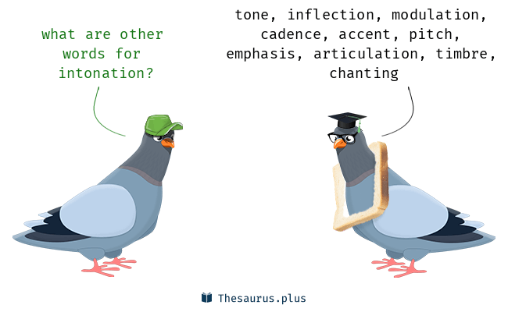
- Falling intonation (low pitch) الهابطة النغمة

 | Statements | الجمل العادية
 | Commands | جمل الأمر
 | Greetings (normal / business) | التحية ( العادية / العمل )
 | Tail questions | الأسئلة القصيرة / الذيلية
 | Wh- questions | أسئلة المعلومات

- Rising intonation ( high pitch) النغمة الصاعدة

 | Yes/ No questions | أسئلة النعم و اللا
 | Tail questions Yes / No | الأسئلة الذيلية عندما تتطلب إجابة
 | Friendly greetings | التحية للأصدقاء
 | Polite requests | الطلبات المهذبة
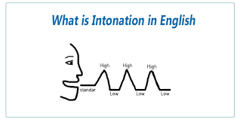

SBP.75 ex.2 Study these questions carefully, which one shows encouragement ? Which one shows puzzlement ?

- How can I get work experience without getting a job first? Puzzlement

- Before you find a full-time job, why don't you consider doing voluntary work ? Encouragement

- Don’t forget that we can add meaning to a sentence by our intonation.
SBP.75 ex.2 Remember that in question, intonation rises or falls at the end. Wh-questions fall at the end while open-ended questions rise.

e.g.What advice can you give?
Are there any jobs which train young people while they are working?

