Name:
Teacher: Aseel Awad
Grade:7

Taqarob School
Unit 2/ The man at the fountain
Comprehension worksheet (1)

English Language Department

Q1. Read the text (New York! ) SB. pg. 18 and answer these questions.
- What are the elements of the story”the man at the fountain”?
- …………………………………………2.……………………………………………
3. …………………………………………… 4. ……………………………………………
- What happened while Phillippe was standing by his cousin’s newspaper stall?
……………..……………………………………………………………………………………..
- According to the writer describe the square on that hot afternoon?
…………………..……………………………………………………………………………….…..
- How did the writer describe the buses in that place?
………………………………………………………………………………………………………
- According to the narrator, the thief was almost hidden by a group of tourists. What did they do there?

……………………………………………………………………………………………………………
- According to the narrator, travelers to the city always took photos of the fountain. Explain why?
…………………….…………………………………………………………………………………..
- What was the fountain made from?
…………………..……………………………………………………………………………………
- Describe the building which interested the thief?
………………………………………………………………………………………………………….
- In your point of view, why do you think Phillippe wanted to follow the thief?
…………………………………………………………………………………………………..……….
- Find from the story
- Simple past …………………..
- Plural noun …………………...
- A word means” small waterfall”…………………………
- A synonym of the word “beautiful” ……………………..
- Superlative …………………….
- Present participle ……………………
- Uncountable noun …………………..
- A word that means a person who steals …………………..
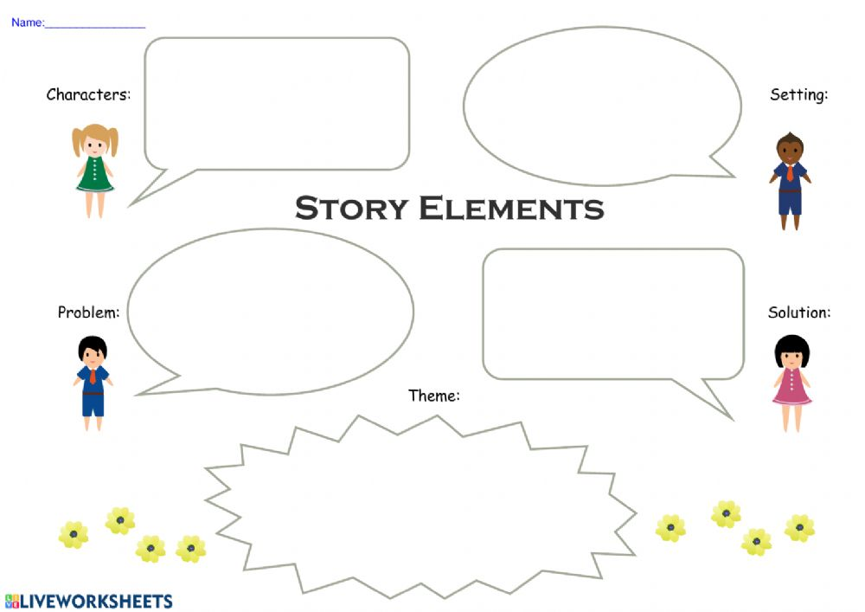
- Proper noun …………………………

