Student's name:----------- Taqarob Schools
Teacher's name: Esraa Al Kilani. Second term ( 2021 -2022)
English department Worksheet unit4 \ Grade 3

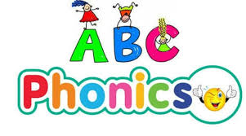

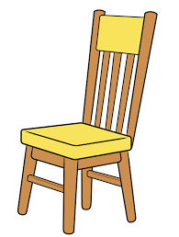 | chair | 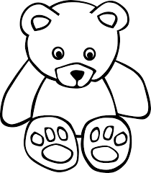 | bear
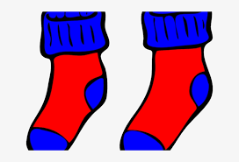 | pair | 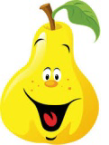 | pear
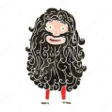 | hairy | 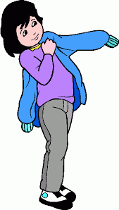 | wear
*******************************************************
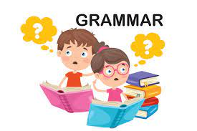Countable and uncountable nouns with some and any

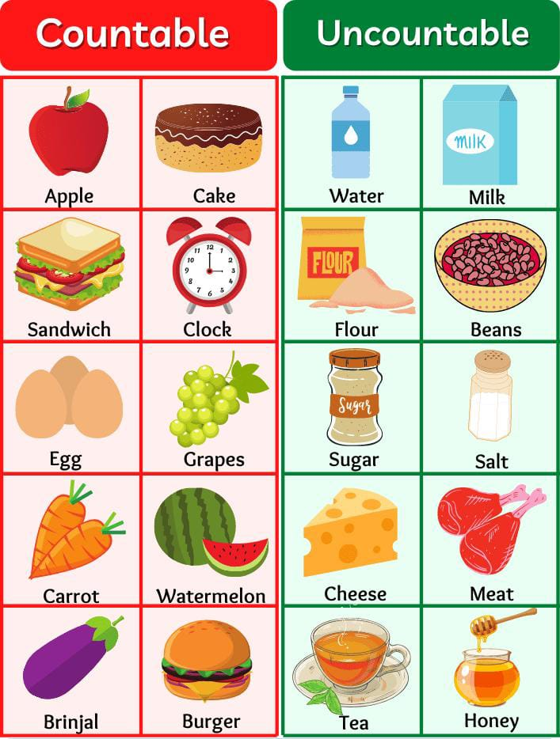

aubergine
There is
Uncountable nouns : There is water in the jug.
Singular nouns : There is an apple on the plate.
Countable plural nouns: There are apples on the plate.
There are
****************************************************************************
countable nouns
Plural: bananas
There are some bananas.

+affirmative
uncountable nouns
Food
She's cooking some food.

Plural: apples
There aren't any apples.
Are there any apples?

countable nouns
- negative
? questions
uncountable nouns
Sugar
- There isn't any sugar.
? Is there any sugar?

****************************************************************************
How many ……………. are there? |  | How much ………….. is there?
Countable nouns |  | Uncountable nouns
Mushrooms, olives, pens, cars, books |  | sugar, food, spinach, tuna, water
There are a lot. | How many mushrooms are there? | There isn't much. | How much sugar is there?
A)Choose the correct answer:
1-There is ( some \ any ) water in the bottle.
2-They didn't eat ( some \ any ) sandwiches.
3-Have you got ( some \ any ) pencils?
4-There are ( some \ any ) books in the bag.
****************************************************************************
B)Fill the gaps with How much or How many
1-_____________ potatoes are there?
2-_____________honey is there?
3-_____________meat is there?
4-_____________peaches are there?
5-_____________pizzas are there?
****************************************************************************
C)Write C for countable or for uncountable:
1-oil ___ 2-pears___ 3-fish____ 4-cup of tea____
5-tea___ 6-cheese___ 7-pasta___ 8-eggs___

****************************************************************************

