Student's name:----------- Taqarob Schools

Teacher's name: Esraa Al Kilani Second term ( 2021 -2022)

English department Worksheet unit3 \ Grade 1



***

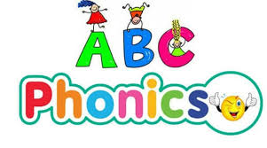

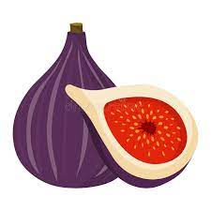 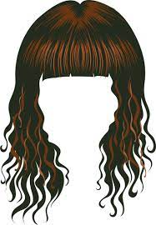 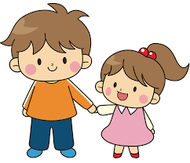 

w**i**g

s**i**ster

w**i**nd

f**i**g

*******************************************************

Grammar

Writing

| Thatتنزيل - 2022-01-18T130513.629.jpg تنزيل (22).jpg | This تنزيل - 2022-01-18T130532.951.jpg |
| --- | --- |
| **That is** your cat.  **That's** your cat. | **This is** my cat. |

| Possessive adjective | Personal pronoun |
| --- | --- |
| تنزيل - 2022-02-14T201117.320.jpg  My | cute-girl-saying-correct-vector-202836367.jpg  I |
| Yourتنزيل - 2022-02-15T215014.008.jpg | You تنزيل (17).png |
| Hisتنزيل - 2022-02-15T214456.330.jpg | Heتنزيل (31).png |
| Herتنزيل - 2022-02-15T214351.609.jpg | She تنزيل (63).jpg |

#Complete the sentences with **this** or **that**: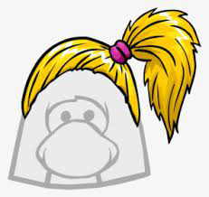

1- ___________ is a funny wig.

2-___________ is Noor.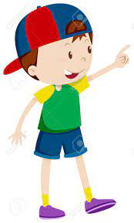

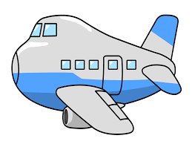

3-___________ is a plane.

*******************************************************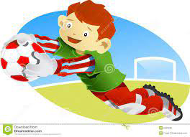

#Choose the correct answer:

1-**I** have got a ball. ______ ball is new.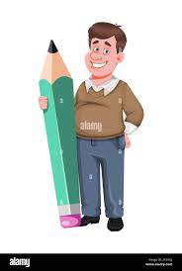

| His | Your | Her | My |
| --- | --- | --- | --- |

2-**The teacher** has got a pencil. ______ pencil is big.

| His تنزيل (2).jpg | Your | Her | My |
| --- | --- | --- | --- |

3-**You** have got a bag. ______ bag is big.

| His | Your | Her | My |
| --- | --- | --- | --- |

***********************************************************

#Write **his**, **her**

| تنزيل (31).png | تنزيل (63).jpg |
| --- | --- |
| تنزيل (28).pngتنزيل (86).jpg | تنزيل (70).jpgimages (4).png |

1-It is ______ hat.

2-It's ______ umbrella.

3-It's ______ car.

4-It is ______ balloon.